Seniors on the Move with Jesus
To love and serve God, each other, and our community | Calvary Community Church  15116 Gary St E, Sumner WA  253-863-3352

December 2025 - Senior Highlights

Potluck – December 11th in MPR
Outing – December 18th
Christmas Day - NO Social event

Fridays at 9am
Breakfast Social - Tim’s Café, Orting

Alan & Nancy’s Column

Hi Seniors

The November Potluck was awesome. We had 76 Seniors, the most we have had in a while. We also had about 6 to 8 new members who showed up for the first time.

We reminded the Seniors that for November and December we will not have a social or game day. Also, our collection from this potluck would go to help any Senior who needed help for a Thanksgiving dinner and that any money remaining from that collection would go to Calvary's Thanksgiving dinner that is open to all. We let the Seniors know that if you had no plans for Thanksgiving Day to stop by Calvary for a great meal and fellowship.

Thanksgiving is a time for family and this year is no different for us. We were able to spend this Thanksgiving with our youngest son and granddaughter in Texas. It's been 4 years since we were with them. Kids are funny and grandkids are weird.

My granddaughter thinks it's not funny if I try to tickle her like I did when she was 10 (she is 14 now) so now I have to adjust my thinking about how I act with her. But thank the Lord she takes after my wife and gives me hugs, sits next to me and calls me old and lame and other terms of affection. I was sad to leave and not see them again for a year or so.

Anyway, I hope that if you had family over this Thanksgiving and your kids and grandkids called you old and lame with the same love that I saw in my granddaughter and son's eyes it is a true blessing.

We wish all a very merry Christmas and a Happy New Year be blessed and see you in church.

Alan & Nancy

December Scripture

Jeremiah 29:11 (NIV)

"For I know the plans I have for you,” declares the Lord, “plans to prosper you and not to harm you, plans to give you hope and a future."


This verse is universally inspiring because it assures us that God’s intentions are good—He is guiding us toward hope, purpose, and a meaningful future. It resonates whether someone is young and just starting out, in midlife navigating challenges, or older and reflecting on their journey.

December Recipe

Hearty Bean and Vegetable Soup


Ingredients
- 1 can of black beans (rinsed and drained)
- 1 can of diced tomatoes (with juices)
- 1 cup frozen mixed vegetables
- 1 cup low-sodium vegetable broth
- 1 teaspoon dried oregano or thyme (optional for extra flavor)

Directions

- In a large pot, combine the beans, diced tomatoes, frozen vegetables and vegetable broth.
- Bring the mixture to a boil, then reduce to a simmer and cook until the vegetables are tender, 10-15 minutes.
- Season with dried herbs and salt and pepper to taste.

Outings Committee

For the December Outing, we have one of our favorites, Mazatlan Restaurant in Bonney Lake. FYI is about a block east of the Safeway at Hwy. 410 and 214th Ave. E. on the Southside of the road.

As usual, you can meet us at Mazatlan restaurant at 11:30 or ride the shuttle fro25m the church - meet at 10:45 at Calvary and leave at 11:10.

If you have questions or want to sign up, but can't make the potluck on the 11th to sign up, call me (Gary) at 253-831-6792.

gw.hobbit@gmail.com or text 253-831-6792

Help Wanted with the Outings Committee
Connie and I (Gary) like to travel. Do you want to get more involved? We can use your help on the outings committee.

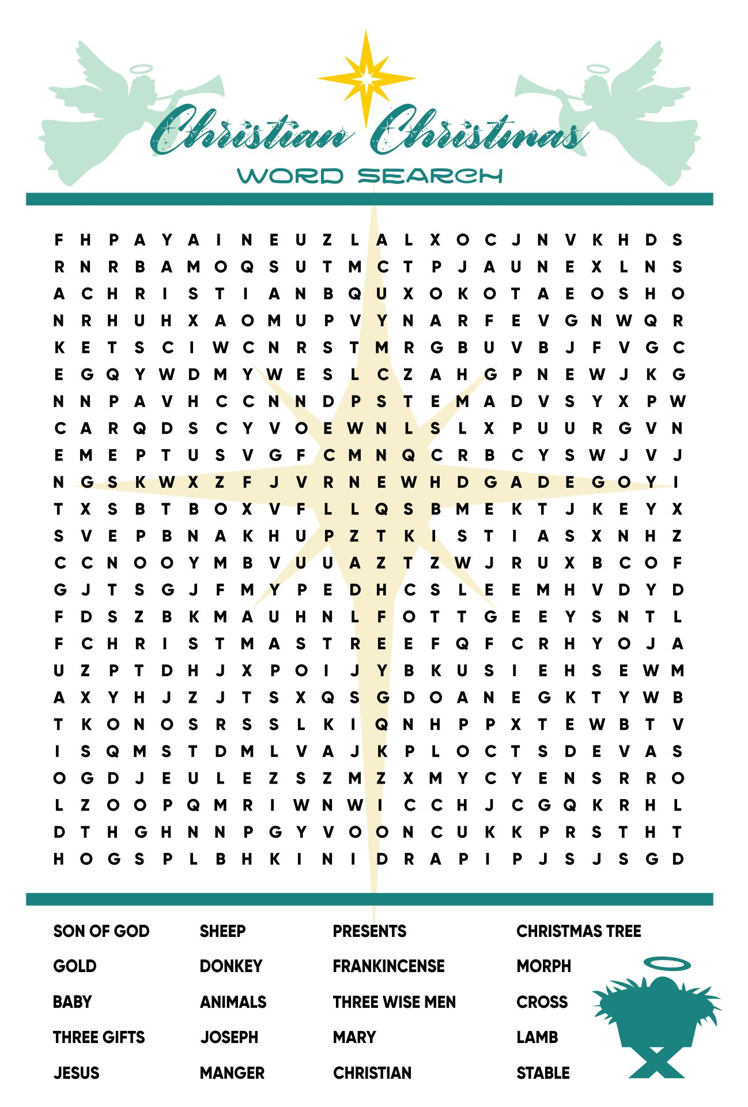


Are you Looking for more to do?
Consider checking out a Senior Centers near you
Auburn Senior Center  808 9th St SE  253-931-3016  WWW.Auburnwa.gov/seniors |  |  | Bonney Lake Senior Center  Open M-F - 8am - 4pm  19304 Bonney Lake Blvd  253-863-7658
Orting Valley Senior Center  Open Mon-Thurs 9am-2pm  120 Washington Ave N (meals)  112 Varner Ave SE (activities center)  360-893-5827  www.seniorcenter@orting.wednet.edu | Puyallup Activity Center  Open M-F - 8am-5pm  230 West Pioneer  253-841-5555 |  |  | Sumner Senior Center  Open M-F - 8am-4:30pm  15506 62nd St Ct E  253-863-2910
Tacoma Senior Centers
Pt Defiance/Ruston Senior Center  Opens at 9am  4716 N Baltimore  253-756-0601 |  | Beacon Senior Center  Open Mon & Tues 8am-3pm  415 S 13th St  253-301-3369 |  | Lighthouse Activity Center  Open Mon/Tues & Thurs/Fri  at 8am-3pm  5016 A Street  253-426-1282

Here are a few local Senior Centers that are in our area. I also have a printed list of senior centers in Pierce County, I plan on putting current newsletters somewhere they’ll be available for people to look at. Most senior centers offer a hot meal for seniors Monday – Friday for a donation, but will provide a meal even when someone is unable to donate. There are also some Senior Centers which will deliver a meal if you can’t make it in to get one. Some food bank will also deliver groceries to someone who can’t make it in to pick up groceries.

If you’re looking for more to do, you could go to your local senior center, register with them and they should be able to mail you copies of their current schedule of events and meals each month. Make some friends, invite them to Calvary seniors’ group or to Calvary Church.

December 2025 – Calvary Seniors Events Calendar
Sunday | Monday | Tuesday | Wednesday | Thursday | Friday |  | Saturday
 | 1 | 2 | 3 | 4 | 5  9am Breakfast/coffee  Tim’s Kitchen, Orting | 6
7 | 8  Kathy Fourre | 9 | 10 | 11  Potluck-noon  Elaine Harding | 12  9am Breakfast/coffee  Tim’s Kitchen, Orting | 13  Daphne Lynch  Jeanne Jacobson
14  Lorraine Adams | 15 | 16 | 17 | 18  Outing  Mazatlan (See page 2) | 19  9am Breakfast/coffee  Tim’s Kitchen, Orting | 20  Arlene Iverson
21 | 22  Sheron Hazelwood | 23 | 24 |   25th | 26  9am Breakfast/coffee  Tim’s Kitchen, Orting  Ron Morris | 27  Bernice Keadle
28 | 29  Heavenly Birthday Lolita Agustin | 30  Gwen Stahnke | 31  Rick Eakins |  | Happy Birthday also to any seniors whose birthday may have missed.  Everyone have a Blessed Month!  Nancy Ribeira

