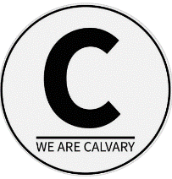 | Seniors on the Move with Jesus
 | To love and serve God, each other, and our community | Calvary Community Church  15116 Gary St E, Sumner WA  253-863-3352

March 2026 - Senior Highlights

Potluck – March 12th in MPR
Outing – March 19th
Social event/games – March 26th
Fridays at 9am
Breakfast Social - Tim’s Café, Orting

Alan & Nancy’s Column
Seniors;
If you did not make it to our February Valentine Day Potluck, you missed a good one. Not only did you miss really great food and fellowship, but you missed our last goodbye to the Seniors as leaders.

Yes, that is correct Nancy and I are no longer the leaders. We have stepped out of that roll, but we have not stepped away from the Seniors group.

I am now the Assistant Director to Mark Jones who is the new Director over the entire Senior group. Mark is not alone I report to him and also assist him with anything that is going on with the Senior group. I also have a backup with Mark and now also with Ken Wahl who is also an Assistant Director and (for now) our temporary treasurer.

I have been telling the Seniors that change is coming to our little group and the change is now.

You will now see Mark and I and maybe Ken share the podium at the potluck and other events we have planned. This change was needed to give Nancy and I some time to enjoy being Seniors and to share the reasonability's of running a ministry.

Our goal in making these changes was to grow the Senior group. Now that we have more people sharing the responsibilities, we can now have a fresh look at how we can add events and more seniors. In the next few months we will be trying new things, some will be great and some may turn out to be not so great. But we won't know until we try.

Blessings Alan & Nancy

March Scripture
Psalm 1:1-3 &. 19:7-10
Today as I looked out the back window a lavender color was seen all over our backyard tree.

It was a beautiful light purplish hue against otherwise bare tree branches. It’s too early for spring I thought to myself.

With a closer look, this lavender hue was the outer covering of starting buds on the tree. Yes, new signs of growth starting to appear. Growth popping out was such a welcome sight with the day’s gray clouds and drizzling rain.

This started me thinking about Psalm 1:1-3. It compares the one who delights and meditates in God’s Word as a tree, yielding its fruit in season and whose leaves do not wither.

For that tree to have leaves and fruit, it had to start budding. Have you noticed once those leaf buds open, it seems the leaves grow out so quickly.

The LORD wants us to grow, to develop, to flourish from knowing and living out His Word. Read
Ps. 19:7-10.

God’s WORD refreshes the soul, makes the simple wise, gives joy to the heart and gives guidance.

Let’s dig in our Bibles and mull, think over and reflect deeply on what, God says.

Outings Committee
In March Nancy and I started helping our Outing committee. We will take the Senior Outing to Gig Harbor Museum in Gig Harbor and have lunch at Anthony's Home Port. Now the cost for the Museum is $10 per Senior. If the cost is a barrier and you would like to go, we can help. Just let us know. Hope to see you at our next potluck and be ready for more changes. See you at church.

Blessings Alan & Nancy

Insights from Mark

As Alan has written for the past several months in the Seniors on the Move newsletter, a change was coming. That change was announced and the members of the Advisory Board (Leadership Team) were introduced at the February potluck. For those of you who missed the February potluck the board currently consists of the following members:

Mark Jones- Director
Delda Jones- Admin Support (Directors, Secretary and Care)
Bonnie Wahi- Secretary (Admin)
Ken Wahl- Assistant Director/ Interim Treasurer
Gary Walker- Activities Coordinator
Nancy Ribeira- Care Lead
Connie Walker- Devotions Lead
Luwanna Poznanski- Devotions Assistant
Bob Poznanski- One on One Prayer Lead
Trish Lawrence- Newsletter Coordinator
Bud Harrington- Technology coordinator

You will note that Ken is the Interim treasurer.
This means we are very much in need of a treasurer. If you have been at Calvary for more than two years and have a finance background, please contact Mark Jones. There are many opportunities to serve in this ministry, so please let us know how to best get you plugged in. As the saying goes, many hands make for light work for.

“Two are better than one because they have a good return for their labor” (ecc 4:9)

So, until next time, love big, serve big and live bigger all for the glory of our Lord!

March Recipe
Roasted Zucchini

Cooking spray
1 tsp. dried basil
4 small zucchinis (about 1 lb. total)
¼+black pepper
1 tsp. olive oil
1 finely chopped garlic clove
1 tsp. balsamic vinegar
- Lightly coat a baking sheet with cooking spray or use non-stick aluminum foil.
- Slice zucchini in ½” thick slices; cut each slice in quarters. Place in a small mixing bowl.
- Drizzle oil, balsamic vinegar and spices over zucchini chunks. Add garlic and toss lightly.
- Transfer zucchini to baking sheet and bake in preheated 450-degree oven for 8 to 10 minutes.
- Yields 4 servings, 2/3 cup each.
- PS We use a bit more spices and balsamic vinegar. Try the recipe and modify to your taste.

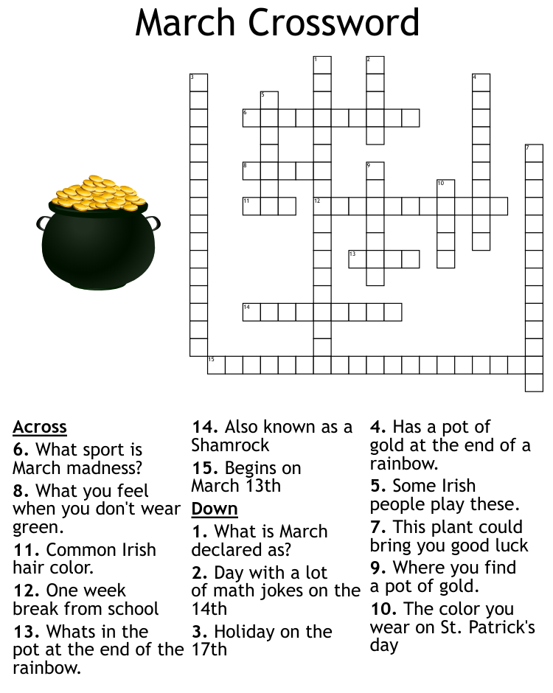
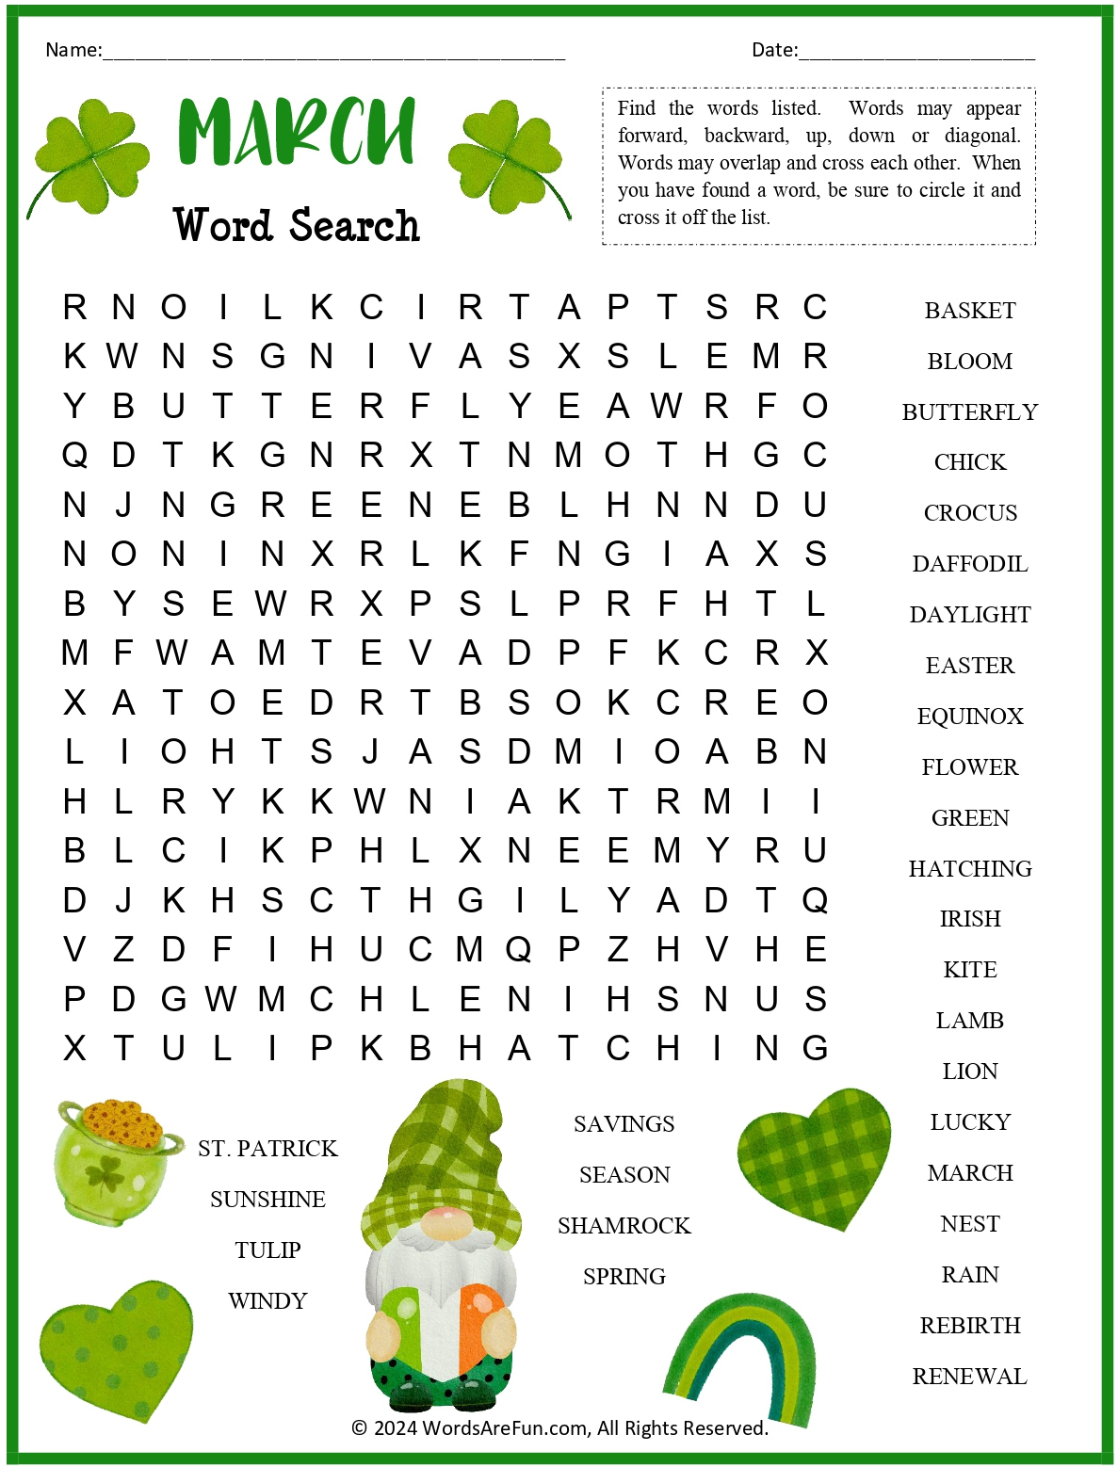

Are you Looking for more to do?
Consider checking out a Senior Centers near you
Auburn Senior Center  808 9th St SE  253-931-3016  WWW.Auburnwa.gov/seniors |  |  | Bonney Lake Senior Center  Open M-F - 8am - 4pm  19304 Bonney Lake Blvd  253-863-7658
Orting Valley Senior Center  Open Mon-Thurs 9am-2pm  120 Washington Ave N (meals)  112 Varner Ave SE (activities center)  360-893-5827  www.seniorcenter@orting.wednet.edu | Puyallup Activity Center  Open M-F - 8am-5pm  230 West Pioneer  253-841-5555 |  |  | Sumner Senior Center  Open M-F - 8am-4:30pm  15506 62nd St Ct E  253-863-2910
Tacoma Senior Centers
Pt Defiance/Ruston Senior Center  Opens at 9am  4716 N Baltimore  253-756-0601 |  | Beacon Senior Center  Open Mon & Tues 8am-3pm  415 S 13th St  253-301-3369 |  | Lighthouse Activity Center  Open Mon/Tues & Thurs/Fri  at 8am-3pm  5016 A Street  253-426-1282

Here are a few local Senior Centers that are in our area. I also have a printed list of senior centers in Pierce County, I plan on putting current newsletters somewhere they’ll be available for people to look at. Most senior centers offer a hot meal for seniors Monday – Friday for a donation, but will provide a meal even when someone is unable to donate. There are also some Senior Centers which will deliver a meal if you can’t make it in to get one. Some food bank will also deliver groceries to someone who can’t make it in to pick up groceries.

If you’re looking for more to do, you could go to your local senior center, register with them and they should be able to mail you copies of their current schedule of events and meals each month. Make some friends, invite them to Calvary seniors’ group or to Calvary Church.

March 2026 – Calvary Seniors Events Calendar
Sunday | Monday | Tuesday | Wednesday |  | Thursday | Friday | Saturday
1  Al Potts | 2 | 3 |  | 4 | 5 | 6  9am Breakfast/coffee  Tim’s Kitchen, Orting | 7
8 | 9  Barbara Johnson | 10  Lee Karsten |  | 11 | 12  Sue Nagy  Potluck-noon | 13  9am Breakfast/coffee  Tim’s Kitchen, Orting | 14  Bill Hickman
15 | 16  Mark Jones | 17 |  | 18 | 19  Outing | 20  Bob Poznanski  9am Breakfast/coffee  Tim’s Kitchen, Orting | 21
22 | 23 | 24  Shannon Agidius |  | 25  Gayle Naylor | 26 | 27  Wanda Coplin  9am Breakfast/coffee  Tim’s Kitchen, Orting | 28
29  Helen Hafer | 30 | 31 |  |  | Happy Birthday also to any seniors whose birthday may have missed.  Everyone have a Blessed Month!  Nancy Ribeira

2026 Outings
Month | Outing | Leader
January | Branks | Gary
February | WA Historical Museum | Gary
March | Gig Harbor Museum | Alan & Nancy
April | ** LaConner Tulip Festival
May
June | Tacoma Rainiers Game
July
August | Point Ruston
September | ** Pike Place and Underground Tour
October | Harvest Festival
November | New Day NW
December | Scrooge/ Christmas Lights

**Optional overnight option.

Leaders needed for March thru December.
Ideas needed for March, May & July!
Please fill out the connecting card and/or let us know.

Seniors Connecting Card

Name: _______________________________ Phone: ___________________________

Email: _________________________________________________________________

Please circle all that you are interested in:

Bible Study: Yes Not at this time

Life Group: Men’s Women’s Couples

Serving Opportunities Care Shuttle Driver Hospitality Outings

Ideas: ______________________________________________________________________
____________________________________________________________________________________________________________________________________________________________________________________________________________________________________

I need assistance with: ______________________________________________________
____________________________________________________________________________________________________________________________________________________________________________________________________________________________________

Prayer Request: _____________________________________________________________
____________________________________________________________________________________________________________________________________________________________________________________________________________________________________

Please tear this page off and turn in at the HUB or take a picture and send to seniors@wearecalvary.com

