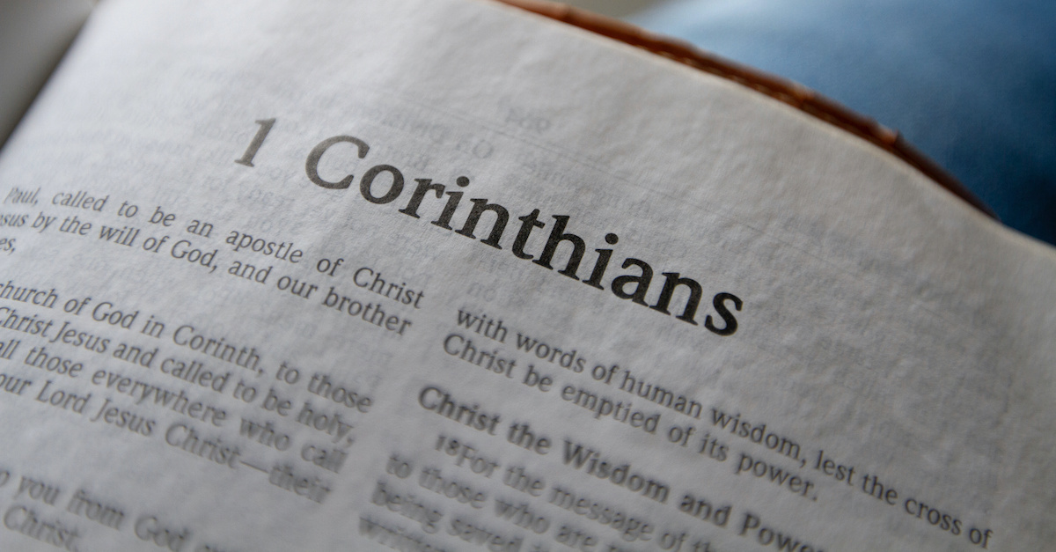

Growth Groups Material
(5 Studies on 1 Corinthians 1-4)
Oct-Nov 2021

Introducing 1 Corinthians
The story so far…
After the resurrection and ascension of Jesus in around AD33, the message of salvation in Him began its worldwide spread in the years that followed. One of the most important missionaries was the Apostle Paul. He planted a church in Corinth in around AD51 and stayed there for around 18 months. The church members were likely from a range of backgrounds – rich and poor, Jew and Gentile.
Fun fact: Historians use Paul’s time in Corinth to piece together the chronology of his life. In Acts 18:12ff, during Paul’s time in Corinth, we read of Gallio, the ‘proconsul of Achaia’ (the region Corinth was situated it). 20th century archaeological discoveries in Greece refer to Gallio’s time in office being around AD51-52. Hence, we can date Paul’s time in Corinth to around the same time.

The city of Corinth during Paul’s time was a melting pot of ethnic people groups, pagan religion and Greek philosophy. Located by the narrow strip of land connecting Achaia to mainland Greece, it also controlled a vital sea-trade route, and as such become a prosperous, wealthy city. The moral corruption that often trickles down from wealth, was rife in Corinth, especially sexual immorality. 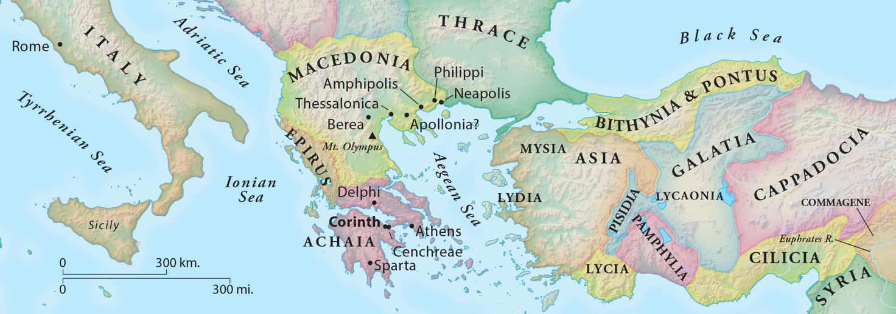
When and why did Paul write 1 Corinthians?
After leaving Corinth, Paul continued in his missionary journeys. A few years later, when he was in Ephesus (around AD54) Paul began hearing of problems emerging in the Corinthian church: from Chloe’s household (1:11); a letter he had received (7:1); and/or the visit of three men from the church, Stephanas, Fortunatus and Achaicus (16:17). 1 Corinthians is the second of (perhaps) four letters Paul wrote to the church:
- A ‘previous’ letter not preserved (referred to in 1 Cor 5:9)
- 1 Corinthians (written in Ephesus in around AD54-55, c.f. 1 Cor 16:8)
- A ‘severe’ letter not preserved (referred to in 2 Cor 2:4, 7:8)
- 2 Corinthians
Paul wrote 1 Corinthians, to address the many moral compromises being made by the church, and their confusion surrounding a range of matters – especially as they relate to the unity, holiness and the orderly ministry of the church. In chapters 1-4, Paul is addressing the division and religious ‘one-upmanship’ which had crept into the church culture. Influenced by the intellectual snobbery and obsession with worldly wisdom which characterized Corinthian culture, the church had misplaced their confidence and become arrogant. They had begun to focus on the power of the messengers rather than on the power of God’s unexpected, strange, seemingly foolish message: Christ crucified.
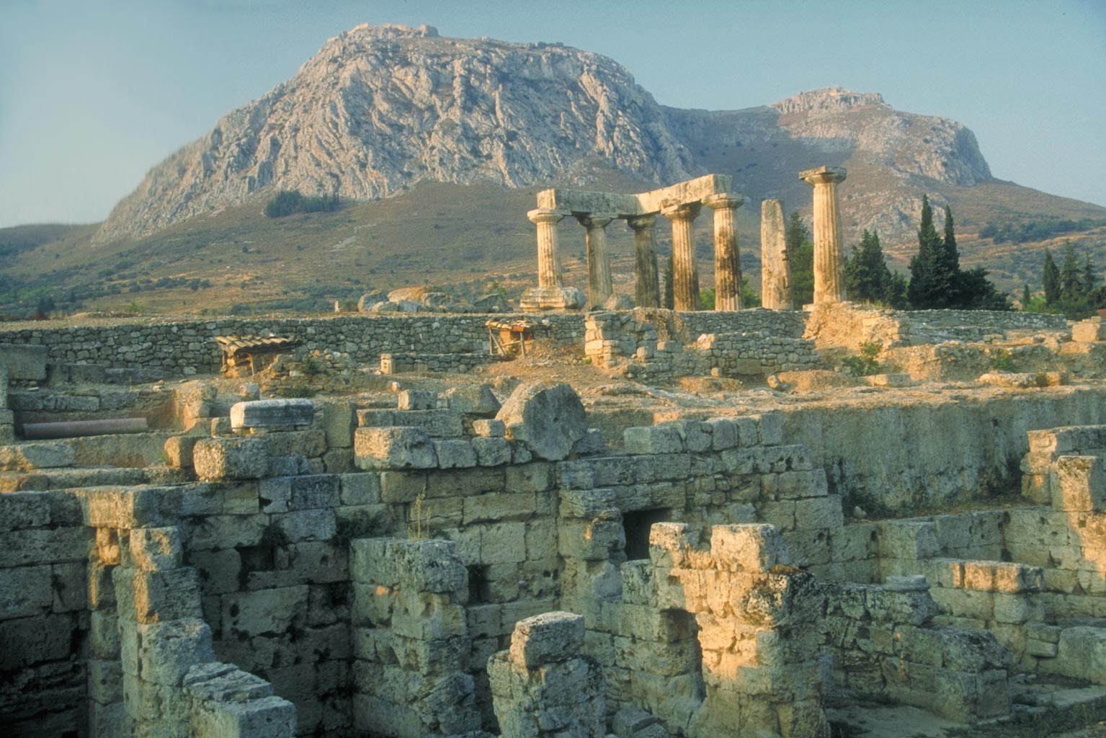
Ruins of the Temple of Apollo at Corinth.

Teaching Series and Booklet Contents
Sermon | Passage/Title
9-10 October | 1 Corinthians 1:1-9 | God’s Church
 | Study 1 ………………………………………………………………………………. | p.5
16-17 October | 1 Corinthians 1:10-31 | God’s Foolish Power
 | Study 2 ………………………………………………………………………………. | p.6
23-24 October | n/a – Overhall Visit
30-31 October | 1 Corinthians 2 | God’s Hidden Wisdom
 | Study 3 ………………………………………………………………………………. | p.7
6-7 November | 1 Corinthians 3 | God’s Co-workers
 | Study 4 ………………………………………………………………………………. | p.8
13-14 November | 1 Corinthians 4 | The World’s Garbage
 | Study 5………………………………………………………………………………. | p.9

Additional Resources
 | Map of Paul’s Second Missionary Journey  © Mark Barry 2008, visualunit.me | p.10
 | Introduction to 1 Corinthians (link to website only)  https://www.thegospelcoalition.org/course/1-corinthians-courses/ | n/a

Study 1 | 1 Corinthians 1:1-9 | God’s Church
- If you had to choose, would you describe yourself as ‘holy’ or ‘becoming holy’?
- Read Acts 18:1-18. This passage describes when Paul planted the church in Corinth.
  - How long did he stay there? What did he do? What were some of the challenges he faced?
- Read 1 Corinthians 1:1-3.
  - How does Paul describe himself?
  - How does he describe the Corinthians?
  - The same concept comes up twice in verse 2 (‘sanctified’ and ‘saints’ come from the Greek word, often translated ‘holy’). Why do you think Paul emphasizes this concept here?
- Read 1 Corinthians 1:4-9. Can you list all the things that God has done, or will do for this church?
- In verse 4, Paul is very positive, thanking God for the church. This seems a little surprising given all the problems in the church, which will become apparent throughout the letter. Have a quick look over some of the following passages and take note of some of their ‘issues’.
1:10-11 | 3:1-4 | 4:8-14 | 4:18-21 | 5:1-2 | 6:1-8 | 6:15-18 | 7:1-2 | 8:1 | 8:7-13 | 10:14-15 | 11:17-22 14:20-23 | 15:12 | 15:33-34 Note: share the many references amongst your group members
- Despite all of this, Paul still describes these people as ‘saints’ or ‘holy’. How could this be possible when they have so many issues?
- Verses 5-7 touch on a major theme which will be addressed later in the book: spiritual gifts. What is Paul’s assessment of the spiritual giftedness of the Corinthian Christians? How does Paul arrive at this view?
- Paul is placing the seemingly ordinary activities of speaking and comprehending true knowledge, at the heart of spirit-fuelled living. What does this teach us about the nature and purpose of spiritual gifts?
- This passage tells a compelling, albeit concise, story of what it means to be God’s church:
- called by God into fellowship with Jesus;
- the recipients of God’s grace;
- sanctified (set apart for God);
- enriched with spiritual gifts;
- being strengthened by God that we might be found blameless;
- awaiting the revelation of Jesus Christ.
Which of these elements excites you the most? Why?
- Pray, thanking God that you belong to His church!

Study 2 | 1 Corinthians 1:10-31 | God’s Foolish Power
- Why is it that we are sometimes embarrassed to talk about Jesus Christ and his death on the cross? What about this message is offensive in the eyes of the world?
- Read 1 Corinthians 1:10-17
  - What issue in the Corinthian church is being described in these verses? Where does it appear to come from?
  - Does this kind of thing still happen in churches today? Can you imagine examples?
  - Paul’s concern, in verse 17, is that the ‘cross of Christ will not be emptied of its effect’. What do you think this means?
- Read 1 Corinthians 1:18-25
  - From these verses, what do you think the people of Corinth were really impressed by?
  - Would you say that modern Jannali/Sydney/Australia is similar to ancient Corinth? How so?
  - The Jews sought signs, and the Greeks sought wisdom. What does our community seek today, in order to back up a religious or spiritual claim?
  - Why does God work through the message of the cross to save people? How does verse 19 (quoted from Isaiah 29:14) fit into this? Note: You may like to read Isaiah 29:14 in context to get a sense of God’s purposes in confounding the wise.
- Read 1 Corinthians 1:26-31
  - What were the Corinthian Christians like, as people?
  - How does this reality demonstrate the power of the message of the cross?
  - What is the implication for us, and how we view ourselves, if God tends to save ‘nobodies’?
- In our setting, at JAC, how might we be tempted to put our confidence for successful ministry in things other than the message of the cross? What kinds of things might we look to? Another way of asking this question might be: Can you think of current examples of ways that we, or others in the Church, empty the cross of its power?

- How could you encourage someone who has just been told that they’re silly and foolish for following Jesus?

- Discuss the following quote? Do you agree? How does this chapter shape your view?
“When we tell someone about Jesus, we don’t need to be clever, just clear”
- Pray for unity and confidence in God’s seemingly foolish, but only means of salvation – Christ crucified

Study 3 | 1 Corinthians 2 | God’s Hidden Wisdom
- How would you define the role of the Holy Spirit? That’s a huge question isn’t it! But have a go - what would you say is His essential work?

- Read 1 Corinthians 2:1-5.
  - How does Paul describe himself in these verses? How was this different to what the Corinthians ordinarily valued (see again 1 Corinthians 1:18-25)

  - How does this unit add to Paul’s big message in chapter 1?

- Read 1 Corinthians 2:6-16
  - What is God’s hidden wisdom, or the ‘mystery’ referred to in verse 7?
Note: “Mystery” in the New Testament denotes not something that cannot be known, but something that has previously been unknown but has now been made known. (c.f. Rom 16:25, Eph 6:19)

  - Why are words like ‘mystery’ and ‘hidden’ good words to associate with the message of the gospel.

  - Who do you think Paul is referring to when he speaks of the ‘rulers of this age’? Who would they be today?

  - Think back to question 1. From these verses can you identify what it is that the Holy Spirit does?

- Paul was an unimpressive man, with an unimpressive message, delivered in an unimpressive way. How did his work amongst the Corinthians have any effect at all?

- How does this chapter help us interpret what is happening when someone accepts the gospel message about Jesus? What about when someone rejects this message?

- The chapter finishes with an astonishing comment: “we have the mind of Christ” (verse 16). Is this saying that Christians can read Christ/God’s mind? In what sense is this idea accurate? In what sense is this idea inaccurate?

- How should our common access to God’s wisdom (in the cross):

  - unite us;
  - eliminate personal pride;
  - lead us to pray for our ministry;
  - fill us with gratitude.

- Pray, thanking God for revealing His mind to us, through the message of the cross, and the work of the Holy Spirit
Study 4 | 1 Corinthians 3 | God’s Co-workers
- What individuals in your life do you credit with helping you become, or grow as a Christian?

- Read 1 Corinthians 3:1-4. What two types of Christians does Paul contrast in these verses?

  - Which category did the Corinthians fall into, and how does Paul prove that?

- Read 1 Corinthians 3:5-9. What is the metaphor Paul is employing in these verses?

  - What point is Paul making here and how does this relate the divisions experienced in the Corinthian church?

  - If you’re engaged in ministry leadership (formally) or otherwise working to make disciples (informally), how should these verses shape our understanding of what we’re doing?

  - ‘Human explanations’ aside, who is ultimately responsible for our spiritual growth?

- Read 1 Corinthians 3:9-17. Paul uses a different metaphor in this unit, compared to verses 5-9. What is it?

  - What do you think represents ‘good quality work’ in building up God’s people? What would ‘poor quality work’ be? According to verses 13-15, what is the ultimate test of the quality of our work? Note: the issue of rewards invites speculation. See 1 Thess 2:19-20 for one possible meaning of the idea. Perhaps rewards for ministry work are the eternal salvation of the people we’ve ministered to.

  - How does it make you feel that your labour will be shown for what it is? How can we ensure that we build things that last? How might this shape our priorities as parents; as friends, as growth group members?

  - How do verses 16 and 17 raise the stakes surrounding our ministry work?

- Read 1 Corinthians 3:18-22. These verses bring Paul’s comments back to the issues being faced by the Corinthians – boasting in human leaders! Have you ever found your view of church being tainted by worldly preferences? Can you describe some examples? How do these verses address that kind of thinking?

- “To be one of God’s co-workers is a great privilege, but it comes with great responsibilities!” Do you think this sentence sums up 1 Corinthians 3 well? In what sense is it a privilege to be God’s co-worker, and what is the great responsibility?

- Pray for our ministry leaders at JAC, both staff and others including Growth Group Leaders, Youth and Children’s Leaders, everyone that you can think of. Pray that they would all understand their place in God’s plans, and that they would produce work that lasts!
Study 5 | 1 Corinthians 4 | The World’s Garbage
- What makes a good church minister? What qualities would you consider essential?

- Read 1 Corinthians 4:1-5.
  - What characteristic does Paul identify as being most important to his ministry?

  - Whose judgement is Paul interested in? Whose judgement is he uninterested in? When will this judgement be revealed?

  - Do you find it hard to live for an ‘audience of one’ (i.e. God) rather than living for the approval of others? What are some areas of life where you find this easier/harder?

  - Why is living to please God alone, so important for ministry leaders and bible teachers?

- Read 1 Corinthians 4:6-13.
  - Paul describes many contrasts between the experience of the Corinthians and his own experience? What are some of the contrasts?

  - Does Paul really think that the Corinthian Christians are ‘rich’, ‘kings’, ‘wise’ etc. What is Paul’s tone in these verses? How does that help us discern the point he is really making?

- Read 1 Corinthians 4:14-21.
  - How does Paul distinguish himself from others who might be influencing the Corinthians church?

  - What does Paul want the Corinthians to do? What do you think this will this look like for them?

- Should Christians expect a similar life to that experienced by Paul? How do these other verses inform our discussion: Matthew 5:1-12, Mark 8:34-38, Phil 2:5-11?

- Do you think that living in Australia makes it easier or harder to live consistently with the message of the cross?

- What opportunities are presently before you to imitate Paul, and Christ, in a cross-shaped life? How do you feel about taking those opportunities up?

- Pray that you, and your leaders would emulate Paul and Christ in costly, self-sacrificial discipleship.

