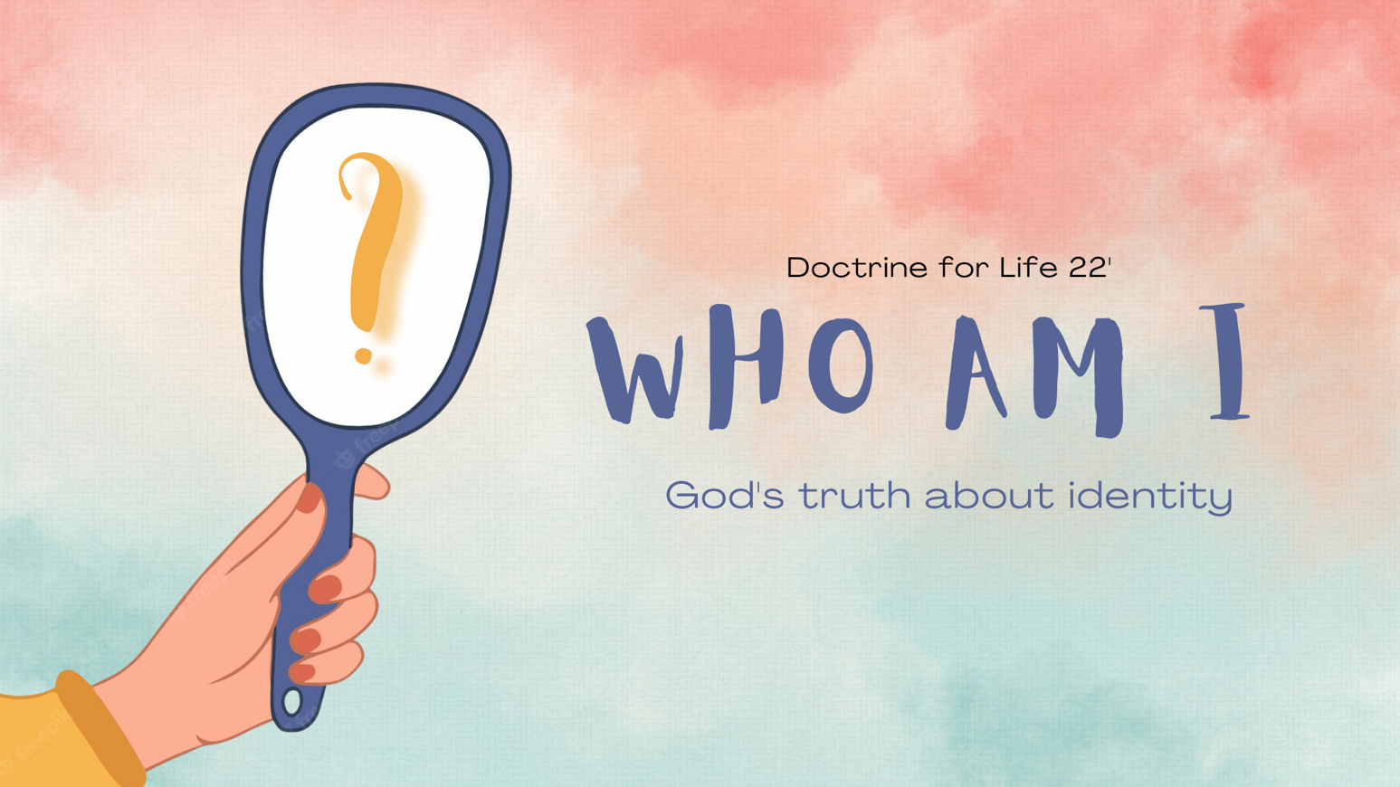
Growth Groups Material
Doctrine for Life
Who am I? – God’s Truth About Identity
Jul-Aug 2022

Booklet Contents
Introducing this series |  | p.3
TEACHING SERIES
For your information only. The studies aren’t strictly correlated to the sermon series
Sermon | Theme
21-24 July | Who am I: Created
28-31 July | Who am I: Corrupted
4-7 Aug | Who am I: Child of God
11-14 Aug | Who am I: Connected
STUDY MATERIAL
Week 1 | Introduction | p.4
Week 2 | ‘Looking Inward’ | p.8
Week 3 | A Christian’s True Identity | p.11
Week 4 | ‘No man (or woman) is an island’ | p.14

Additional Resources & Videos
You can find links to some additional resources AND the videos used throughout the material at our series website: https://jannalianglican.org.au/dfl22/

Note: This website is only accessible through this URL (it is not linked to elsewhere on the JAC website). This is so that the copyright integrity of the videos being used in the material can be protected. We have permission to distribute these videos to our church community, but not the general public.
Introducing this series

This Doctrine for Life series of studies and talks is looking at the question of identity. Identity is a bit of an abstract concept isn’t it? We’re talking about how we view ourselves. What makes me “me”, and what makes you “you”. In particular, in this series, we’re trying to understand and evaluate. from a Christian perspective, how our modern culture thinks about identity. The world presents a different view of personal identity and authentic living to the approach encouraged in the Bible? But why and how are they different? How can we understand those differences and evaluate them? How can we rejoice in, and express our God-given identity in Christ? These are some of the questions we hope to address.

To be sure, we won’t be able to give the whole biblical picture on personal identity in four weeks. Nor can we unravel all of the complex philosophical and pastoral questions that shape and emerge from our modern approach to identity. As you’ll see, we enter into some sensitive topics like transgenderism, for example. Issues like this are symptoms of a world that has changed its thinking on identity and what it means to live authentically. Getting lost already? Don’t worry, the first study will orient you to the key concepts that we’re playing with.

Be mindful though: the material we’ve put together will feel very different to a normal ‘bible study’. There are some book excerpts to read and some videos to watch, along with some bible passages to consider. It won’t line up perfectly with the passage or theme being addressed in the sermon for any given week. It’s good to take a more topical approach like this from time to time. We want our minds stretched to think carefully about the culture we find ourselves in. Alongside and under the Bible, other material that’s informed by Christian theology can help us with this.

We pray the next few weeks will be helpful for your continued growth as a follower of Jesus who loves and lives the truth!

- Introduction

The aim of this study is to introduce and begin to wrestle with some of the concepts we are talking about during this series.

- Begin by reading the text below. This comes from Carl Trueman’s book, Strange New World. In this book Trueman is acknowledging and trying to account for why the modern world, particularly in Western countries like Australia, is experiencing significant conflict over what it means to be truly human. This extract comes at the beginning of Trueman’s book.

Carl Trueman, Strange New World: How Thinkers and Activists Redfined Identity and Sparked the Sexual Revolution, p19-20

Many of us are familiar with books and movies whose plots revolve around central characters finding themselves trapped in a world where nothing behaves in quite the way they expect. Perhaps Lewis Carroll's Alice in Wonderland and Alice Through the Looking-Glass might be the classic examples of this in children's literature. But this is a standard plotline in many other works. From Franz Kafka's The Trial to The Matrix series of movies, dystopian confusion is a hardy perennial of our culture.
Yet this phenomenon is no longer confined to the fictional products of our day. For many people, the Western world in which we now live has a profoundly confusing, and often disturbing, quality to it. Things once regarded as obvious and unassailable virtues have in recent years been subject to vigorous criticism and even in some cases come to be seen by many as more akin to vices. Indeed, it can seem as if things that almost everybody believed as unquestioned orthodoxy the day before yesterday-that marriage is to be between one man and one woman, for example---are now regarded as heresies advocated only by the dangerous, lunatic fringe.
Nor are the problems confined to the world "out there." Often, they manifest themselves most acutely and most painfully within families. Parents teaching their family traditional views of sex find themselves met with incomprehension by their children who have absorbed far different views from the culture around them. What a parent considers to be a loving response to a child struggling with same-sex attraction or gender dysphoria might be regarded by the child as hateful and bigoted. And this is as true within the church as it is within wider
society. The generation gap today is reflected not simply in fashion and music but in attitudes and beliefs about some of the most basic aspects of human
existence. The result is often confusion and sometimes even heartbreak as many of the most brutal engagements in the culture war are played out around the dinner table and at family gatherings.
Welcome to this strange new world. You may not like it. But it is where you live, and therefore it is important that you try to understand it.

- OPTIONAL: Instead of (or in addition to) reading the text above, you might like to watch a video of Trueman talking about how and why the world feels ‘strange’.

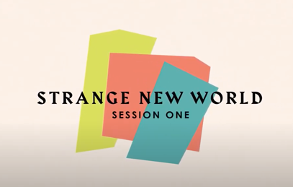
If on a device, click on the image above to access this video. Alternatively, navigate to our series webpage (see page 2) and find the relevant video under ‘Week 1 Videos’.

- Are there comments in this reading (or the video) that resonate with you? In what ways do you find modern society, and particularly its approach to identity strange?

The big concept that we’ll keep examining throughout this series is called ‘Expressive Individualism’. Trueman says that this is what’s behind the sexual revolution of the 20th century, and the strange things we’re noticing in modern society. But what is it? Expressive Individualism is defined in this quote:

Trueman, Strange New World, p22-23
The modern self assumes the authority of inner feelings and sees authenticity as defined by the ability to give social expression to the same. The modern self also assumes that society at large will recognize and affirm this behaviour. Such a self is defined by what is called expressive individualism […] In short, the modern self is one where authenticity is achieved by acting outwardly with one’s inward feelings.

A different author, Brian Rosner, summarises the concept of ‘Expressive Individualism’ with 7 key tenets (or essential beliefs):

Brian Rosner, How to Find Yourself: Why Looking Inward is not the Answer, p24
- The best way to find yourself is to look inward.
- The highest goal in life is happiness.
- All moral judgements are merely expressions of feeling or personal preference.
- Forms of external authority are to be rejected.
- The world will improve dramatically as the scope of individual freedom grows.
- Everyone’s quest for self-expression should be celebrated.
- Certain aspects of a person’s identity – such as their gender, ethnicity, or sexuality – are of paramount importance.

- OPTIONAL: Instead of (or in addition to) reading the texts above, you might like to watch a video of Trueman explaining the concept of ‘Expressive Individualism’

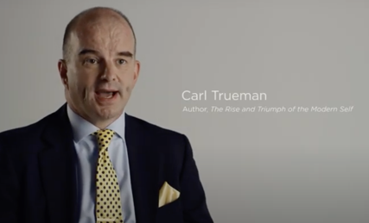
If on a device, click on the image above to access this video. Alternatively, navigate to our series webpage (see page 2) and find the relevant video under ‘Week 1 Videos’.

- What evidences of ‘expressive individualism’ do you see in your world today?

- Do you think ‘expressive individualism’ is a good or bad thing? In what sense might it be good. In what sense is it problematic?

- Read these Bible passages and consider what they say about who we are, why we exist and how to find guidance. What would these verses mean for a view of life based on ‘expressive individualism?’

Gen 1:27
Col 1:16
Rom 12:3
Rev 4:11

- This series of studies, will feel different to a ‘normal’ Bible study. We won’t just read one passage and then talk about its contents. All of this might feel more ‘academic’ or ‘abstract’ than what you’re used to. As we consider the weeks ahead, read Romans 12:1-2 and consider the following questions.

  - Why is it important to engage our minds as we seek to worship God?

  - As those saved by Jesus, what are we aiming for?

  - What are trying to avoid?

- In Romans 12:2 Paul says discernment (the ability to judge complex situations rightly) is important. Pray for discernment as we continue to think about ideas like expressive individualism, identity, and what God says about it all.

2. Looking Inward

- Have you ever come across catchphrases like “Follow your heart!”, or “You do you!”? Where have you seen phrases like this? Do you think they are helpful or unhelpful as life advice?

There are lots of examples of celebrities ‘coming out’ (identifying as homosexual), or ‘transitioning’ their gender identity. It is interesting to notice the way the majority of our culture respond to stories like this.

- Read the words written by Stephen McAlpine below. What point is he making?

Stephen McAlpine, Being the Bad Guys: How to Live for Jesus in a World that Says You Shouldn’t, p77-79

When Then British TV personality Phillip Schofield came out live on the UK morning show he co-hosts, there was an outpouring of affirmation and congratulations. Schofield, for so long the familiar, safe face of daytime TV, made the emotional announcement in early February 2020. He spoke on Instagram of the pain it had caused his family, but also of his relief: "Every day on This Morning I sit in awe of those who have been brave and open in confronting their truth- —so now it's time for me to share mine."
Schofield's wife, Steph, and their two daughters watched as he came out on live television in front of the rest of Britain. By Schofield's own admission in media interviews afterwards, it has been a difficult time for his spouse of 27 years and his twenty-something daughters. He also confessed that he did not know if his marriage would survive, and refused to say if he was in a relationship with another man.
Such "comings out" are painful. Schofield is one of a rare breed who gets to do it on national television. And he has not been flippant about it-he acknowledges the hurt and conflict, especially for his family, whom he evidently loves.
Yet it is the response to Schofield's conviction that he had to be honest with himself that is most revealing. Comedian David Walliams tweeted, "I am sending all my love to Phillip Schofield today. I have always held him in the highest regard, and now have nothing but respect and admiration for him." Celebrity lifestyle guru Gok Wan praised him for his “bravery". And Dancing on Ice judge John Barrowman tweeted this about the show's host: "So proud of you and your family Phillip. Welcome to your true and authentic self."
This final comment summarises the general response in the media. Schofield is now being his "authentic self"; he knew since before he was married that he was gay but suppressed it. As this narrative goes, his life up to this point was therefore less than authentic. His wedding vows, his marriage, the heterosexual family man: this other Phillip Schofield was the inauthentic version, untrue to himself, and in the process, untrue to the long line of those who have shown their own authenticity by coming out. He was late to be brave and “do the right thing", but he has now put this right.

- When we come across situations, like that described by McAlpine, what approach to identity formation is being promoted?

- In the following video, Brian Rosner, discusses the benefits and dangers of ‘looking inward’ to discover ourselves. Watch from 7.34 until about 10:30.

If on a device, click on the image above to access this video. Alternatively, navigate to our series webpage (see page 2) and find the relevant video under ‘Week 2 Videos’.

- According to Rosner, what are the benefits of ‘looking inward’ and what are the problems.

- The Bible gives us a compelling reason adopt a healthy suspicion of our inner desires. Read the following passages and summarize their teaching about the human heart.
Note: when we talk about the heart, we’re not referring to the physical organ, but rather the inner self – the place where are desires and decisions come from. Some of these passages may use the word ‘mind’ instead of ‘heart’.

Gen 6:5
Ps 14:1-3
Jer 17:9
Mark 7:17-23
Rom 1:21, 28

The doctrine which emerges from passages such as those above is sometimes called ‘Total depravity’. In other words: all humans, apart from God’s grace, are morally corrupted, inclined to evil, and spiritually dead.

- Do you believe that human beings are essentially good, or essentially bad? What is the Bible’s position on this matter?

- The take home point for this week’s study is that we should have a healthy suspicion of our inner desires. (They might not all be wrong, but we need to be careful). If we adopted this attitude wholeheartedly:

  - How would it help us evaluate the ‘Looking inward’ (a.k.a. expressive individualism) approach to identity?

  - If you’re a parent, how would this attitude shape the vision for life we set before our children?

  - How might it shape the way we attribute blame when we’re involved in wrongdoing (e.g. do we blame the circumstances, other people etc.)?

  - How might it help us in our ongoing fight against sin in our lives?

- Read Proverbs 3:5-6. Pray in line with this passage - namely for humility concerning our own thoughts and desires.

3. A Christian’s True Identity

Have you come across the acronyms YOLO and FOMO? They stand for “You Only Live Once” and “Fear Of Missing Out”.

- Have you seen ways that these ideas have pervaded your own pursuit of happiness? Do you see it having an impact on others, or society at large?

These philosophies are inconsistent with the new identity given to Christians by God, through the gospel. Let’s consider one example of some Christians who grasped their new identity in Christ and lived accordingly.

- Read 2 Corinthians 8:1-9. Paul is speaking to the Corinthian church about how the gospel had transformed the Christians in Macedonia (e.g. the Philippians and Thessalonians)

  - What did the Macedonian churches do?

  - How does Paul summarise the grace of Jesus Christ towards his people?

  - How ought Christians understand themselves?

  - Brainstorm all the spiritual or eternal riches that Christians possess.

  - How do our spiritual or eternal riches empower sacrificial giving or service in this life?

- In the following video, Brian Rosner, discusses how the new Christian identity shapes our character. Watch from 25.10 until about 29.00

If on a device, click on the image above to access this video. Alternatively, navigate to our series webpage (see page 2) and find the relevant video under ‘Week 3 Videos’.

- According to Rosner, Christians inhabit ‘a better story’. In your own words, how would you describe the ‘better story’ that God’s people are now a part of. How is this different to the ‘story of life’ the world believes in?

- Rosner uses the example of his friend Bill. Do you know anyone like Bill? Tell the group about people who model Christ-like living and self-denial to you.

- What could you change in your life today to invest more in the world to come, rather than this current world?

- J.I. Packer reflects on the identity of a Christian in the follow excerpt. What is his essential advice?

J.I. Packer, Knowing God, p258-60
Meanwhile, the immediate message to our hearts of what we have studied in the present chapter is surely this: do I, as a Christian, understand myself? Do I know my own real identity? My own real destiny? I am a child of God. God is my Father; heaven is my home; every day is one day nearer. My Saviour is my brother; every Christian is my brother too. Say it over and over to yourself first thing in the morning, last thing at night, as you wait for the bus, any time when your mind is free, and ask that you may be enabled to live as one who knows it is all utterly and completely true. For this is the Christian's secret of - a happy life? yes, certainly, but we have something both higher and profounder to say. This is the Christian's secret of a Christian life, and of a God-honouring life: and these are the aspects of the situation that really matter. May this secret become fully yours, and fully mine.
To help us realise more adequately who and what, as children of God, we are, and are called to be, here are some questions by which we do well to examine ourselves again and again.
Do I understand my adoption? Do I value it? Do I daily remind myself of my privilege as a child of God? Have I sought full assurance of my adoption? Do I daily dwell on the love of God to me? Do I treat God as my Father in heaven, loving, honouring, and obeying him, seeking and welcoming his fellowship, and trying in everything to please him, as human parents would want their child to do? Do I think of Jesus Christ, my Saviour and my Lord, as my brother too, bearing to me not only a divine authority but also a divine-human sympathy? Do I think daily how close he is to me, how completely he understands me, and how much, as my kinsman-redeemer, he cares for me? Have I learned to hate the things that displease my Father? Am I sensitive to the evil things to which he is sensitive? Do I make a point of avoiding them, lest I grieve him? Do I look forward daily to that great family occasion when the children of God will finally gather in heaven before the throne of God, their Father, and of the Lamb, their brother and their Lord? Have I felt the thrill of this hope? Do I love my Christian brothers and sisters, with whom I live day by day, in a way that I shall not be ashamed of when in heaven I think back over it? Am I proud of my Father, and of his family, to which by his grace I belong? Does the family likeness appear in me? If not, why not?

- If we were to follow Packers’ advice, and cultivate a deep sense of our identity as children of God, how might that shape our view of:

  - Our careers;

  - Our future;

  - Our use of money;

  - Death;

  - What we desire for our children;

  - Sacrificial service of others, or in ministry

- Pray, thanking God for our adoption into God’s eternal family. Ask that we would have a growing sense of this new identity, and that this would spur us on to lives of self-denial and service, like Jesus.

4. ‘No man (or woman) is an island’

- John Donne was a Christian, English Poet who lived in the 16th and 17th centuries. He famously wrote:

John Donne, Meditation XVII, 1624
No man is an island,
Entire of itself,
Every man is a piece of the continent,
A part of the main.
If a clod be washed away by the sea,
Europe is the less.
As well as if a promontory were.
As well as if a manor of thy friend's
Or of thine own were:
Any man's death diminishes me,
Because I am involved in mankind,
And therefore never send to know for whom the bell tolls;
It tolls for thee.

- What do you think Donne is getting at in this poem? Do you agree with his sentiment?

- More recently, Tony Merida has made a similar point:

Tony Merida, Love your Church: 8 Great Things about being a Church Member, p23-24
As image-bearers of God, people are made for community. The triune God is a relational God, and he has created us for relationships.
Perhaps this is why so many popular television shows have to do with community. In the 80s, Cheers featured a group of friends who met to socialize at a local bar. Many folks can finish the theme song: "Sometimes you wanna go where everybody knows your name.” Friends, a show revolving around six friends who live in Manhattan, was wildly popular in the 90s. (And this show has recently witnessed a resurgence of interest among millennials and Gen-Zers.) "I'll be there for you / Cos you're there for me too" was sung by many avid followers. In the 2000s, millions became attached to the characters of the sci-fi show Lost, which told the story of survivors of an airplane crash, living together on a mysterious island; it, too, magnified the importance of relationships.
The popularity of social media also illustrates our longing for community. People want to be known, want to know others, and need friends. Many people have described finding a powerful sense of community in local gyms, as well. It has become more than a place to exercise. This need for community is also why our kids always wonder, "Will I meet any new friends?” at the start of each new school year. (If only they were as excited about biology!)
God has given us a need for community-and he has given us the place where that need for community is met: the church. Sin breaks fellowship with God and with others, but we are reconciled to God and one another through the gospel. God, then, establishes this unity in Christ. But we do have to maintain it (Ephesians 4 v 2). He gives us a place where we belong; now we need to commit to belonging.
Experiencing the blessing of community requires you to avoid distancing yourself from other brothers and sisters in the church, and to avoid neglecting times together (in small groups, in corporate worship, and in ongoing communication). This is what made the COVID-19 experience so challenging, and it is why churches creatively tried to keep believers connected in community and worship, albeit in less-than-ideal ways.

- Does your experience confirm or challenge this notion: that we’re made for relationship with other people?

- The Bible portrays humanity as being fundamentally wired toward community. How do each of these passages contribute to that picture?

Gen 2:18
Mark 12:28-31
1 Cor 12:12-27
Heb 10:24-25

- American writer, Trevin Wax has said that “Advanced stages of expressive individualism are characterized by isolation!”. Do you think this is right? How might a self-focused view of fulfillment lead to isolation (or loneliness)?

- How could a selfless, other person-centred commitment to others enhance community in the following spheres:

  - Our families

  - Weekend church gatherings

  - Workplaces

  - Growth groups

  - Serving teams

- Tony Merida, in his book, Love Your Church, makes a number of suggestions about embracing our role as part of the church community. Reflect on these ideas, below. How have you benefitted from brothers or sisters who have done these things well? Are you involved in these types of things? How could you become more involved in these things?

  - Hospitality – e.g. having people in your home, sharing meals together

  - Welcoming – e.g. seek out those who are new or alone in our gatherings

  - Gathering – e.g. being at church regularly

  - Caring – e.g. doing practical good to others

  - Serving – e.g. helping run a ministry

- To finish, read Jesus’ words in John 13:34-35. The corporate life of a Christian community is immensely powerful and can be very attractive. Pray that we would be marked by genuine love for one another.

