Growth Groups Material
(5 Studies on 1 Corinthians 5-7)
Aug-Sep 2022

Introducing 1 Corinthians
The story so far…
After the resurrection and ascension of Jesus in around AD33, the message of salvation in Him began its worldwide spread in the years that followed. One of the most important missionaries was the Apostle Paul. He planted a church in Corinth in around AD51 and stayed there for around 18 months. The church members were likely from a range of backgrounds – rich and poor, Jew and Gentile.
Fun fact: Historians use Paul’s time in Corinth to piece together the chronology of his life. In Acts 18:12ff, during Paul’s time in Corinth, we read of Gallio, the ‘proconsul of Achaia’ (the region Corinth was situated it). 20th century archaeological discoveries in Greece refer to Gallio’s time in office being around AD51-52. Hence, we can date Paul’s time in Corinth to around the same time.

The city of Corinth during Paul’s time was a melting pot of ethnic people groups, pagan religion and Greek philosophy. Located by the narrow strip of land connecting Achaia to mainland Greece, it also controlled a vital sea-trade route, and as such become a prosperous, wealthy city. The moral corruption that often trickles down from wealth, was rife in Corinth, especially sexual immorality.
When and why did Paul write 1 Corinthians?
After leaving Corinth, Paul continued in his missionary journeys. A few years later, when he was in Ephesus (around AD54) Paul began hearing of problems emerging in the Corinthian church: from Chloe’s household (1:11); a letter he had received (7:1); and/or the visit of three men from the church, Stephanas, Fortunatus and Achaicus (16:17). 1 Corinthians is the second of (perhaps) four letters Paul wrote to the church:
- A ‘previous’ letter not preserved (referred to in 1 Cor 5:9)
- 1 Corinthians (written in Ephesus in around AD54-55, c.f. 1 Cor 16:8)
- A ‘severe’ letter not preserved (referred to in 2 Cor 2:4, 7:8)
- 2 Corinthians

Paul wrote 1 Corinthians, to address the many moral compromises being made by the church, and their confusion surrounding a range of matters – especially as they relate to the unity, holiness and the orderly ministry of the church.
In chapters 5-7, Paul shifts from his introductory principles (the word and the way of the cross) to addressing specific issues at Corinth which have been brought to his attention. Close reading of 5:1-2; 6:1, 12; 7:1 reveals the kind of things the Corinthians were doing or thinking. Take note, also, of a feature of ancient Greek thinking called ‘Platonic dualism’ – which essentially drove a wedge between spiritual things and physical things. Spiritual things were elevated and seen as important. Physical or material things, even the human body, less important. The Corinthians, shaped by this philosophy, appeared to have applied this in different ways: Either (1) indulge all bodily appetites because they are meaningless anyway, or (2) restrain bodily appetites completely, as a show of spiritual fortitude.
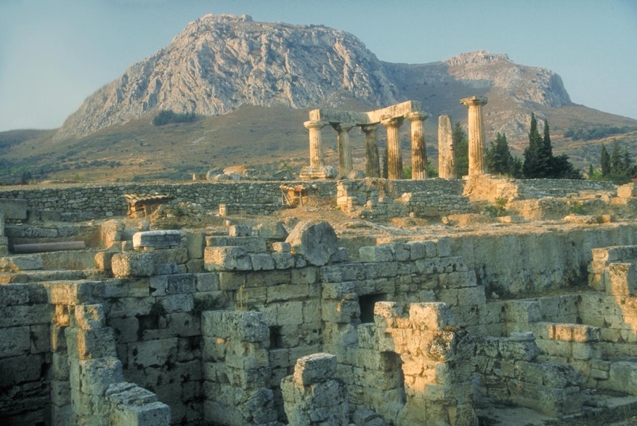 | Ruins of the Temple of Apollo at Corinth.

Teaching Series and Booklet Contents
Sermon | Passage/Title
18-21 August | 1 Corinthians 5:1-6:8 | The pure church
 | Study 1 ………………………………………………………………………………. | p.5
25-28 August | 1 Corinthians 6:9-20 | The pure body
 | Study 2 ………………………………………………………………………………. | p.6
1-4 September | 1 Corinthians 7:1-9 | Sex in marriage
 | Study 3 ………………………………………………………………………………. | p.7
8-11 September | 1 Corinthians 7:10-24 | When marriages end
 | Study 4 ………………………………………………………………………………. | p.8
15-18 September | 1 Corinthians 7:25-40 | Esteeming singleness
 | Study 5………………………………………………………………………………. | p.9

Additional Resources
 | Map of Paul’s Second Missionary Journey  © Mark Barry 2008, visualunit.me | p.10
 | Introduction to 1 Corinthians (link to website only)  https://www.thegospelcoalition.org/course/1-corinthians-courses/ | n/a

Study 1 | 1 Corinthians 5:1-6:8 | The pure church
- “It’s not right to judge what anyone else does!”. Do you agree or disagree? Are there any situations in which you’d change your answer?
- Read 1 Cor 5:1-5. What situation has arisen in the church in Corinth? What was the church reaction? What is Paul’s reaction?
- What do you think it means to hand someone over to Satan? What are we told about the goal of doing this? Consider reading Matthew 18:15-20 for additional guidance.
- Read 1 Cor 5:6-8. What do you think Paul is warning against in this section? How is it connected to verses 1-5?
- Paul refers to the Passover event (and festival) originating in Exodus – the ‘birth of the nation’ moment in Israel’s history. Read Exodus 12:14-20. How is the moral purity of God’s people related to their salvation?
- Read 1 Cor 5:9-13. What principle does Paul remind the Corinthians of in this section?
  - Who is Paul really focused on? How would you apply this principle today? Do we cut off contact completely with these people? What is being suggested?
- Why do we find it easier to tolerate, rather than challenge unrepentant sin? Why is it important to recognize and challenge church members who continue in unrepentant sin? What are the risks? What are the risks of not challenging sin?
- The church ought to be a community of grace! How can we balance graciousness with the need to address one another’s sin seriously?
- Read 1 Cor 6:1-8. What is the situation Paul is concerned by? How is this situation similar to what Paul was addressing in chapter 5?
- According to Paul, what are the problems with believers resolving disputes before unbelievers?
- Believers have better moral discernment than unbelievers. Discuss

Study 2 | 1 Corinthians 6:9-20 | The pure body
- Discuss: As a Christian what areas of life do you find it easy to differ from the world’s values. Which areas do you find it harder (e.g. drawn to the values of the world)?
- Read 1 Cor 6:9-11. What is Paul’s point to the Corinthians by listing all kinds of sinful behaviour? How is it related to what we learnt in our last study?
- Do these verses mean that a follower of Jesus who practices sexual immorality or greed will be ruled out of heaven? What else in this chapter helps us answer that question?
- Read 1 Cor 6:12-20. This section is especially about sexual sin.
  - How were the Corinthians justifying their sexual immorality?
  - What reasons does Paul give for attaching more significance to our bodies, and how we use them?
- Do you need to change anything about the way you think about, or use your body?
- Paul exhorts us to ‘run from sexual immorality’. What types of sexual immorality are prevalent in our culture? How should we run from them?
- “The union with Christ which produces no effect on heart and life is a mere formal union, which is worthless before God. The faith which has not a sanctifying influence on the character is no better than the faith of devils.” (J.C. Ryle in Holiness). What do you think about this quote?
- Pray for each other, and for our church that we would be distinct from the world and pursue holy living, particularly as it relates to sexuality.

Study 3 | 1 Corinthians 7:1-9 | Sex in marriage
- “Our culture sees sex as everything one minute (how can you live a full life without it?) and as nothing the next (why does it even matter who we have sex with?)” Do you agree with this statement? How do we see both extremes shaping our view of sex?
- Read 1 Cor 7:1-9. What had the Corinthians said or asked Paul about (7:1)? Why do you think they might have thought this?
- What reasons does Paul give throughout this section for marrying? Is that what you would expect?
- What instructions are given to the following categories of people. And what is the reasoning?
Category | Instruction | Reasons
Husband
Wife
Unmarried/Widow

- In verse 3, the original language for ‘fulfilling’ could also mean ‘giving’. What does this say about the nature of the marriage relationship? How might this guard us against misconstruing verse 4?
- How is the principle in verse 3, at odds with wordly thinking about sex? How should God’s people be different?
- It’s common for people in society to think that the Bible/God/Christianity:
  - Is anti-women and reinforces gender inequality. What in this section undermines that assumption?
  - Is anti-sex. What in this section undermines that assumption?
- How should a married couple approach their sex life?
  - What principles emerging from this passage are relevant to this?
- What are the risks if married people aren’t having sex? What temptations should married men or women be conscious of. Are these temptations the same or different for single people?
- Pray for the married amongst you. Pray for others at church, and their marriages. Thank God for the gift of sex. Pray that we would all avoid sexual immorality, whatever our marital status.

Study 4 | 1 Corinthians 7:8-24, 39-40 | When marriages end?
- God longs for marriages to be healthy, and to endure for life. Do you see the institution of marriage (or your marriage) in the same way?
- Read 1 Cor 7:8-16 and 39-40. What instructions are given to the following categories of people. And what is the reasoning?
Category | Instruction | Reasons
Unmarried
Widow(er)
The married
Someone married to an unbeliever (who wishes to remain married)
Someone married to an unbeliever (who leaves)

- Do verses 10 and 39 mean that the divorce of married believers is always prohibited? Read Matthew 19:1-12 for Jesus’ view on marriage and divorce?
- Abuse or domestic violence could also represent grounds for divorce. What in this passage could support that position?
- Read 1 Cor 7:17-24. What key principle does Paul repeat several times? Can you list all the situations to which he applies this principle? Why do you think Paul has included this section in the midst of his teaching on marriage, divorce and singleness?
- What is most important for all believers, irrespective of those things that might be different amongst us? Read 1 Cor 7:29-31. How do these verses add to Paul’s point?
- How does this section challenge our thinking about what seems important in life?
- Pray that we would share God’s mind on marriage, and for wisdom for those involved in, or affected by marriage breakdown.

Study 5 | 1 Corinthians 7:25-38 | Esteeming Singleness
- How does our society view those who are single, and not in a sexual relationship?
- Read 1 Cor 7:6-9. What is Paul’s preference for people regarding marriage or singleness?
- Read 1 Cor 7:25-38. Here we get an extended reflection from Paul’s on singleness. How would you summarise Paul’s reasoning for considering singleness as preferable to marriage?
- Read verses 29-31 again. What do you think Paul means when he says ‘the time is limited’. How is he challenging the Corinthians to re-order their priorities? Do we need to be corrected by Paul’s advice here?
- Would you ever encourage someone to forego marriage in order to serve the Lord with less distraction? Why does that notion seem absurd to our modern ears?
- Paul is writing into a situation where some people were over-emphasizing the benefits of singleness. Think about our own church culture: do we over-emphasize marriage or singleness? What could we change to have a more balanced Biblical view? What could we do to make the single life more appealing, or liveable?
- If you are single, how would Paul encourage you to make the most of your circumstances, for the Lord?
- Pray for those amongst us who find singleness hard. Pray for our church that we would encourage and support single people. Pray that we would all recognize where we’re up to in God’s timetable, and serve him with devotion.

