Growth Groups Material
(9 studies on Genesis 12-50)
April-June 2023

Booklet Contents
Introduction | p.3-4

Teaching Schedule | Sermon | Passage/Title
 | 27-30 April | Genesis 11:27-12:20, 15 | When promises are big | p.6
 | 4-7 May | Genesis 16-17 | When promises are doubted | p.8
 | 11-14 May | Genesis 22 | When promises are tested | p.10
 | 18-21 May | Genesis 24 | When promises are passed on | p.12
 | 25-28 May | Genesis 25, 27 | When promises are stolen | p.14
 | 1-4 June | Genesis 28-36 | When promises are made to sinners | p.16
 | 8-11 June | Genesis 37 | When promises face problems | p.18
 | 15-18 June | Genesis 41 | When promises have power | p.20
 | 22-25 June | Genesis 42, 50 | When promises are preserved | p.22

Additional Resources
Map of Ancient Near East during the time of the patriarchs | p.24
Abraham’s Family Tree including relatives who married into the family | p.25
Reading Plan for Genesis 12-50 aligned with teaching schedule | p.26
We’ve put together some additional resources that might help you as you make your way through Genesis. Some of them are included in this booklet (see above). Everything, including the above, can be found on our series website. You’ll find some videos, podcasts, and links to other helpful material:

https://jannalianglican.org.au/fullofpromise

Introduction
The story so far…
In Genesis 1-11 we read of the eternal God and Creator, speaking the world into existence and placing humanity at the centre of his plans. Everything God made was good! But humanity, exemplified by Adam and Eve, turned from trusting God and the words he’d spoken and rebelled against his rule. From there, everything went downhill. And that’s an understatement! Adam and Eve were kicked out of the garden of Eden, separated from God’s presence and his tree of life. Human relationships were broken. The creation was cursed. Death reigned.
But amidst this judgment, there was a glimmer of hope. Speaking to the serpent (Satan), God promised that one day a special descendant of Eve would put things right:
I will put hostility between you and the woman,
and between your seed and her seed.
He will strike your head,
and you will strike his heel. (Gen 3:15)

Who could this chosen seed be? The search begins. In God’s kindness, human life progresses but things keep getting worse. Things get so bad that God plans to wipe out all creation in the flood, but he graciously preserves a remnant through Noah and his family. But then humanity is back to rebelling against God. In chapter 11 they build a tower to reach the heavens – making a name for themselves, rather than honouring God’s name. So, God scatters the people all over the earth and confuses their language.
In Genesis 12, things change! God’s gracious plans to restore relationship with humanity begin to take shape. After 11 chapters of God’s curse being felt, God promises to bless Abraham, his descendants, and through them God will bless the whole world. The chosen seed of Genesis 3:15 will come from this family.

Chapters 12-50 are full of this promise! Hence our series title. We’ll see God’s promises reiterated, doubted, trusted, kept, threatened – and more. It’s a gripping narrative. Ultimately we’ll learn with Abraham and his family, about the character of this God: how his promise-keeping, steadfast love is sure, despite human sinfulness.
Genesis was an important piece of divine revelation for the emerging Israelite nation. Like a family history. It’s likely that Moses was the author, writing sometime after the Exodus from Egypt. God wanted his people (and us now) to know their heritage, and the promises he had made to them. As far as structure goes, it looks like Moses adopted the following approach:
The tôlēdôt (‘generations’) headings in Genesis
Heading | Title | Subsequent Content | Reference
2:4 | These are the generations... of the heavens and the earth | The story of Adam and his descendants | 2:4-4:26
5:1 | This is the book of the generations... of Adam | Genealogy of Adam to Noah | 5:1-6:8
6:9 | These are the generations... of Noah | The story of the flood of Noah | 6:9-9:29
10:1 | These are the generations... of the sons of Noah | Table of nations/genealogy of those descended from Noah | 10:1-11:9
11:10 | These are the generations... of Shem | Genealogy from Shem to Abraham | 11:10-26
11:27 | These are the generations... of Terah | The story of Abraham | 11:27-25:11
25:12 | These are the generations... of Ishmael | Genealogy of Ishmael | 25:12-18
25:19 | These are the generations... of Isaac | The story of Jacob and Esau | 25:19-35:29
36:1,9 | These are the generations... of Esau | Genealogy of Esau | 36:1-37:1
37:2 | These are the generations... of Jacob | The story of Jacob and his sons | 37:2-50:26

For us, this structure means we will organise our series around the main human characters or ‘patriarchs’ as they are sometimes called: Abraham, Isaac, Jacob and Joseph. (FYI, the stories of these men feature in the section titled after their father). Maybe that’s a hint to us of what was so important in this stage of salvation history: continuing the family line to find the chosen seed, to see God’s promises fulfilled!
We pray that in the coming months, God will use this part of his word to grow you more into the likeness of Jesus… the chosen seed….the son of Abraham.
Page left intentionally blank (use for notes, prayer points etc)

Study 1 | Genesis 11:27-12:20, 15 | When promises are big
Context: We pick up the story of Genesis at the end of chapter 11. Be sure to read the ‘story so far’ in the introduction on page 3. In short, things are looking very bleak for humanity, and God’s relationship with humanity, at this point in the biblical storyline. Remarkably, the early chapters of Genesis have been marked by God’s goodness and grace in the face of human rebellion. From chapter 12 on we see God’s plan to save and bless the world take shape.Terah’s son Abram and his family will be key! Who will solve the problem of sin, which keeps God and his creatures separate? Will humanity get better and earn their way back into Gods’ favour? On what basis will God accept humanity back?
Introduction
- Christians often talk about the Bible being one big story? Have a go at outlining the main events in the story to each other!

Observation
- Read Genesis 11:27-12:9
  - What did God promise to do through and for Abram?

  - How did Abram respond to God’s promises?

- Read Genesis 12:10-20
  - How do these verses shape our view of Abram. Is it different to earlier in the chapter?

  - How do the events of these verses threaten or preserve the fulfillment of God’s promises to Abram?

- Read Genesis 15:1-6. On what basis was Abram considered righteous by God?

Interpretation
- How do the promises to Abram reflect a return to the perfect world of Genesis 1-2?

- How is the person and work of Jesus anticipated in the promises to Abram?

- God called Abram out of the blue [see Joshua 24:2-4] and initiated his plans to bless the world through his family. What does this teach us about God’s character? How does Abram’s sin (12:10-20) shape what we learn about God?

Application
- John Stott has written of Genesis 12:1-3: ‘It may truly be said without exaggeration that not only the rest of the Old Testament but the whole of the New Testament are an outworking of these promises of God.’ What do you think is meant by this? Do you agree?

- Abram’s faithful obedience to God’s call is a good example to us (except for Genesis 12:10-20). What promises of God have we been given? How should we respond?

Study 2 | Genesis 16-17 | When promises are doubted
Context: In our last study we saw God initiate his plans to bless the whole world through Abram and his descendants. In Genesis 13 and 14 – questions around Abram’s possession of the promised land come up. He makes a deal with his nephew Lot about who goes where, and then he finds himself in battle with the local powerbrokers. The promised land is actually a busy and dangerous place! But God gives Abram military success. Here, Melchizedek appears from nowhere to bless Abram. (Melchizedek is actually important in the Bible – see Psalm 110:4, Heb 5:10, 6:20, 7:1-17 for more). God’s grace continued to Abram - he declared Abram righteous in his sight because of his faith, or belief in God’s promises. God confirms his promises to Abram by making a covenant (or contract). That’s the strange ceremony in 15:9-17. In chapter 16 we see Abram doubt God’s promises and take things into his own hands (yes, despite all the assurances). But in chapter 17 – God’s back at it, confirming his plans to bless Abram with descendants.
Introduction
- Has anyone ever made a promise to you that is hard to believe? Is there a promise God has made to you that you find hard to believe?

Observation
- Read Genesis 16:1-15
  - How was Sarai feeling about God’s promise of offspring? What do Abram and Sarai decide to do about this?

  - Is Hagar’s son Ishmael the father of the chosen family who God blesses?

  - How does God show kindness to Hagar and Ishmael?

- Read Genesis 17. List the blessings God promises to Abram. What things must Abram and his offspring do to keep their side of the covenant?

Interpretation
- What does we learn about Abram and Sarai from the events of chapter 16?

- Can you describe in your own words, what a covenant is? Is it good to be in a covenant relationship with God?

- Do men need to be circumcised now, in order to be saved? Why not? (Romans 4:9-12)

- Read Galatians 3:15-19. Who, ultimately, is the offspring that this covenant promised, according to Paul

Application
- Sarai asked Abram to sleep with Hagar. Abram did it. Later, Abram laughed at God’s promise. What decisions or behaviour in your life might demonstrate doubt in God’s promises?

- When we sin how does God’s covenant reassure us that we are not lost? What reassuring sign of the covenant has God made with us? (see Ephesians 1:13-14)

Study 3 | Genesis 21-22 | When promises are tested
Context: In our last study we saw God continue to assure Abram and Sarai (now Abraham and Sarah, since chapter 17) of his promises to give them a descendant and heir, despite their doubts. That theme continued in chapter 18 when three divine messengers/angels/The Lord appears to Abraham. Then the attention of the Lord turns to the judgment of Sodom and Gomorrah. Why does this appear here? Maybe to remind us of God’s righteous anger towards sin. Human sin is still very much a problem despite God’s favour towards Abraham. The conversation of 18:22-33 is interesting. How does God’s judgment toward sin reconcile with his plans for righteous people like Abraham. In chapter 19 the judgment of Sodom and Gomorrah unfolds. In Chapter 20 Abraham is back to his doubting ways (like 12:10-20) lying about Sarah, then in chapter 21 Isaac is finally born – Hallelujah. The story of Hagar and Ishmael is wrapped up – then chapter 22 comes like a slap in the face. God tells Abraham to kill Isaac – the son of the promise!
Introduction
- When did you last meet a newborn baby? How did you feel? How do you think Abraham and Sarah felt when God kept his promises and Isaac was finally born? (Genesis 21:1-7)

Observation
- Read Genesis 22:1-10. What is your reaction to these confronting scenes?

- Read Genesis 22:11-19. How did Abram respond to God’s instructions? What details in the passage stand out to you?

Interpretation
- Verse 1 helps readers interpret this story as a test for Abraham. What was being tested?

- How did Abraham demonstrate his faith in God’s promises?

- Abraham calls the mountain where all this happened: ‘The Lord Will Provide’ (22:14). How is this name ultimately fulfilled in the New Testament?

Application
- How do you feel in light of Abraham’s faith demonstrated in chapter 22? How does Abraham’s example challenge us to live out our own faith in God’s promises? What costly sacrifices should we consider making in order to obey God?

- Read Hebrews 11:17-19. Abram’s faithful obedience to God’s call is a good example to us. What promises of God have we been given? How should we respond to them.

- Read John 3:16 and Romans 8:32. How does the sacrifice of Jesus echo the story of Genesis 22. How does this shape our view of God?

Study 4 | Genesis 24 | When promises are passed on
Context: In our last study we saw God test Abraham’s faith, asking him to sacrifice his one and only son Isaac. Abraham passed the test – he trusted God’s promises so much that he was willing to go ahead. Thankfully, Isaac’s life was preserved as an animal to be sacrificed was provided instead! In chapter 23, Sarah dies – and Abraham’s possession of the promised land is growing in security. The locals are kind to him and Abraham is able to buy land from them. This part of the promises (the land) is starting to come true! But what about a big family? Abraham only has one son through Sarah. And no grandchildren yet. Isaac doesn’t even have a wife. Hence, God turns match-maker for Isaac, in chapter 24…
Introduction
- If you are married can you share something of how you first met your spouse? If not, are there stories of friends, or parents meeting that you can share?

Observation
- Recap the story of God’s promises to Abraham so far, then read Genesis 24:1-4. What is the problem that needs to be addressed? Why is this important?

- Read the rest of Genesis 24
  - What is the servants plan to identify the right woman for Isaac?

  - What eventuates?

  - How do each of the characters respond to God’s incredible working in this chapter: the servant, Rebekah, Laban and Bethuel?

Interpretation
- How does the way this story is told lead us to praise God?

- In verses 12, 14 and 27 the servant uses the Hebrew word hesed (translated kindness in the HCSB, or steadfast love in some translations). How does God show his hesed to his people in Genesis? How does he show it to us?

Application
- Do you think the servant’s particular approach of prayer and specific request is a model for us to follow today? Why or why not?

- How is Rebekah a model of faith to us? What have you had to leave behind in order to join God’s chosen family?

- This chapter shows us God’s providence: his sovereign hand controlling all the ordinary affairs of life, directing things according to his purposes. This truth assures us that we are never in the grip of blind forces (like fortune, chance, fate etc.) but rather that all that happens to us is divinely planned. How have you seen God’s providence at work in your life? How does this truth challenge you? How does it comfort you?

Study 5 | Genesis 25-27 | When promises are stolen
Context: Now that Isaac has a wife, the promises to Abraham can pass down to the next generation! But Rebekah needs to bear children so the chosen family can continue. However, Rebekah is barren (like Sarah). God answers Isaac’s prayers and twins Jacob and Esau are conceived. These chapters are primarily taken up with the struggle between Jacob and Esau, as to who will be inherit the promise and continue the chosen family line. In the middle of the section, in chapter 26, the promises are re-affirmed to Isaac, but his doubts are exposed just as his fathers were. He lies to the locals about Rebekah being his sister (c.f. Gen 12:10-20; Gen 20). Incredibly, in God’s grace, Isaac comes out with more prosperity than before – and firmly establishes his grip on the promised land. Now back to Jacob and Esau:
Introduction
- Have you known a family where there was a clearly a favourite child? How did this impact family dynamics?

Observation
- Read Genesis 25:19-26. What is God’s word to Rebekah?

- Read Genesis 25:27-34. Who do you think was in the wrong here: Jacob or Esau?

- Read Genesis 27. Summarize what happens.

- How do each of the characters respond after the deception? Who acts rightly?
  - Isaac

  - Rebekah

  - Jacob

  - Esau

Interpretation
- How do the events of chapters 25 and 27 fulfill God’s prophetic word to Rebekah (25:23)?

- Read Romans 9:6-18. What does Paul add to our understanding about this incident? How is Jacob like a Christian believer?

Application
- How does it make you feel knowing that God brings about his purposes through human sinfulness?

- The way Esau dismissed his birthright is warned against in Hebrews 12:16-17. Do you currently value worldly things more than your status as a recipient of God’s promises? What are the dangers if this is the case.

- How does the truth that God chooses the people whom he will bless/save challenge you?

Study 6 | Genesis 28-36 | When promises are made to sinners
Context: At the end of chapter 27 Jacob is on the run, fleeing from his angry brother Esau, whom Jacob had impersonated to win his father’s blessing. His plan is to go to Paddan-Aram (to the East, where Abraham’s family was originally from, to find a wife from the extended family – not from the local people). Before Jacob’s departure though, Isaac blesses Jacob, and hands over the Abrahamic promises. The question before our minds is what will become of Jacob, who, to be honest, has been a bit of a scoundrel.
Introduction
- How do you feel about Jacob so far?

Observation
- Read Genesis 28:10-22. What does Jacob see and hear in his dream?

- How does Jacob respond to this revelation from God? How does this set our expectations for the chapters that follow?

- Split into pairs or smaller groups. Have groups read chapters 29-33 and summarize for the group what happens in each chapter. What stands out to you from these chapters?

- Why would Jacob have been afraid returning to Esau? (see Gen 32:1-8; Gen 27:41-46)

- How does Jacob respond to his fears about returning to Esau? How does Esau respond to Jacob’s return?

Interpretation
- How was Esau’s acceptance of Jacob, symbolic of God’s acceptance of Jacob?

- Do you think Jacob matured in his trust of God over the course of his journey to and from the land of Canaan? What has he learnt?

- Recall your answer to question 3, and then read Genesis 35:1-3. What does the author want us to take away from the story of Jacob?

Application
- Jacob learnt over the course of his life that trying to prosper by doing things his way (e.g. trickery, deceit, ingenuity) didn’t always work – but rather God was generous to him. In what areas of your life do you need to learn this lesson?

- Jacob was a scoundrel who left Canaan with just one staff, but returned years later with two camps, which is to say he had a big family and was rich (see Gen 32:9-10). In what sense is Jacob’s story our story, as Christians?

- God is incredibly gracious to unworthy people like all of us. How does this make you feel?

Study 7 | Genesis 37 | When promises face problems
Context: Chapter 37 marks the beginning of the generations of Jacob (which in Genesis means the story of Jacob’s sons). Chapters 28 to 35 follow Jacob’s journey away from the promised land, towards Paddan- Aram, and then back. While he’s away, Jacob meets his uncle Laban, marries Leah, then Rachel, and also has 12 sons (to 4 women). In chapter 36, we learn about Esau’s descendants. In chapter 37 the story shifts to Jacob’s sons.
Introduction
- What do you know about the story of Joseph? Share it with the group?

Observation
- Read Genesis 37. Why did Joseph’s brothers hate him? What did they do to him?

- What weaknesses, sin or problems can you identify in Jacob’s family from this account? List them all.

- Recall what we learnt about Jacob last week. How are Jacob’s sons just like their father?

Interpretation
- This is meant to be the family that God has chosen as his instrument to bless the world? What do we learn about the character of this family? How do you feel about the health of God’s promises at this stage?

- After Joseph is taken to Egypt as a slave he experiences further mistreatment at the hands of his master Potiphar, and Potiphar’s wife. He is imprisoned. Read Genesis 39:2-6 and 21-23. What is emphasized in these verses? How does this help us understand Joseph’s journey?

- Read Genesis 50:15-21. According to Joseph, what part did God play in the events that brought him to Egypt as a slave?

- Read Acts 2:22-24 and 4:27-28. In what ways does the story of Joseph remind us of Jesus and his story?

Application
- Do you see yourself and your own sinful shortcomings in the characters of chapter 37? What sinful behaviours or attitudes do you need to put to death?

- Have you experienced mistreatment and hardship, like Joseph? If you are willing, share this with your group.

- How does what we have seen in this study encourage us when:
  - Life is hard and it feels like God and his promises are a long way from fulfilment?

  - God’s people (including us!) are sinful, weak and dysfunctional?

  - Jesus and his people are hated, rejected and even persecuted?

Study 8 | Genesis 41 | When promises have power
Context: In Genesis 38 the action continues with Joseph’s brother Judah and his sexual sin with his widowed daughter-in-law, Tamar (who features in Jesus ancestry – Matt 1:3). This chapter provides a contrast to the way Joseph will handle sexual temptation in chapter 39, and adds to our sense of how sinful and dysfunctional the chosen family is. God will bring about his plans through sinners. In chapter 39 Joseph is framed as a rapist by Potiphar’s wife, and imprisoned. In chapter 40 we’re introduced to God’s gifting to Joseph: dream interpretation. This background is crucial to understanding chapter 41. Pharoah needs a dream interpreted – and Joseph will be the man called upon.
Introduction
- Are there any parts of your life where you feel that God is powerless? Why do you feel this way?

Observation
- Read Genesis 41:1-33. What is Pharoah’s dream? What is the interpretation?

- How does Joseph understand his ability to interpret dreams (c.f. 41:16, 40:8)

- Read Genesis 41:33-57. What plan is put in place for the Egyptians to survive the impending famine? What is Joseph’s role in this?

Interpretation
- Compare Joseph’s position at the start of the chapter to his position at the end. What has changed? What is behind this change? Why?

- Why does the author of Genesis include the meaning of the names of Joseph’s sons (vs 50-53)

- How does the account of Joseph’s decline, and then rise to prominence, remind us of Jesus? What is similar? What is different?

Application
- Prior to his exaltation as the ruler of Egypt, Joseph underwent significant trials and tests. How do you think God uses trials and tests for us? Read and consider Hebrews 12:4-11 and James 1:2-4 in your discussions.

- What comfort can we draw from seeing the huge extent of God’s power and sovereign control over all things (like dreams, famines, even Pharoah himself)?
Study 9 | When promises are preserved
Context: In this study we’re asking you to read through chapters 42-47 in your group. This will provide the context for the key passages. But by way of summary – the account of what happens to Joseph is one of suffering, followed by exaltation. As the exalted ruler of Egypt he finds himself able to save his brothers and their families during the famine. But the question remains – how will Joseph treat his brothers after their awful treatment of him?
Introduction
- How would you describe the relationship between God and evil?

Observation
- Can you summarize the main events in Joseph’s life thus far?

- Split into pairs or smaller groups. Have groups read chapters 42 – 47 and summarize for the group what happens in each chapter.

- What stands out about Joseph’s behaviour in these chapters?

- What stands out about Joseph’s brothers in these chapters? What has changed since chapter 37?

- Read Genesis 45:1-8 & 50:15-21
  - According to Joseph, what part did God play in the events that brought him to Egypt as a slave?

  - How is this connected to the promises God originally made to Abraham, and reiterated to his descendants?

Interpretation
- How did God work through the events of these chapters to fulfil his promises to Abraham’s descendants? If you were one of the people in this story, caught up in the events, do you think you would have recognized God’s hand at work?

- Read Romans 8:28-30. How is the story of Joseph a picture of the Christian life?

- How would you describe the status of God’s promises to Abraham and his descendants, at this point in the biblical storyline?

Application
- What can we learn about humility and repentance from the story of Joseph’s brothers?

- Like Joseph, are you able to say of your own suffering that “God meant it for good”?

- Reflect on all the territory we’ve covered in Genesis 12-50. What have you come to appreciate about God’s character?

- List one thing you’ve learnt from each of these people:
  - Abraham (Gen 12-24)

  - Isaac (Gen 22-28)

  - Jacob (Gen 25, 27-49)

  - Joseph (Gen 37-50)
Map of Ancient Near East during time of Patriarchs
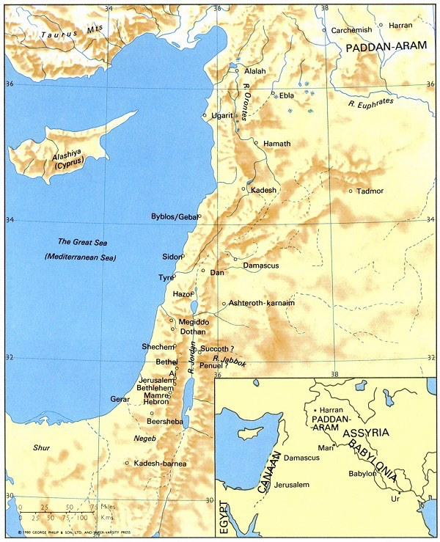
Abraham’s Family Tree

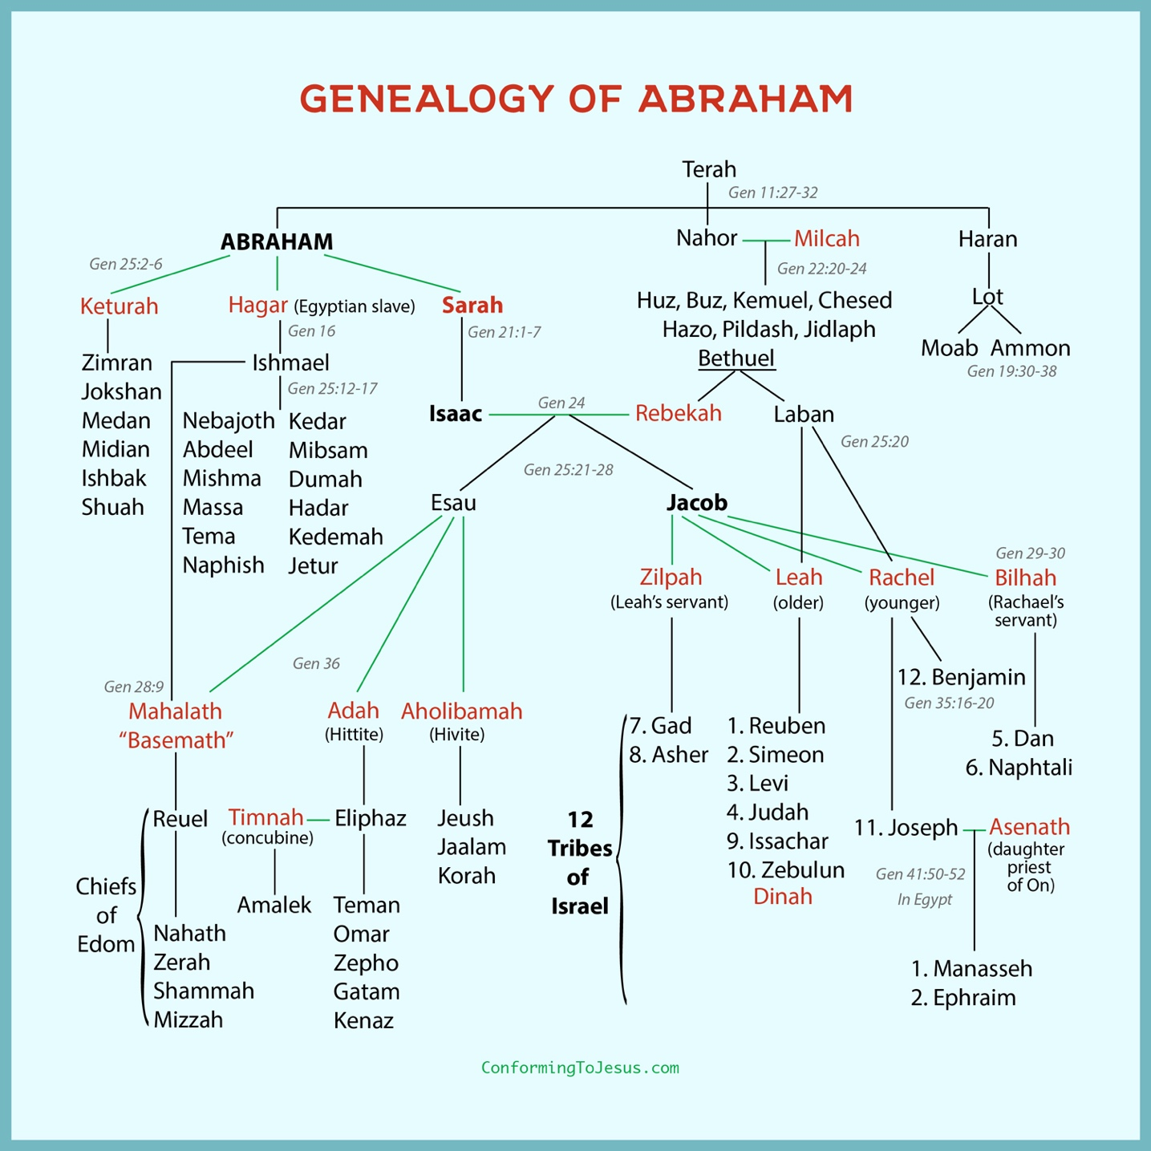

Reading Plan for Genesis 12-50
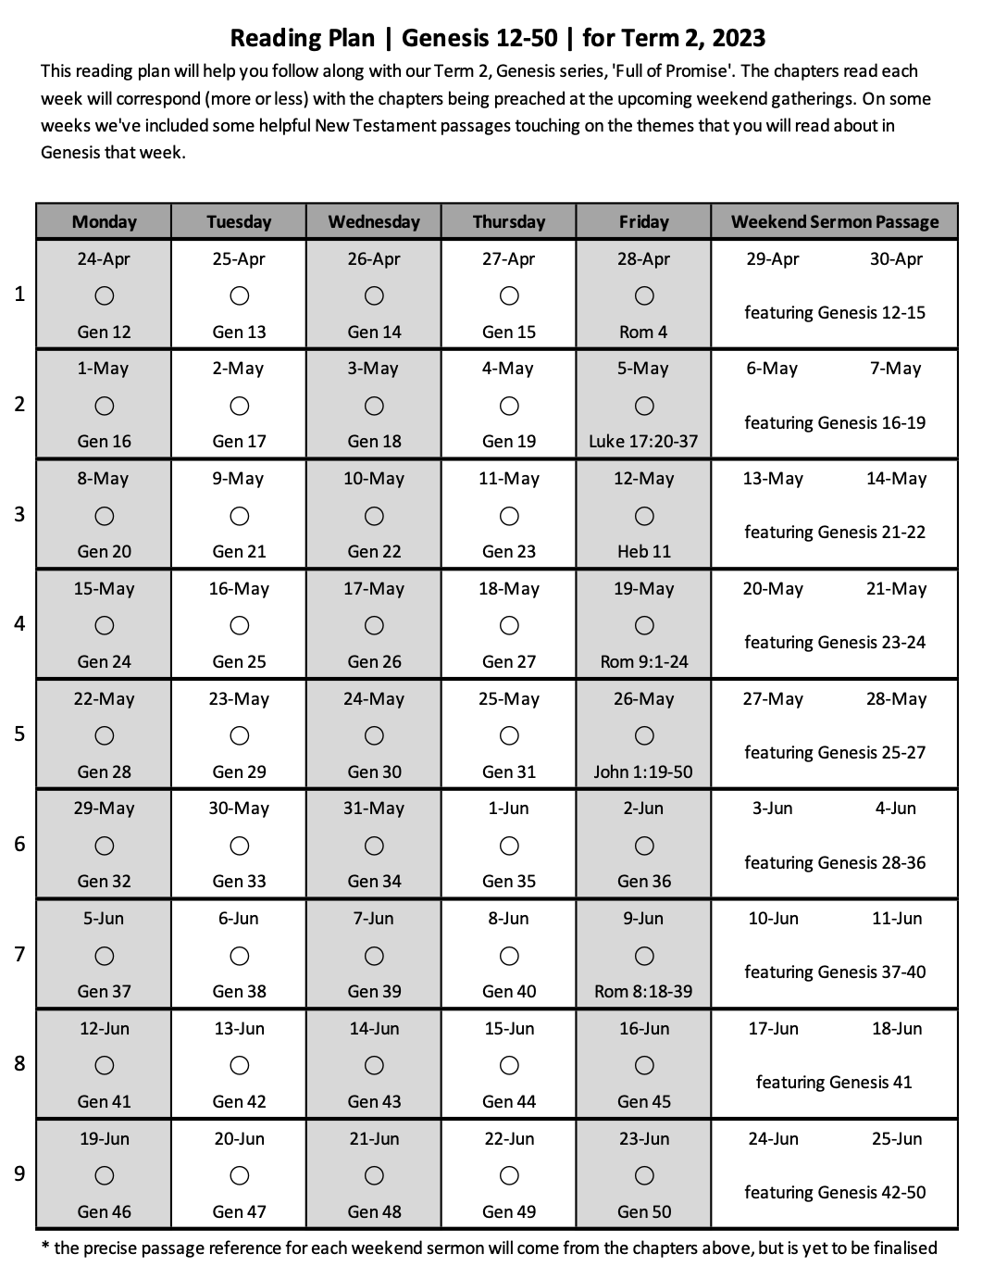

Page left intentionally blank (use for notes, prayer points etc)

