**Vestal United Methodist Church**

**328 Main Street**

**Vestal, NY 13850**

**www.vestalumc.org**

**(607) 785-3367**

**July 27, 2025 9:30 A.M.**

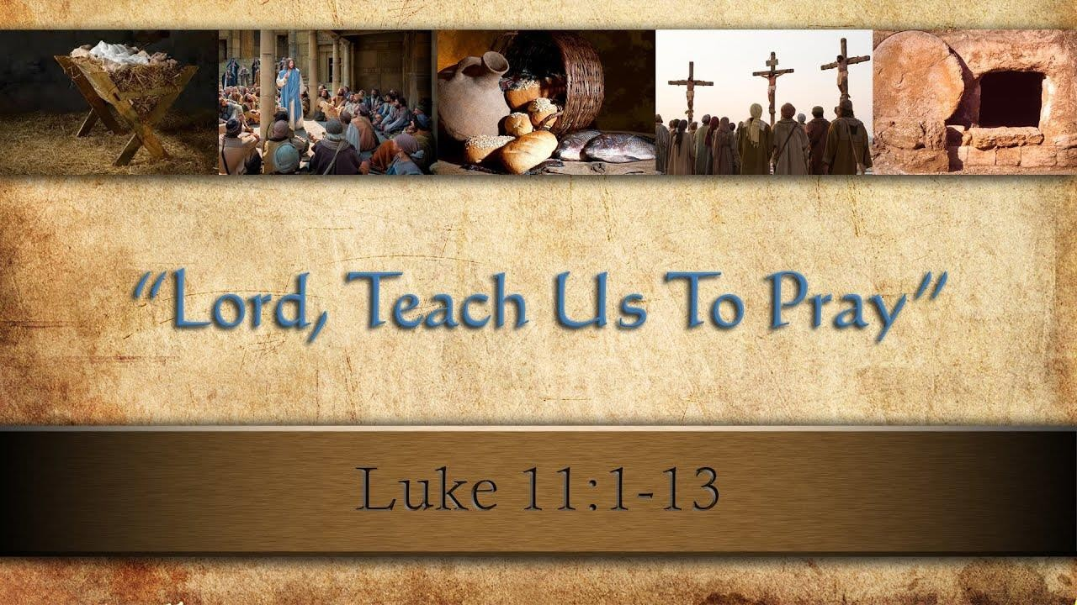

**7th SUNDAY AFTER PENTECOST**

**Welcome to all our guests, members, and friends, both young and not-so-young!**

**Please know that it is a joy to have you among us in person or in the virtual world.**

* Indicates congregation is invited to stand, if able.

**Prelude**

**Welcome**  Pastor

**Announcements** Liturgist

**\*Call to Worship**

Leader: We have been called here to face into God’s gracious way of living. We are to leave the past behind us and walk into these new days of our ministry.

**People: Sometimes we’d rather remember how things used to be. Sometimes we are afraid to be disciples.**

Leader: But this is a new day, and Christ is sharing freedom with us. It is a day to put aside all fear, to leave doubting behind, and take courage in God’s loving call.

**People: We will strive for faithfulness, even at the cost of popularity, and we will be disciples of Christ, renewing and gealing the world around us.**

**\*Opening Hymn # 145** “Morning Has Broken”

**\*Passing the Peace of Christ:**

Liturgist: Please turn to those around you, filled with a spirit of joy and welcome, and share the peace of Christ with your neighbors.

*(We encourage online worshipers to share comments of peace on our video platform. We also invite all worshipers, if possible, to take a moment to send a text message of peace and love to someone who isn’t present in worship today.)*

**\*The Opening Prayer**

**Gracious God, we thank you that we can rest in you, secure amid the conflict and confusion of life. We thank you that you provide for our needs and that you have trusted us to one another’s care. Help us to receive with humility and to give with joy. Help us to share what we have without fear of tomorrow. May we be peacemakers and justice makers, that one day humanity may choose bread over weapons and fairness over greed. Amen.**

**Anthem**

**Psalter Reading # 806** (responsive reading with sung responses) Psalm 85

**The Mystery Box (Young Disciples)** Pastor

**Video** “What If the Church”

**Hymn # 405** “Seek Ye First”

**Gospel Reading** Luke 11:1-13

**The Message** “The Father’s Gift”

**Prayer Concerns and Prayer Chorus # 2080 v. 1** “All I Need Is You”

**Pastoral Prayer and the Lord’s Prayer**

**WE BRING GOD’S TITHES AND OUR OFFERINGS**

***Please support the work of your church’s ministries by placing your offering on the plate during the service, mailing a check to the church, or giving online on our website*** [**http://www.vestalumc.org/**](http://www.vestalumc.org/)

**Offertory**

**\*Doxology UMH 95**

**JESUS, THE LIGHT OF THE WORLD, GOES BEFORE YOU**

**“We go out to share the good news of God’s love through our loving actions”**

**\*The Closing Hymn # 545**  “The Church’s One Foundation”

**\*Benediction** Pastor

**Postlude**

**THIS WEEK @ VUMC**

**July 27 Sunday**

**9:30 Worship Service**

**VBS Musical Performance**

**July 29 Tuesday**

**11 A.M. - 6 P.M.**

**DOUG’S FISH FRY**

**Serving in Worship**

Pastor: Rev. Dr. Glenn C. Ferguson

Young Disciples: Pastor

Liturgist: Hal Ehrhardt

Organist: Dan Rosenau

Special Music: VBS

Acolyte: Evan Bowerman

Audio Visual/Live Stream: Tim Andrews, Jean Stout

Welcome Team: Jeff Gray

Attendance 7/20 : 87