Vestal United Methodist Church
328 Main Street
Vestal, NY 13850
www.vestalumc.org
(607) 785-3367
September 14, 2025 9:30 A.M.
14th Sunday after Pentecost
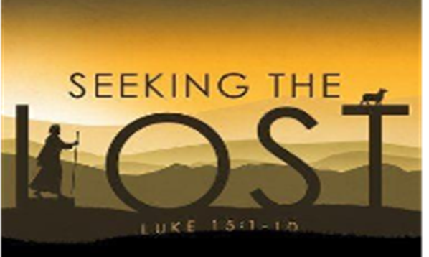

Welcome to all our guests, members, and friends, both young and not-so-young!
Please know that it is a joy to have you among us in person or in the virtual world.

* Indicates congregation is invited to stand, if able.

Prelude “He Leads Me” Medley arr. Victor Labenske

Welcome Pastor

Announcements Liturgist

*Call to Worship
Leader: Come to Christ, the living bread, who satisfies those who hunger and thirst for what is right.

People: We come to Christ, who gives living water, that we may never thirst again.

Leader: Come to Christ, that being filled yourself, you may minister to the hunger and thirst of others.

People: We come to God, in wordship and praise, through Jesus Christ, who gives us life.

*Opening Hymn # 79 v. 1-4 “Holy God, We Praise Thy Name”

*Passing the Peace of Christ:
Liturgist: Please turn to those around you, filled with a spirit of joy and welcome, and share the peace of Christ with your neighbors.
(We encourage online worshipers to share comments of peace on our video platform. We also invite all worshipers, if possible, to take a moment to send a text message of peace and love to someone who isn’t present in worship today.)

The Opening Prayer
Spirit of God, who dawns upon us like the morning light, be gracious unto us and bless us, we pray. May your touch enliven us as the rain makes the grass grow greenly, so that we might give forth your praise. It is through your blessing that we live, and in your name that we pray. Amen.

Special Music “Day by Day” Stephen Schwartz

The Mystery Box (Young Disciples) Pastor

*Hymn # 2279 (Sung 3x) “The Trees of the Field”

Kick Off

Gospel Reading Luke 15 1-10

The Message “Lost and Found” Prayer Concerns and Prayer Chorus # 2152 (TFWS) “Change My Heart O God”

Pastoral Prayer and the Lord’s Prayer

WE BRING GOD’S TITHES AND OUR OFFERINGS
Please support the work of your church’s ministries by placing your offering on the plate during the service, mailing a check to the church, or giving online on our website

Offertory “God is in Control” arr. Heather Sorenson

*Doxology UMH 95

JESUS, THE LIGHT OF THE WORLD, GOES BEFORE YOU
“We go out to share the good news of God’s love through our loving actions”

*Closing Song “Trading My Sorrows”

*Benediction Pastor

Postlude “Tis So Sweet to Trust in Jesus” arr. Victor Labenske

Upcoming Events @ VUMC

Sunday 9/14 Kick Off Sunday
Wear your favorite Team Jersey! Sunday Schools Begin

Sunday 9/21 Cornell University Choir
ENJOY HEAVENLY MUSIC!

Saturday 9/27 BLOOD DRIVE
﻿8 AM to 2 PM VUMC Dining Room

Sunday 9/28 11 AM BLESSING OF THE ANIMALS
On the VUMC Lawn

TUESDAYS @ 7 PM BIBLE STUDY with Rev. Glenn Ferguson
7 PM in the Library WE WELCOME ALL TO JOIN US!!
PLEASE Contact Rev. Ferguson: pastor@vestalumc.org OR gcf1953@gmail.com

COMMITTEE MEETING DATES:
Finance Committee: Monday 9/22 7 PM Library
Lay Leadership Committee: Monday 9/15 7 PM Library
SPRC: Monday 9/15 7 PM Room 24
United Women in Faith: Saturday 9/21 2 PM Belfry

Serving in Worship
Pastor: Rev. Dr. Glenn C. Ferguson
Young Disciples: Pastor
Liturgist: Lana Roske
Organist: Dan Rosenau
Special Music: VUMmer Hummers & Chancel Choir with
Ava Crump, Preston Moore, and John FitzGerald
Acolyte: Derek Kretzmer
Audio Visual/Live Stream: Tim Andrews, Jean Stout
Welcome Team: Brenda Bunzey
Attendance 9/7 85

