Vestal United Methodist Church
Welcoming All-Caring for All-Sharing God’s Love with All
328 Main Street
Vestal, NY 13850
www.vestalumc.org
(607) 785-3367
February 15, 2026 9:30 A.M.
Transfiguration Sunday
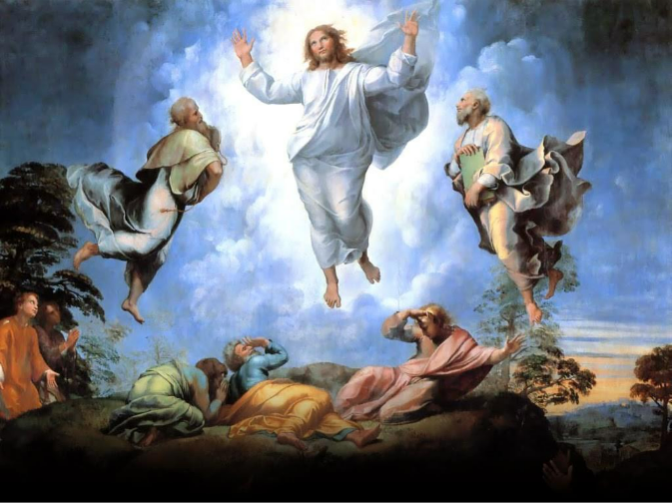

Welcome to all our guests, members, and friends, both young and not-so-young!
Please know that it is a joy to have you among us in person or in the virtual world.
* Indicates congregation is invited to stand, if able.

Prelude “Oh Lord, You’re Beautiful” arr. Heather Sorenson

Welcome

Announcements

Introit “Gather Us In” Marty Haugen

*Call to Worship
Leader: O God, it is good to be here in your presence, among your people.

People: Make us radiant with the light of your Christ.

Leader: Help us to worship with reverence and serve you in the world.

People: May our words, our songs, and our thoughts, be pleasing to you, O God. For we pray in the name of Jesus our Lord. Amen.

*Opening Hymn # 173 “Christ, Whose Glory Fills the Skies”

*Passing the Peace of Christ:
Leader: Please turn to those around you, filled with a spirit of joy and welcome, and share the peace of Christ with your neighbors.
(We encourage online worshipers to share comments of peace on our video platform. We also invite all worshipers, if possible, to take a moment to send a text message of peace and love to someone who isn’t present in worship today.)

*The Opening Prayer
Hope of the poor, friend of the persecuted, advocate of the suffering, O God, we praise you, for you have been our help. Turn our tears to laughter and give us what we need to live. Then keep us faithful, that we may never be satisfied until all have what they need. May all people receive your blessing, through Jesus Christ who died, and rose again, and in whom we find life. Amen.

New Testament Reading 2 Peter 1:16-21

Special Music “In the Bleak Midwinter”

The Mystery Box

Video “Black History Month-Inspiration”

Hymn # 258 “O Wondrous Sight! O Vision Fair”

Gospel Reading Mathew 17:1-9

The Message “Garments of Light”

Prayer Concerns and Prayer Chorus # 2166 v.1 “Christ Beside Me”

Pastoral Prayer and The Lord’s Prayer

WE BRING GOD’S TITHES AND OUR OFFERINGS
Please support the work of your church’s ministries by placing your offering on the plate during the service, mailing a check to the church, or giving online on our website

Offertory Praise Song “The Battle Belongs to the Lord” Jamie Owens-Collins

*Doxology # 95

JESUS, THE LIGHT OF THE WORLD, GOES BEFORE YOU
“We go out to share the good news of God’s love through our loving actions”

Hymn # 2022 “Come Away with Me”

*Benediction

Postlude “Jesus Is the Rock” Tony Gongen

Pastor Glenn’s Tuesday evening Bible Study on the book of Genesis continues this week, Tuesday at 7:00 p.m. All are welcome, including those who have not been with us before.

Ash Wednesday - The season of Lent begins this coming Wednesday with the service wherein we recall the sacrifice of Jesus and receive ashes as reminders of his love and service. The Ash Wednesday service begins at 7:00 p.m.


Chili Cook-off - On Sunday, February 22, we’ll be having a chili cook-off after the Worship Service and Sunday School Classes. This event is being organized by the Outreach Team and should be tasty and fun! Together, we’ll figure out who makes the best tasting chili in the church. Stay tuned for more information.

Serving in Worship
Pastor: Rev Dr. Glenn C Ferguson
Liturgist: Hal Ehrhardt
Organist: Dan Rosenau
Special Music: Ava Crump, Chris Vincens, Preston Moore and Ben Vincens
Acolyte: Grayden Masse
Audio Visual/Live Stream: Tim Andrews & Barry Biddle
Welcome Team: Lorie Woughter
Attendance: 2/8 95

