Vestal United Methodist Church
Welcoming All-Caring for All
Sharing God’s Love with All

328 Main Street Vestal, NY 13850
www.vestalumc.org
(607) 785-3367
April 19, 2026 9:30 A.M.
Third Sunday of Easter

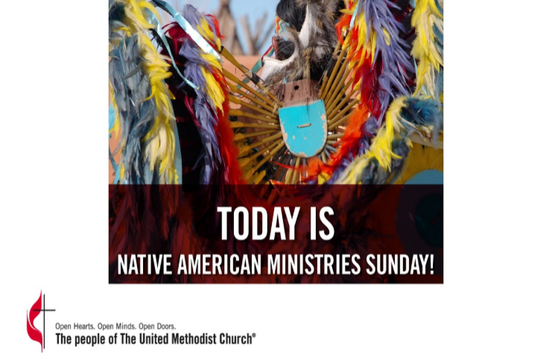

Welcome to all our guests, members, and friends, both young and not-so-young!
Please know that it is a joy to have you among us in person or in the virtual world.
* Indicates congregation is invited to stand, if able

Prelude “For the Beauty of the Earth” arr. James Biery

Welcome

Announcements

Music Meditation Daniel Hill

*Call to Worship
Leader: Sing Praises to God, you faithful. Give thanks to God’s holy name.

People: Weeping may linger for a night, but joy comes in the morning.

Leader: You turn our weeping to dancing, O God; you remove the garments of mourning and clothe us in gladness.

People: May we praise you and be silent. We will give thanks to you, O God, forever.

*Opening Hymn # 191 (v. 2 in Cherokee) “Jesus Loves Me”

*Passing the Peace of Christ
Leader: Please turn to those around you, filled with a spirit of joy and welcome, and share the peace of Christ with your neighbors.
(We encourage online worshipers to share comments of peace on our video platform. We also invite all worshipers, if possible, to take a moment to send a text message of peace and love to someone who isn’t present in worship today.)

Unison Prayer Hymnal # 329

Music Meditation Daniel Hill

The Mystery Box

New Testament Reading 1 Peter 1:17-23

*Hymn # 378 (v. 2 in Cherokee and v. 3 in Creek) “Amazing Grace”

Gospel Reading Luke 24:13-35

The Message “Jesus Walks With Us”

Prayer Concerns and Prayer Chorus # 330 “Great Spirit Now I Pray”
Pastoral Prayer and the Lord’s Prayer

WE BRING GOD’S TITHES GIFTS, AND OUR OFFERINGS
Please support the work of your church’s ministries by placing your offering on the plate during the service, mailing a check to the church, or giving online on our website- http://www.vestalumc.org

Music Meditation Daniel Hill

*Doxology # 95

JESUS, THE LIGHT OF THE WORLD, GOES BEFORE YOU
“We go out to share the good news of God’s love through our loving actions”

*Hymn # 148 “Many and Great, O God”

*Benediction

Postlude Daniel Hill

Dan Hill is a member of the Cayuga Nation and plays traditional Native American music on wooden flutes that he has carved himself. Dan has played for our services at least the past two years. We would like to acknowledge this gathering is being held on the traditional lands of the Onondaga Nation. The Onondaga Nation is a member of the Haudenosaunee (Ho de no shaw’ nee) Confederacy – people of the Longhouse, which is an alliance of Native Nations united for hundreds of years by law, traditions, beliefs, and cultural values. The Haudenosaunee consist of the Mohawk, Oneida, Onondaga, Cayuga, Seneca and Tuscarora nations. We are thankful for the gifts they have brought to this land and pay our respects to Elders both past and present.

Pastor's Bible Study- We are nearing the end of our study of the book of Genesis. The group has decided to turn to the book of The Revelation to John next, beginning April 14. If you've always had questions about this part of the Bible or if you've found it confusing, this study could be for you. We will do a thorough study of the nature of the book, its purpose, historical setting, its contextual meaning, and what it might mean for us today. We meet in the library on Tuesdays at 7:00 p.m. Feel free to bring any Bible with you, but you might want to bring an NRSV if you have one.

Serving in Worship
Pastor: Rev Dr. Glenn C Ferguson
Liturgist: Violamae Secord
Organist: Dan Rosenau
Special Music: Daniel Hill, Cayuga Nation, Native American Flute
Acolyte: William Lanouette
Audio Visual/Live Stream: Keith & Becky Harrison, Tim Andrews
Welcome Team: Lorie Woughter
Attendance: 4/12 84

