Vestal United Methodist Church
Welcoming All, Caring for All,
Sharing God’s Love with All
328 Main Street Vestal, NY 13850
www.vestalumc.org 607-785-3367
May 10, 2026 9:30 a.m.
Sixth Sunday of Easter

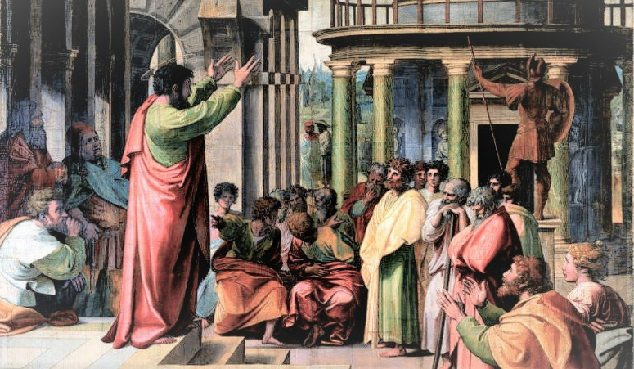

Welcome to all our guests, members, and friends,

both young and not-so-young!

Please know that it is a joy to have you among us in person or in the virtual world.
*Indicates the congregation is invited to stand

Prelude "Prière à Notre-Dame" Léon Boëllmann

Welcome

Announcements

*Call to Worship
Leader: See what love has been given to us, that we should be called children of God.

People: By this we know love, that Jesus Christ has come in the flesh, and lived and died, that God’s love might be made plain among us.

Leader: Therefore, beloved, let us not love, in word or in speech but in deed and in truth.

People: Because we love one another, we know that we have passed from death into life. This is the victory that overcomes the world. Through Jesus our risen Christ. Amen.

*Opening Hymn # 337 “Only Trust Him”

*Passing the Peace of Christ
Leader: Please turn to those around you, filled with a spirit of joy and welcome, and share the peace of Christ with your neighbors.
(We encourage online worshipers to share comments of peace on our video platform. We also invite all worshipers, if possible, to take a moment to send a text message of peace and love to someone who isn’t present in worship today.)

Unison Prayer
God of grace and glory, we thank you that the life of eternity can be ours in the present through the resurrection of Jesus Christ. Teach us always to abide in Christ, that we may bear the fruits of love and joy through the guidance of your Spirit of truth. Amen.

Psalter Reading # 790 Psalm 66:8-20

Special Music “O Come and Sing Unto the Lord” arr. Robert leaf

The Mystery Box

Video “Stuff Moms Never Say"

*Hymn # 402 “Lord, I Want to Be a Christian”

New Testament Reading Acts 17:21-31

The Message “To an Unknown God”

Prayer Concerns and Prayer Chorus # 2163 (TFWS) “Sanctuary”

Pastoral Prayer and the Lord’s Prayer

WE BRING GOD’S TITHES GIFTS, AND OUR OFFERINGS
Please support the work of your church’s ministries by placing your offering on the plate during the service,
mailing a check to the church, or giving online on our website- http://www.vestalumc.org

Offertory “Minor Prelude” David Burroughs

*Doxology # 95

JESUS, THE LIGHT OF THE WORLD, GOES BEFORE YOU
“We go out to share the good news of God’s love through our loving actions”

*Hymn # 114 “Many Gifts, One Spirit”

Benediction

Postlude “Tis So Sweet to Trust in Jesus’ arr. Lavawan Riley

*******The flowers on the Altar this week are dedicated by The Family*******
in memory of Cooper John Reeser

Interested in Becoming a Member of Vestal UMC?
The pastor will be holding meetings for anyone interested in finding out what membership means and who are ready to unite with the church on Sundays after worship May 31 and June 7, at 11:00 a.m. in the pastor's office. He plans to receive those who wish to join during the worship service on Sunday, June 21. If you are transferring from another church, please give us the name of the church and contact information so that we can arrange the transfer. If you are not transferring, you will be joining by what is called Profession of Faith. In either case, we need to know whether or not you've been baptized.
Please send the pastor an email letting him know of your intention to be present for the preparatory meetings. His email address is pastor@vestalumc.org. Presence at those meetings in no way obligates you to join. If you have any questions or concerns, please call Pastor Glenn or send an email.

Get Your Chicken BBQ at Vestal UMC
Our church will host it's first monthly Chicken Barbecue starting at 11 AM on Sunday, May 10th. It will last until 2 PM or until the chicken is gone. No reservations are needed. First Come - First Served. In addition to a freshly grilled chicken half you will receive two sides and a roll for a total of $16. Cash is preferred, but we hope to have electronic payment options available. Checks will also be accepted.Also available will be cold drinks (bottles or cans) You can get your meal "to go" or you can enjoy it with friends as we will have some tables and chairs under awnings next to the pit.

Serving in Worship
Pastor: Rev Dr. Glenn C Ferguson
Liturgist: John Wicklund
Organist: Dan Rosenau
Special Music: VUMmer Hummers & VUMC Chimers
Acolyte: William Lanouette
Audio Visual/Live Stream: Tim Andrews
Welcome Team: Jeff Gray
Attendance: 5/3 105

