Vestal United Methodist Church
Welcoming All, Caring for All,
Sharing God’s Love with All
328 Main Street Vestal, NY 13850
www.vestalumc.org 607-785-3367
October 11, 2026 9:30 a.m.

Twentieth Sunday after Pentecost

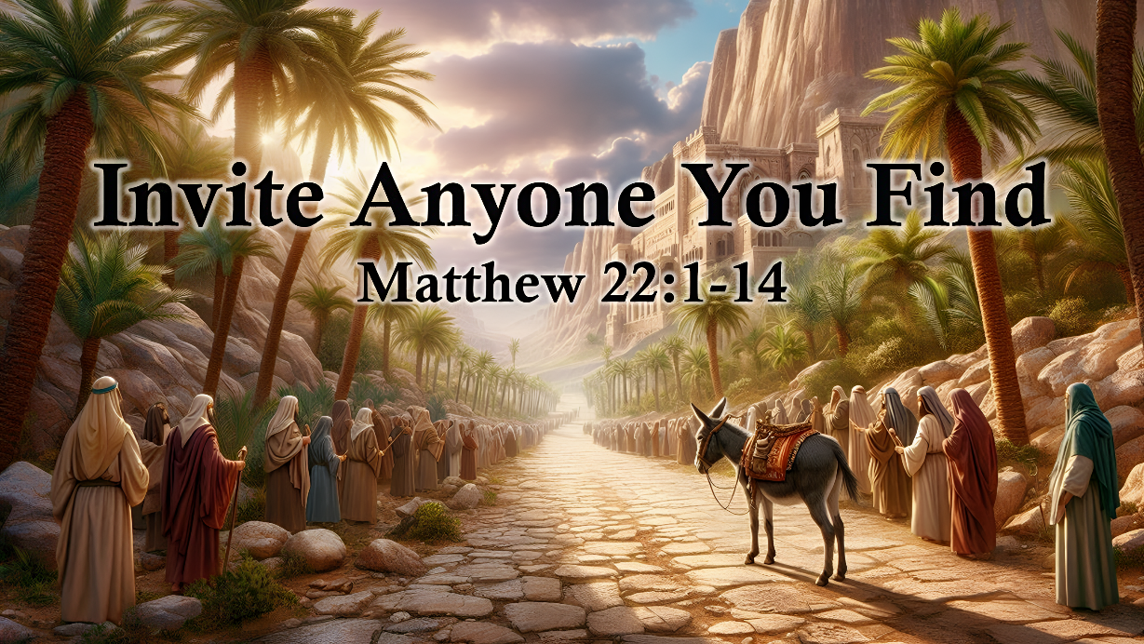

Welcome to all our guests, members, and friends,

both young and not-so-young!

Please know that it is a joy to have you among us in person or in the virtual world.
*Indicates the congregation is invited to stand, if able

Prelude “Down to the River to Pray” arr. Ken Medema

Welcome

Announcements

*Call to Worship
Leader: We wait for God that God might save us.

People: Let us be glad and rejoice in God’s salvation.

Leader: God will swallow up death forever and will wipe away the tears from all faces.

People: Let us be glad and share in God’s salvation.

*Opening Hymn # 181 “Ye Servants of God”

*Passing the Peace of Christ
Leader: Please turn to those around you, filled with a spirit of joy and welcome, and share the peace of Christ with your neighbors.
(We encourage those worshipping online to share comments or peace on our video platform. We also invite everyone to take a moment, when possible, to send a text message of peace and love to someone who isn’t present in person today.

Unison Prayer
O God of truth and understanding, generation after generation you have listened patiently while your people questioned your love. We too have doubted your love and judged you without truly knowing you. Awaken us to your presence that we may know through our own experiences that you are faithful in caring for your creation; Through the grace of Jesus Christ. Amen.

Special Music “Passed Thru the Waters” Avery & Marsh

The Sacrament of Baptism

The Mystery Box

*Hymn # 2248 “Baptized in Water”

Gospel Reading Matthew 22:1-14

The Message “God’s Invitation to Life”

Prayer Concerns and Prayer Chorus # 2248 v.2 “Someone’s Praying, Lord”

Pastoral Prayer and the Lord’s Prayer

WE BRING GOD’S TITHES GIFTS, AND OUR OFFERINGS Please support the work of your church’s ministries by placing your offering in the plate during the service, mailing a check to the church, or giving online via our website- http://www.vestalumc.org

Offertory “It’s Me, It’s Me, O Lord” Spiritual

*Doxology # 95

JESUS, THE LIGHT OF THE WORLD, GOES BEFORE YOU
“We go out to share the good news of God’s love through our loving actions”

*Hymn # 339 “Come Sinners, to the Gospel Feast”

*Benediction

Postlude “Praeludium Dieterich Buxtehude

The flowers on the altar this week are in Honor of Emily Rose from the Family

This week at Vestal UMC

Monday - Senior Ministries at noon in the library

Tuesday - Pastor’s Bible study of the book of Exodus at 7:00 p.m. in the library

Wednesday - Music and Worship Arts in the library at 7:00 p.m.
Capital Funds Campaign Committee meeting in Room 24 at 7:00 p.m.

Thursday - Choir practice at 7:00 p.m. in the Sanctuary

Jail Ministry Collection - For the month of October, we will be collecting 5"x7" puzzle books.

Serving in Worship
Rev. Glenn C Ferguson
Liturgist: Gabriel Barbieri
Organist: Daniel Rosenau
Special Music: VUMmer Hummers
Acolyte: Violamae Secord
Audio/Video: Barry Biddle & Tim Andrews
Welcome Team: Hal Ehrhardt
Attendance: 10/4 98

