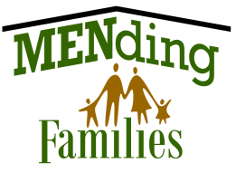DO Something Special to Celebrate Your Dad on FATHER’s DAY 2022

COOKOUT and GREATEST DAD CAMPAIGN®

Write a short essay explaining why
YOUR DAD is the GREATEST!

Bring your Prizes, Free Food, Music & Games Family

Event Date: Sunday, JUNE 19th

Cosca Regional Park * 11000 Thrift Road * Clinton, MD starts 1:00pm – 7:00pm must be present at 2:00pm to win!

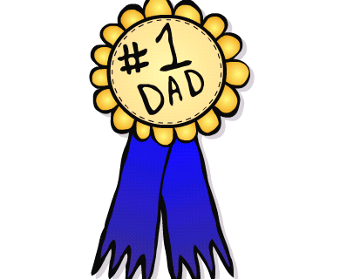
Application and Parent Permission Form available on line. For more info contact:
301-221-7292 Or visit website:
mending-families.org

Sponsored by MENding Families, Inc.: Stacie Banks Hall, Executive Director CeMENting Foundations: Jeffrey Roscoe, CEO

