Trinity Worship 9:00am - February 22nd, 2026

Prelude, Ringing of the Bell, Words of Welcome

537 Beautiful Savior sts. 1–2, 4
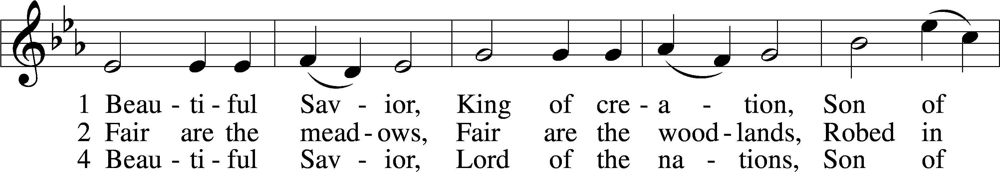
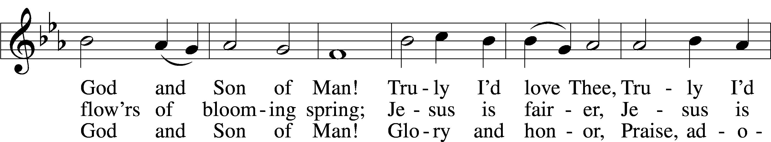
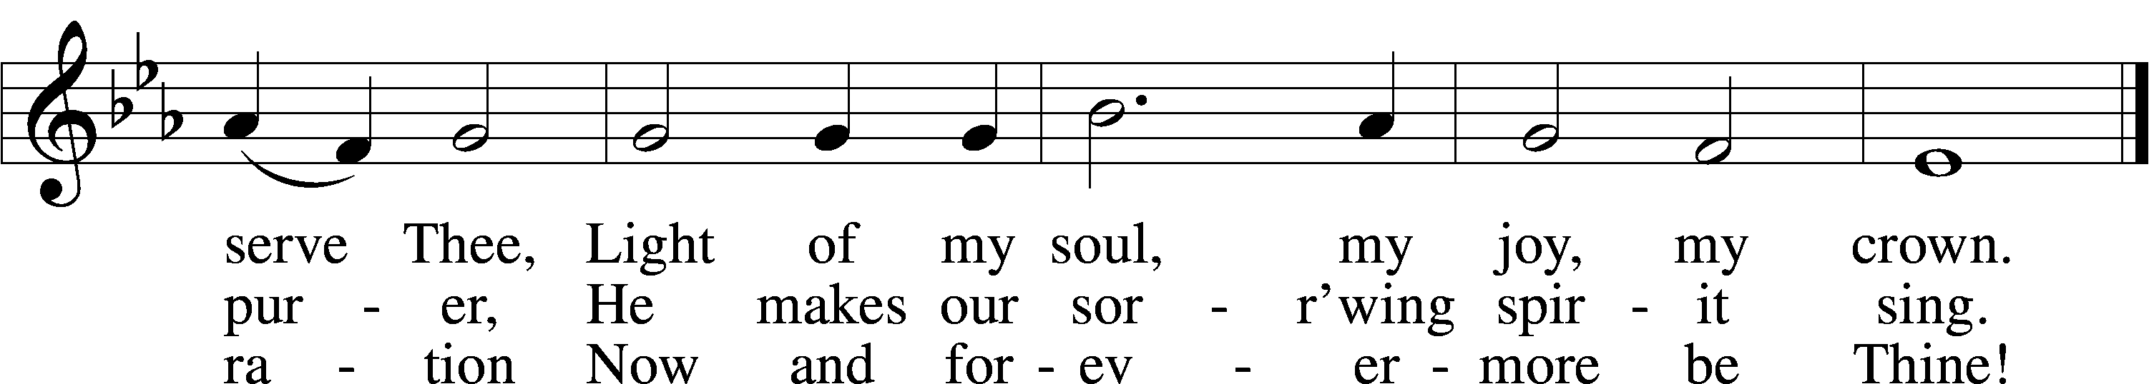
Text: Münsterisch Gesangbuch, 1677, Münster; tr. Joseph A. Seiss, 1823–1904
Tune: Silesian, 19th cent.
Text and tune: Public domain

Invocation
P In the name of the Father and of the T Son and of the Holy Spirit.
C Amen.

Exhortation LSB 184
P Beloved in the Lord! Let us draw near with a true heart and confess our sins unto God our Father, beseeching Him in the name of our Lord Jesus Christ to grant us forgiveness.

P Our help is in the name of the Lord,
C who made heaven and earth.
P I said, I will confess my transgressions unto the Lord,
C and You forgave the iniquity of my sin.

Silence for reflection on God’s Word and for self-examination.

Confession of Sins LSB 184
P O almighty God, merciful Father,
C I, a poor, miserable sinner, confess unto You all my sins and iniquities with which I have ever offended You and justly deserved Your temporal and eternal punishment. But I am heartily sorry for them and sincerely repent of them, and I pray You of Your boundless mercy and for the sake of the holy, innocent, bitter sufferings and death of Your beloved Son, Jesus Christ, to be gracious and merciful to me, a poor, sinful being.

Absolution LSB 185
P Upon this your confession, I, by virtue of my office, as a called and ordained servant of the Word, announce the grace of God unto all of you, and in the stead and by the command of my Lord Jesus Christ I forgive you all your sins in the name of the Father and of the T Son and of the Holy Spirit.
C Amen.

Offertory LSB 192
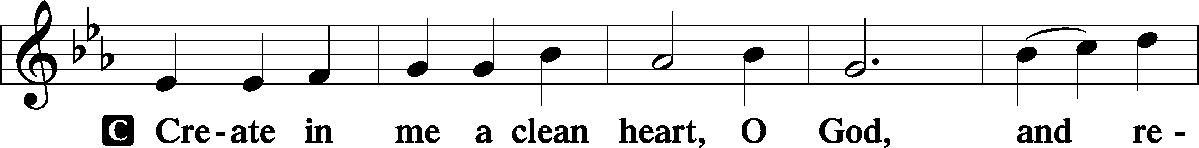
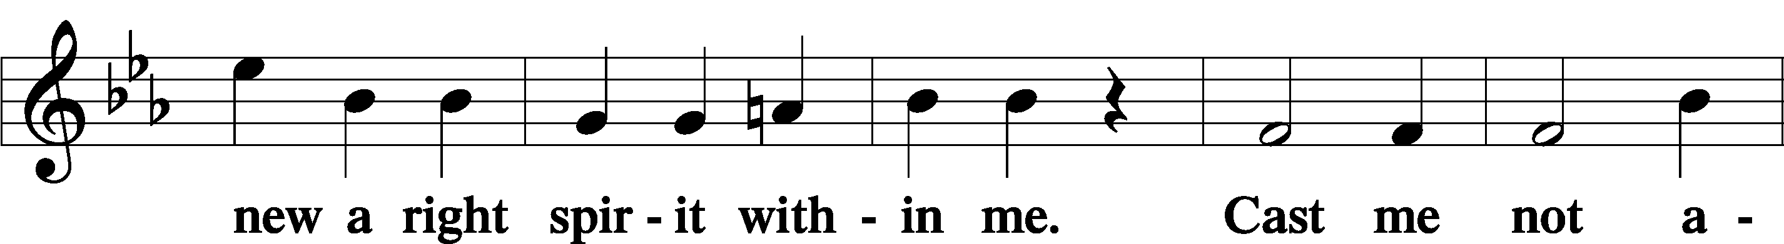
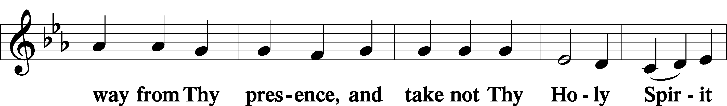
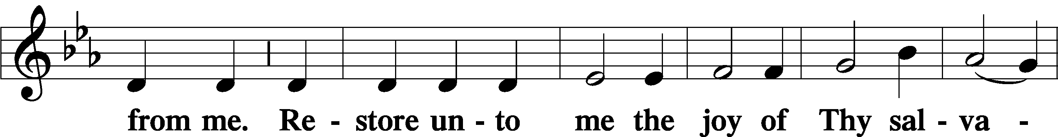
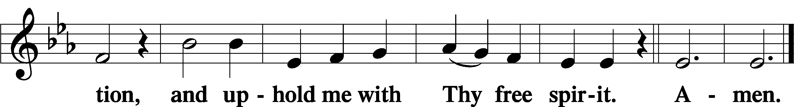

Salutation and Collect of the Day
P The Lord be with you.
C And with thy spirit.

P Let us pray.
O Lord God, You led Your ancient people through the wilderness and brought them to the promised land. Guide the people of Your Church that following our Savior we may walk through the wilderness of this world toward the glory of the world to come; through Jesus Christ, Your Son, our Lord, who lives and reigns with You and the Holy Spirit, one God, now and forever.

C Amen.

Old Testament Reading Genesis 18:1–8
¹And the Lord appeared to him by the oaks of Mamre, as he sat at the door of his tent in the heat of the day. ²He lifted up his eyes and looked, and behold, three men were standing in front of him. When he saw them, he ran from the tent door to meet them and bowed himself to the earth ³and said, “O Lord, if I have found favor in your sight, do not pass by your servant. ⁴Let a little water be brought, and wash your feet, and rest yourselves under the tree, ⁵while I bring a morsel of bread, that you may refresh yourselves, and after that you may pass on—since you have come to your servant.” So they said, “Do as you have said.” ⁶And Abraham went quickly into the tent to Sarah and said, “Quick! Three seahs of fine flour! Knead it, and make cakes.” ⁷And Abraham ran to the herd and took a calf, tender and good, and gave it to a young man, who prepared it quickly. ⁸Then he took curds and milk and the calf that he had prepared, and set it before them. And he stood by them under the tree while they ate.

A This is the Word of the Lord.
C Thanks be to God.

Epistle Philippians 2:5–11
⁵Have this mind among yourselves, which is yours in Christ Jesus, ⁶who, though he was in the form of God, did not count equality with God a thing to be grasped, ⁷but made himself nothing, taking the form of a servant, being born in the likeness of men. ⁸And being found in human form, he humbled himself by becoming obedient to the point of death, even death on a cross. ⁹Therefore God has highly exalted him and bestowed on him the name that is above every name, ¹⁰so that at the name of Jesus every knee should bow, in heaven and on earth and under the earth, ¹¹and every tongue confess that Jesus Christ is Lord, to the glory of God the Father.

A This is the Word of the Lord.
C Thanks be to God.

Holy Gospel John 13:1–20
P The Holy Gospel according to St. John, the thirteenth chapter.
C Glory be to Thee, O Lord.

¹Now before the Feast of the Passover, when Jesus knew that his hour had come to depart out of this world to the Father, having loved his own who were in the world, he loved them to the end. ²During supper, when the devil had already put it into the heart of Judas Iscariot, Simon’s son, to betray him, ³Jesus, knowing that the Father had given all things into his hands, and that he had come from God and was going back to God, ⁴rose from supper. He laid aside his outer garments, and taking a towel, tied it around his waist. ⁵Then he poured water into a basin and began to wash the disciples’ feet and to wipe them with the towel that was wrapped around him. ⁶He came to Simon Peter, who said to him, “Lord, do you wash my feet?” ⁷Jesus answered him, “What I am doing you do not understand now, but afterward you will understand.” ⁸Peter said to him, “You shall never wash my feet.” Jesus answered him, “If I do not wash you, you have no share with me.” ⁹Simon Peter said to him, “Lord, not my feet only but also my hands and my head!” ¹⁰Jesus said to him, “The one who has bathed does not need to wash, except for his feet, but is completely clean. And you are clean, but not every one of you.” ¹¹For he knew who was to betray him; that was why he said, “Not all of you are clean.”
¹²When he had washed their feet and put on his outer garments and resumed his place, he said to them, “Do you understand what I have done to you? ¹³You call me Teacher and Lord, and you are right, for so I am. ¹⁴If I then, your Lord and Teacher, have washed your feet, you also ought to wash one another’s feet. ¹⁵For I have given you an example, that you also should do just as I have done to you. ¹⁶Truly, truly, I say to you, a servant is not greater than his master, nor is a messenger greater than the one who sent him. ¹⁷If you know these things, blessed are you if you do them. ¹⁸I am not speaking of all of you; I know whom I have chosen. But the Scripture will be fulfilled, ‘He who ate my bread has lifted his heel against me.’ ¹⁹I am telling you this now, before it takes place, that when it does take place you may believe that I am he. ²⁰Truly, truly, I say to you, whoever receives the one I send receives me, and whoever receives me receives the one who sent me.”

P This is the Gospel of the Lord.
C Praise be to Thee, O Christ.

Nicene Creed
C I believe in one God,
the Father Almighty,
maker of heaven and earth
and of all things visible and invisible.

And in one Lord Jesus Christ,
the only-begotten Son of God,
begotten of His Father before all worlds,
God of God, Light of Light,
very God of very God,
begotten, not made,
being of one substance with the Father,
by whom all things were made;
who for us men and for our salvation came down from heaven
and was incarnate by the Holy Spirit of the virgin Mary
and was made man;
and was crucified also for us under Pontius Pilate.
He suffered and was buried.
And the third day He rose again according to the Scriptures
and ascended into heaven
and sits at the right hand of the Father.
And He will come again with glory to judge both the living and the dead,
whose kingdom will have no end.

And I believe in the Holy Spirit,
the Lord and giver of life,
who proceeds from the Father and the Son,
who with the Father and the Son together is worshiped and glorified,
who spoke by the prophets.
And I believe in one holy Christian and apostolic Church,
I acknowledge one Baptism for the remission of sins,
and I look for the resurrection of the dead
and the life T of the world to come. Amen.

685 Let Us Ever Walk with Jesus sts. 1–2
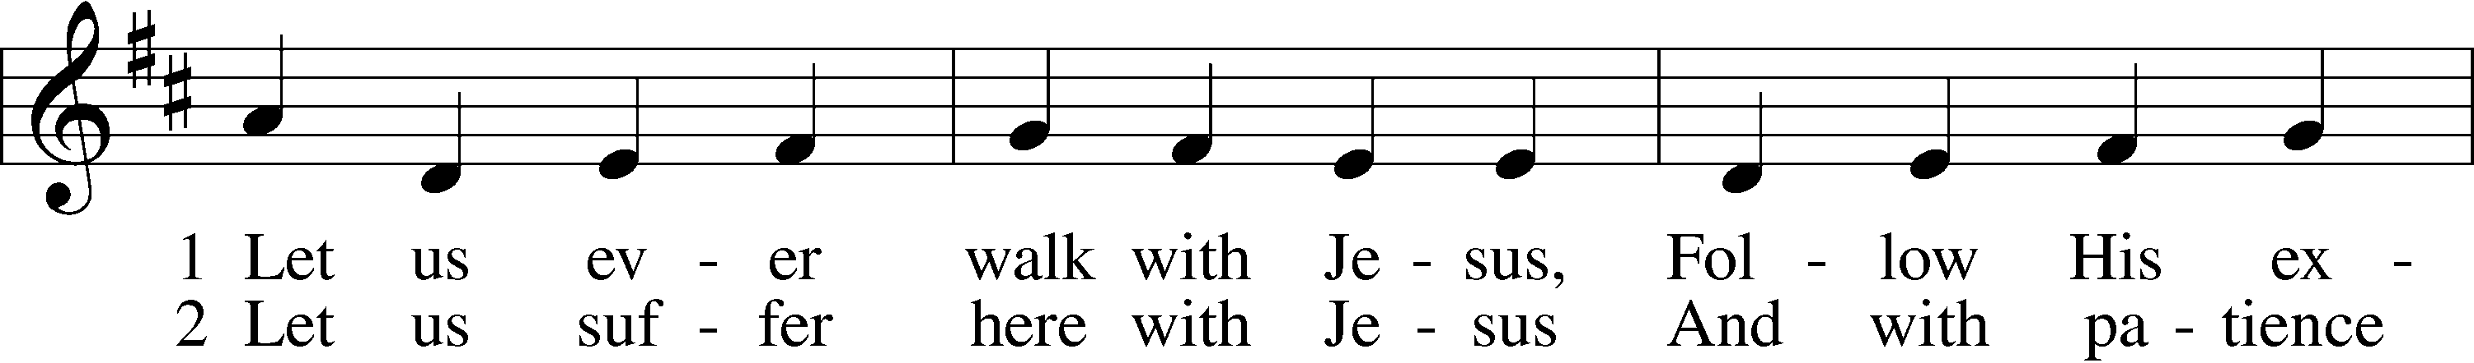
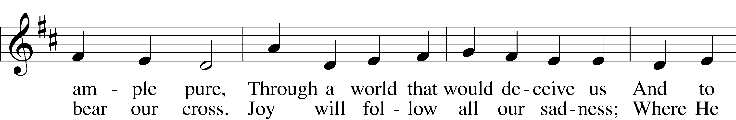
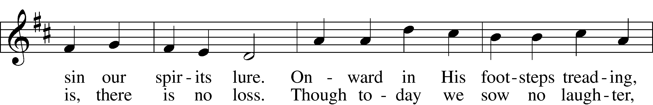
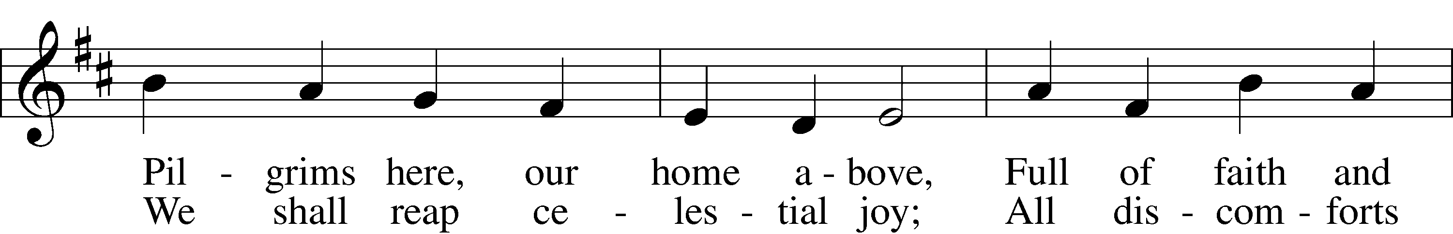
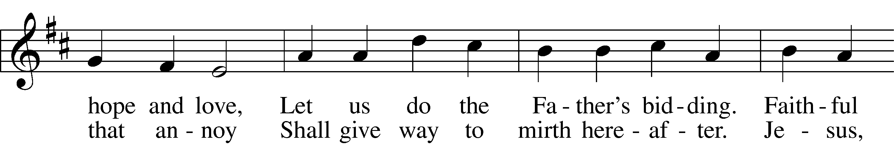
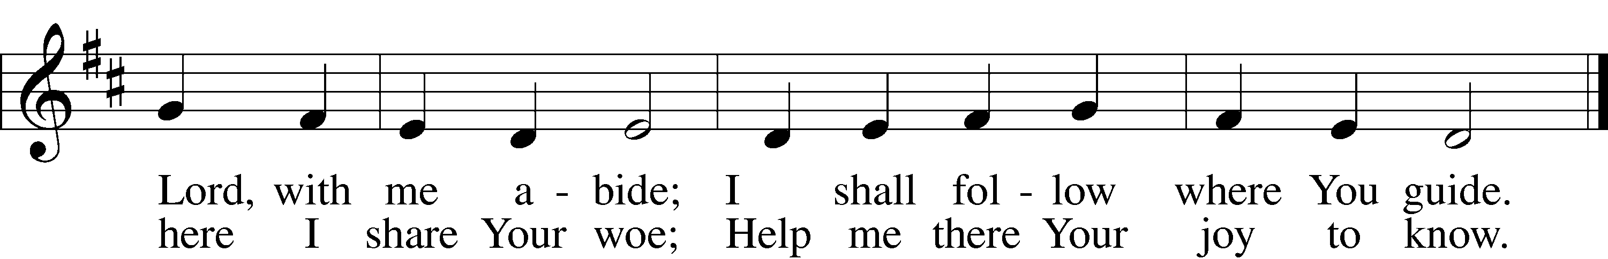
Text: Sigismund von Birken, 1626–81; tr. Lutheran Book of Worship, 1978, alt.
Tune: Georg G. Boltze, 18th cent.
Text: © 1978 Lutheran Book of Worship. Used by permission: LSB Hymn License no. 110002769
Tune: Public domain

Sermon

685 Let Us Ever Walk with Jesus sts. 3–4
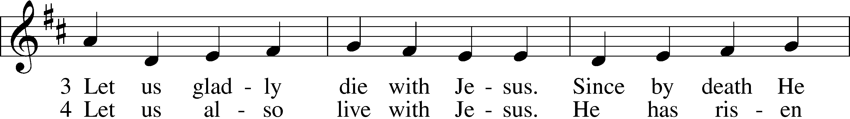
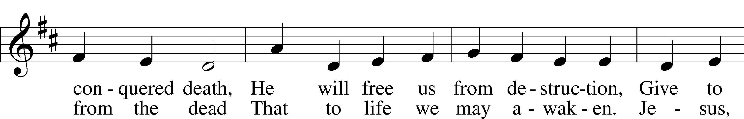
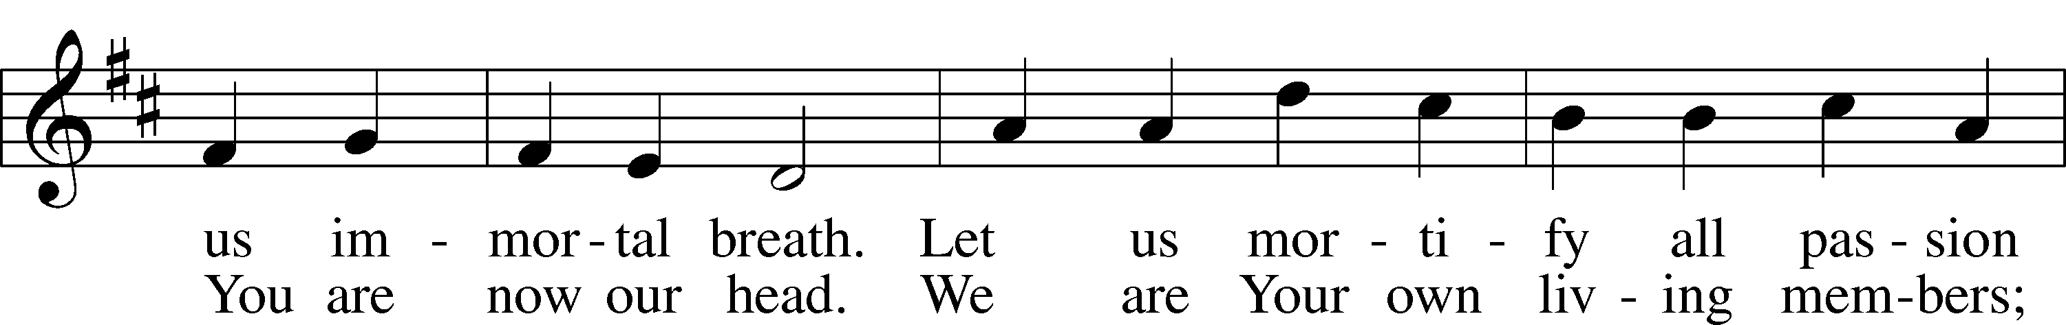
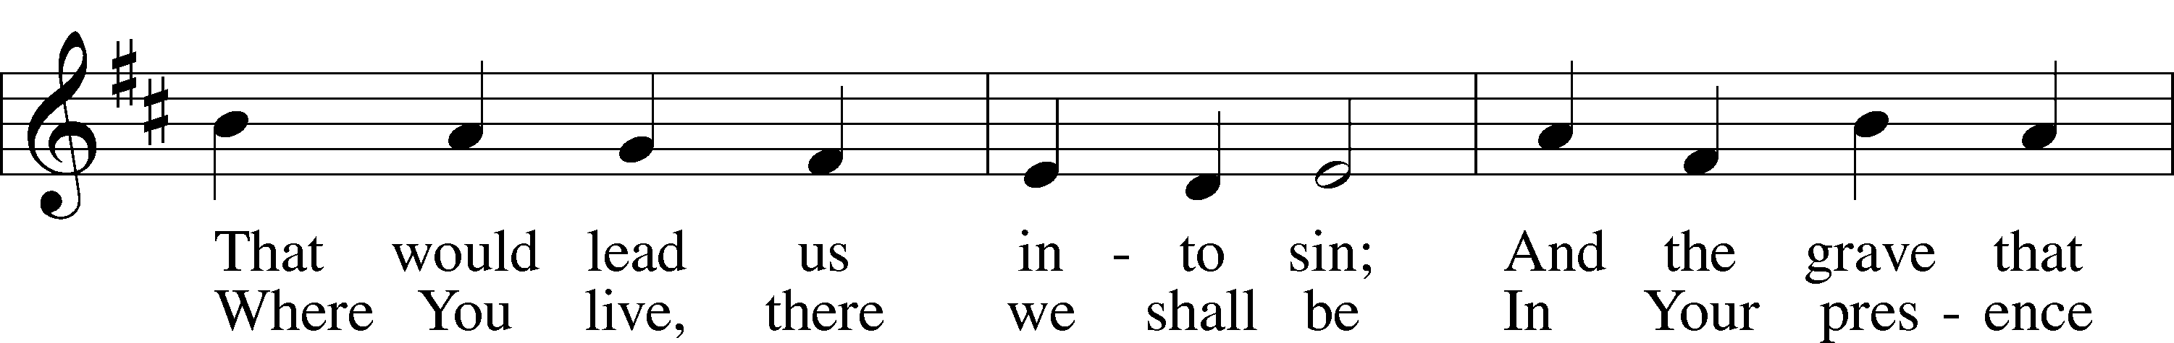
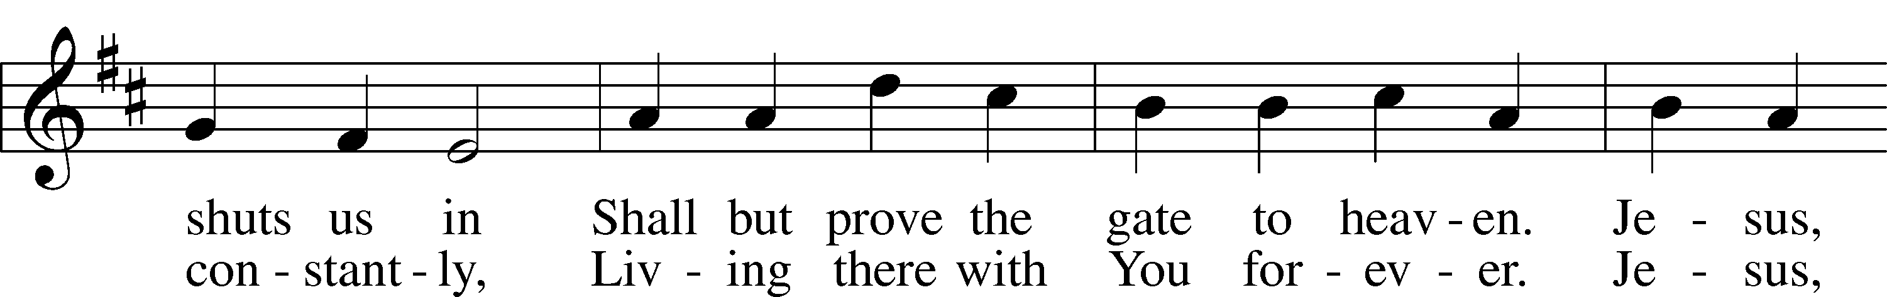
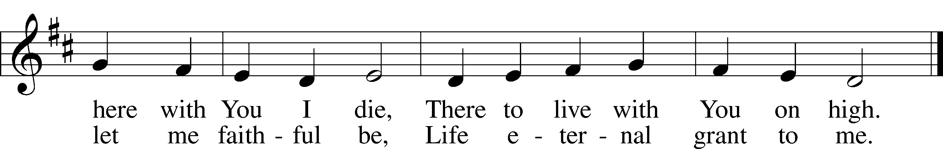
Text: Sigismund von Birken, 1626–81; tr. Lutheran Book of Worship, 1978, alt.
Tune: Georg G. Boltze, 18th cent.
Text: © 1978 Lutheran Book of Worship. Used by permission: LSB Hymn License no. 110002769
Tune: Public domain

Offering

Prayer of the Church & The Lord's Prayer

Words of Institution

Pax Domini
P The peace of the Lord be with you always.
C Amen.

Blessed Assurance
Blessed assurance Jesus is mine, O what a foretaste of glory divine
Heir of salvation purchase of God, Born of His Spirit washed in His blood

Chorus
This is my story this is my song, Praising my Savior all the day long
This is my story this is my song, Praising my Savior all the day long
Perfect submission perfect delight, Visions of rapture now burst on my sight
Angels descending bring from above, Echoes of mercy whispers of love (Chorus)
Perfect submission all is at rest, I in my Savior am happy and blest
Watching and waiting looking above, Filled with His goodness lost in His love (Chorus)
^{CCLI Song #22324}
^{CCLI License #99560}

As The Deer
As the deer panteth for the water, so my soul longeth after Thee.
You Alone are my heart's desire, And I long to worship Thee. (Ref)

Refrain
You alone are my strength, my shield; To You alone may my spirit yield.
You alone are my heart's desire, And I long to worship Thee.

You're my friend and You are my brother, Even though You are a King.
I love You more than any other, So much more than anything. (Ref)

I want You more than gold or silver, Only You can satisfy.
You alone are the real joy giver, And the apple of my eye. (Ref)

680 Thine the Amen, Thine the Praise
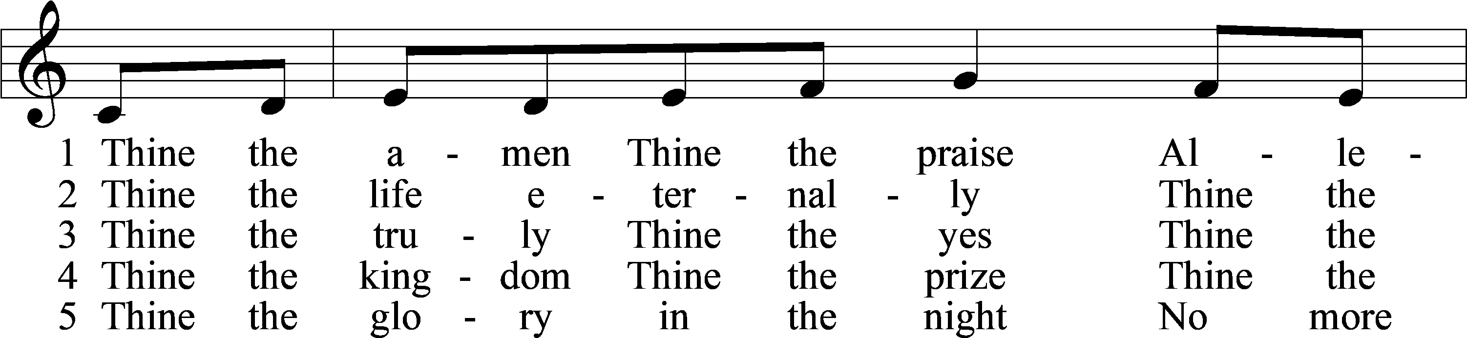
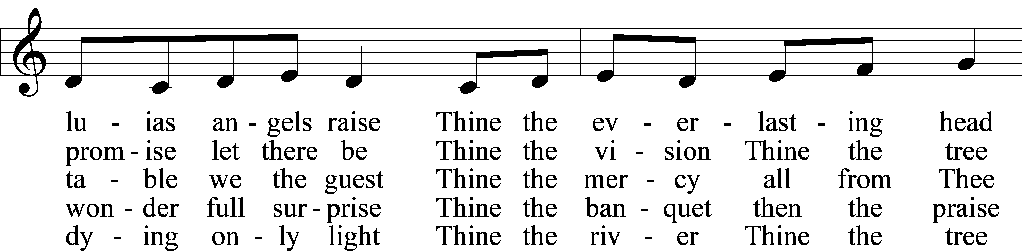
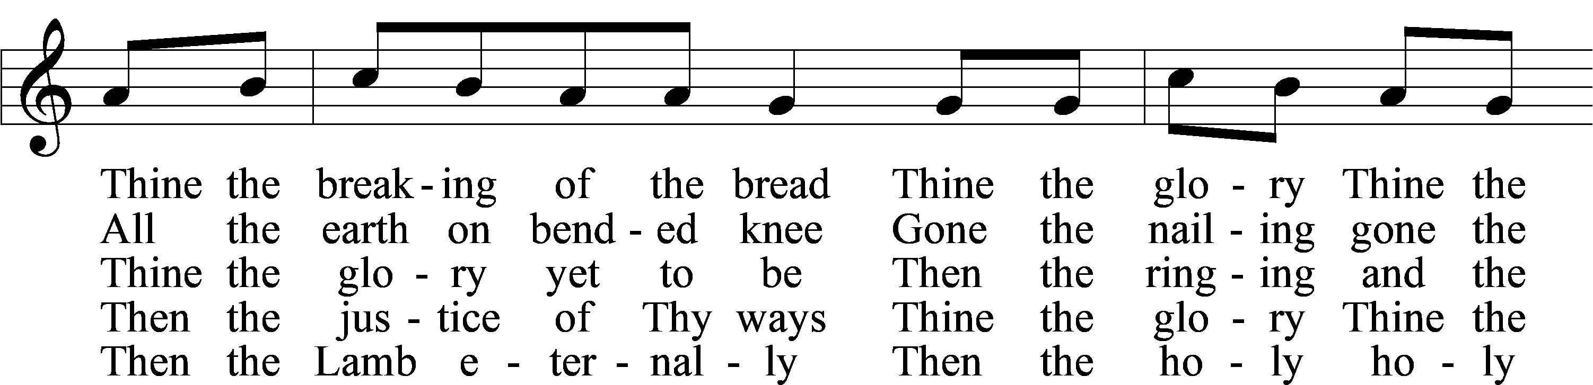
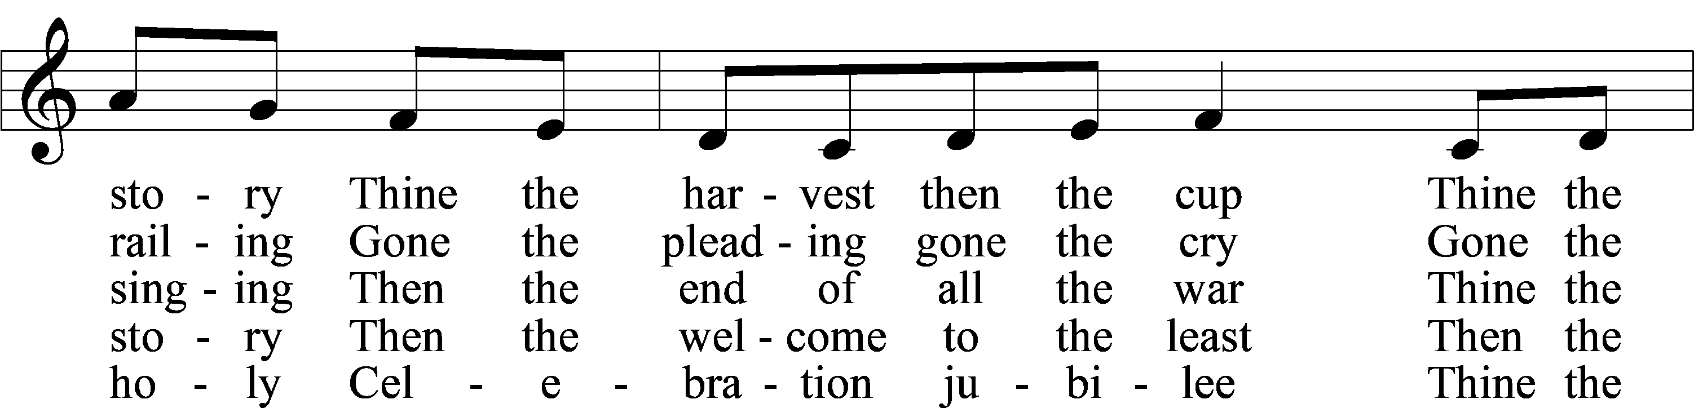
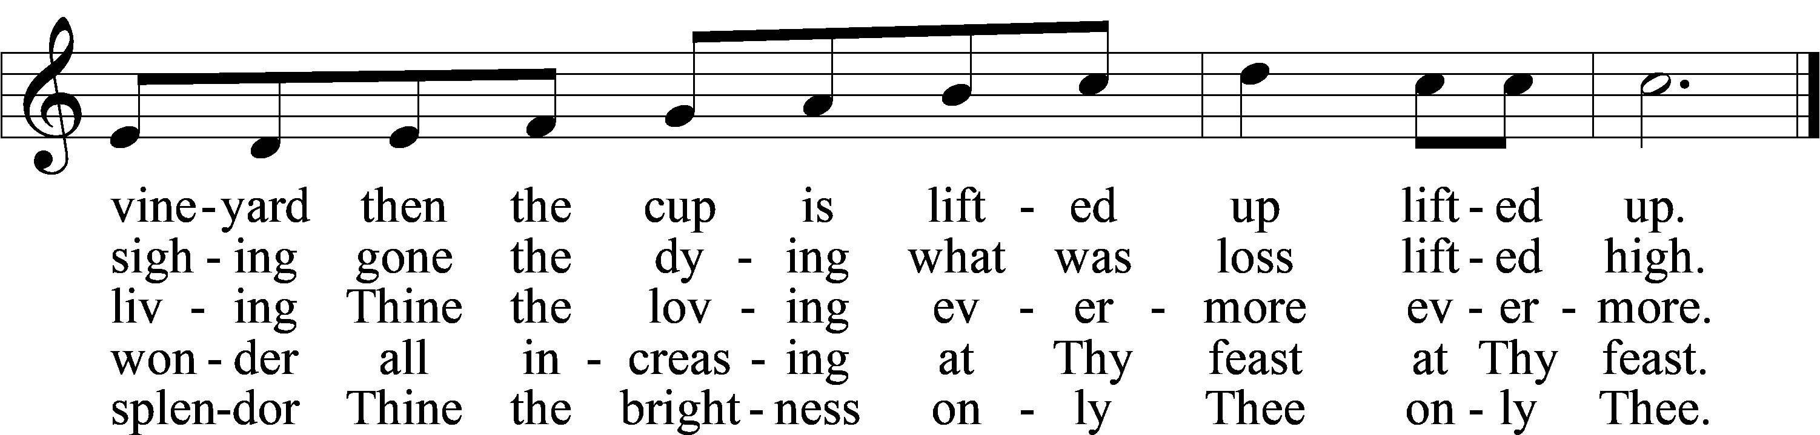
Text: Herbert F. Brokering, 1926–2009
Tune: Carl F. Schalk, 1929–2021
Text and tune: © 1983 Augsburg Publishing House. Used by permission: LSB Hymn License no. 110002769

632 O Jesus, Blessed Lord, to Thee
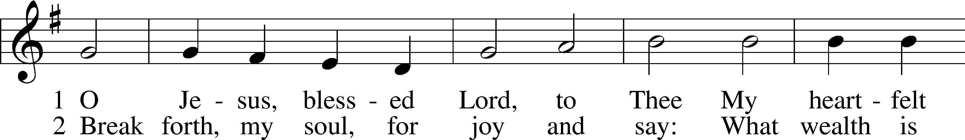
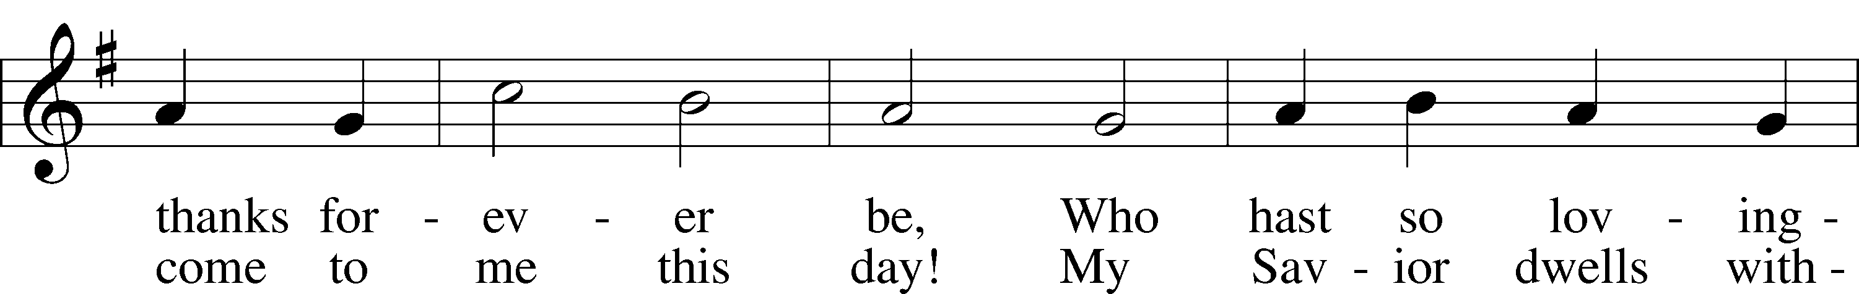
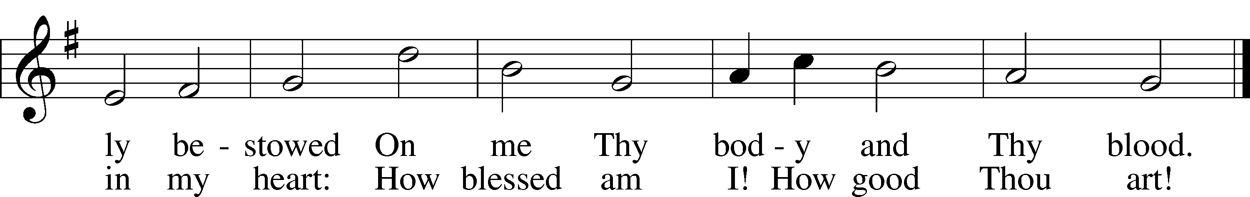
Text: Thomas Hansen Kingo, 1634–1703; tr. Arthur J. Mason, 1851–1928
Tune: Trente quatre Pseaumes de David, 1551, Geneva, ed. Louis Bourgeois
Text and tune: Public domain

Post-Communion Collect
A Let us pray.
We give thanks to You, almighty God, that You have refreshed us through this salutary gift, and we implore You that of Your mercy You would strengthen us through the same in faith toward You and in fervent love toward one another; through Jesus Christ, Your Son, our Lord, who lives and reigns with You and the Holy Spirit, one God, now and forever.
C Amen.

Benediction 202
P The Lord bless you and keep you.
The Lord make His face shine upon you and be gracious unto you.
The Lord lift up His countenance upon you and T give you peace.
C Amen.

924 Lord, Dismiss Us with Your Blessing
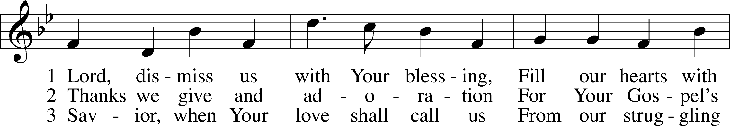
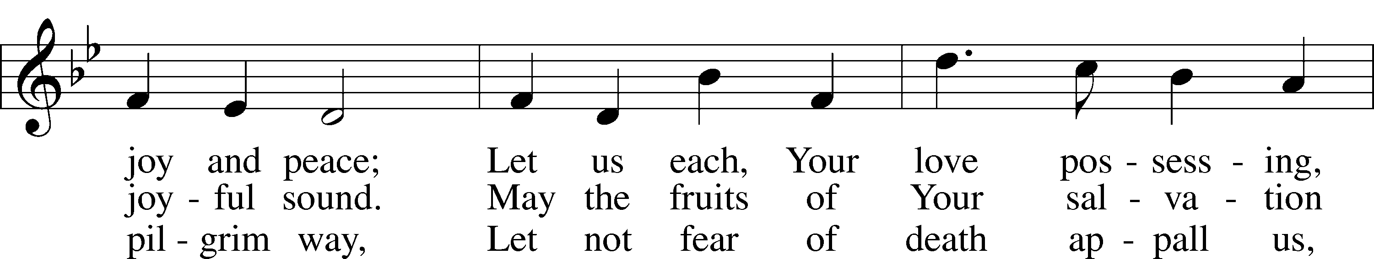
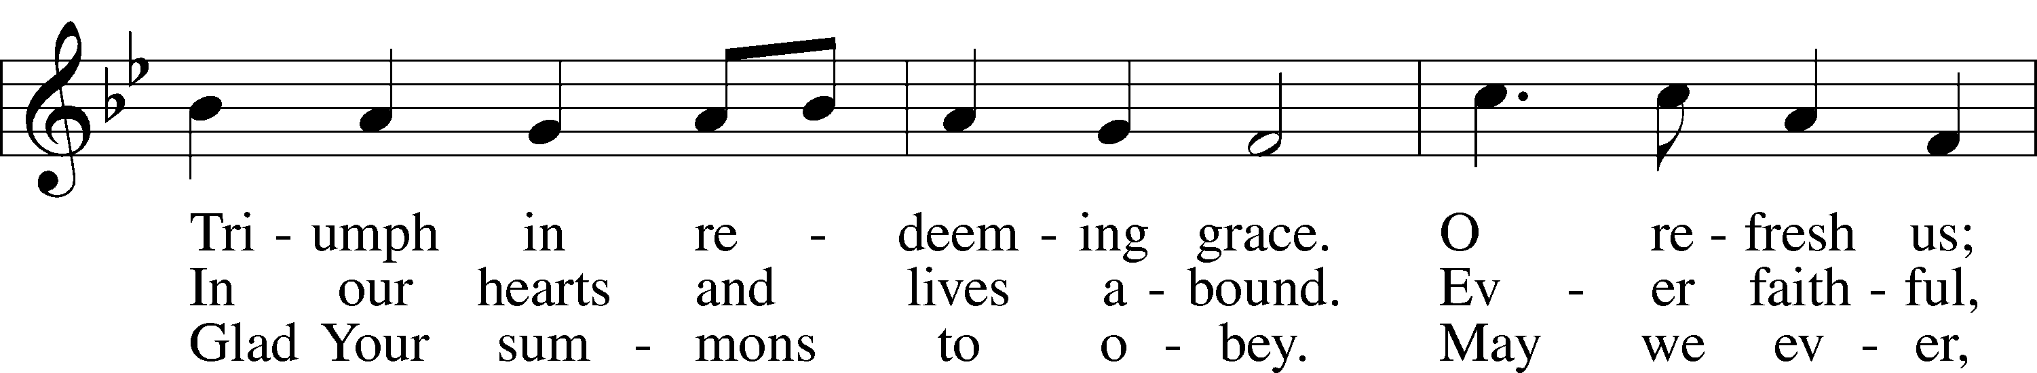
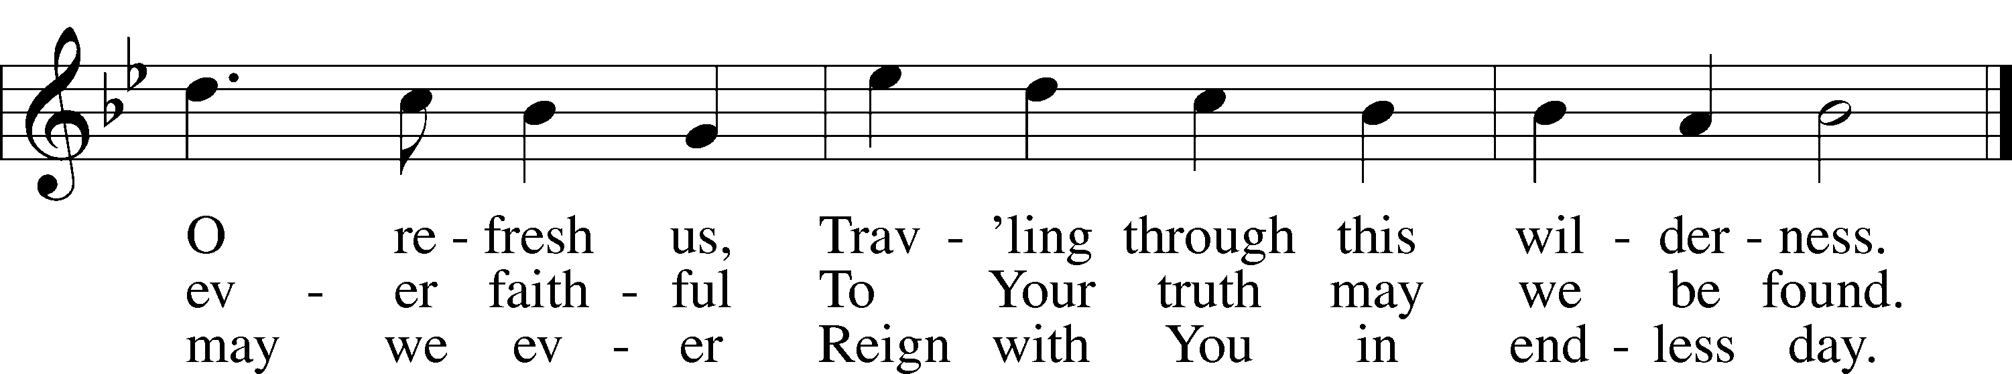
Text (sts. 1–2): attr. John Fawcett, 1740–1817, alt.; (st. 3): Godfrey Thring, 1823–1903, alt.
Tune: Henry T. Smart, 1813–79
Text and tune: Public domain

Postlude

Acknowledgments
Unless otherwise indicated, Scripture quotations are from the ESV® Bible (The Holy Bible, English Standard Version®), copyright © 2001 by Crossway, a publishing ministry of Good News Publishers. Used by permission. All rights reserved.
Created by Lutheran Service Builder © 2026 Concordia Publishing House.

