Christway Christian Church Missions 2021

Knowing Jesus…Making Him Known

“This is how God loved the world, He gave His Only Son, that whoever believes in Him will not perish, but will have eternal life”
John 3:16

“Go therefore and make disciples of all the nations, baptizing them in the Name of the Father and the Son and the Holy Spirit, teaching them to obey all that I commanded you; and I am with you always, to the end of the age.”
Matthew 28:19-20

Mission Team: Karen Barnes, Barry Clanton, Mack & Barbara Kitchens, Ginger Tucker

2021 Missions Supported
Bethshean Mexico Mission - $600.00 per month
- Cris Garcia, bethshean@gmail.com
- Abdiel and Shannon Rocha, shannoncolerocha@yahoo.com
Care Pregnancy Center (Augusta) - $200.00 per month
- Susan Swanson, Director, P. O. Box 1775, Augusta, GA 30903
Christian Arabic Service (Egypt) - $200.00 per month
- Safaa and Mona Fahmi, Directors, pences69@gmail.com
Reaching the Billions (China) - $400.00 per month
- David and Lynn Poling, davidpoling1@gmail.com
Christian Missionary Fellowship, Ethiopia - $400.00 each per month
- Travis and Emily Weeks, teweeks@cmfmissionary.org
- Aaron and Morganne Weeks, aaronweeks@cmfi.org
Pioneer Bible Translators, Tanzania, East Africa - $200.00 per month
- Tim and Erin MacSaveny, tim-erin.macsaveny@pbti.org
Project Kenya - $400.00 per month
- Tim and Terri Crane, teri@projectkenya.org
Daniel Barnes, ACTS (ARC International, www.arcint.net) - $400.00 per month
- Daniel Barnes, Daniel.j.barnes.14@gmail.com
Eden Ministries - $200.00 per month
- Kevin and Susan Fry, ian.fry@eden-ministries.org
iCare - $200.00 per month
- Ginger and Walt Amerson, ginger@i-care4.org
Good Neighbor Fund (Benevolence) - $200.00 per month
Emergency Response Fund -$200.00 per month
Bethshean Mexico Mission
We will continue to partnership with Cris Garcia and the mission work in Mexico. Cris has been serving in Mexico for over 45 years. The mission has planted several churches (a total of 7 to date), built a medical clinic, built a home for elderly people, established a Christian camp, and been very involved in the training of ministers to serve in the churches.
Some of their goals:
- Complete the construction of a new church in Villa Gonzalez
- Secure permission to open the medical clinic
- Hire a full-time nurse for the clinic
- Find funding for two new ministers
- Conducting VBS; Retreats for Men and Women
- Continue to grow the Bible College. They are meeting in temporary facilities. They have property and hope to build classrooms and offices soon for a more permanent campus.
- Continue to groom Abdiel Rocha to serve as the Director of Bethshean.

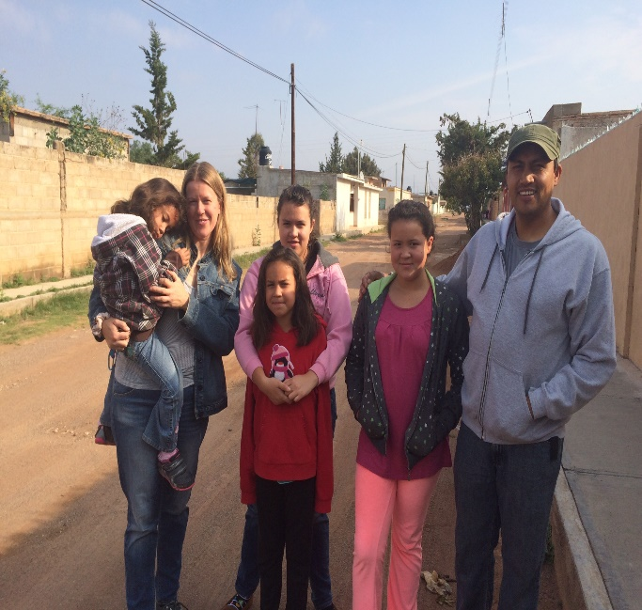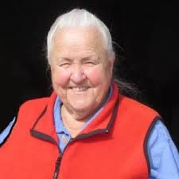
Abdiel and Shannon & family Cris Garcia, Director

Care Pregnancy Center of Augusta
CPC has been serving the area for many years with new focus: Being the voice of reason and hope for unborn children. Through the efforts of CPC, many babies have been saved. In addition to counseling expecting mothers, parenting classes are offered. CPC provides additional support by providing items that new born babies need. They provide guidance on healthy relationship. This ministry is equally caring about both mother and child. CPC has three locations: Augusta, Martinez, and Waynesboro. They are always looking for volunteers at the Center.

Goals for 2018
- Closing of the Abortion Clinic off Davis Road
- Support and enact our new program, Girl’s Hope for Their Future, for young women who have experienced abuse as a child
- Expanding the teaching of Abstinence until marriage throughout this area using curriculum from A&M Partnership.

Christian Arabic Services
Located in Cairo, Egypt, Safaa and his wife Mona, serve as Director or CAS. This work started in 2003. The emphasis is to teach and train leaders who will in turn lead congregations in the ways of the Lord. Much of what they do is done in a hostile religious and government environment. Since starting in 2003, thousands of church leaders have been trained in New Testament principles. Under their teaching, over 220 churches are now practicing weekly observance of the Lord’s Supper. One entire denomination is dissolving and restoring as a New Testament pattern of worship and baptism. Since this mission has started, they have partnered with Hope International University (Fullerton, California) establishing 14 campus branches in Egypt and Sudan. Plans are currently underway to establish a branch campus in Lebanon. Many from surrounding Countries in Africa come to one of these campuses for training. In addition to training ministers, Safaa is deeply involved in translating Bible training aids for minister.
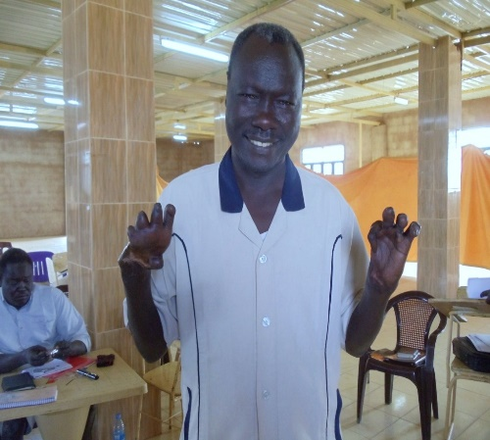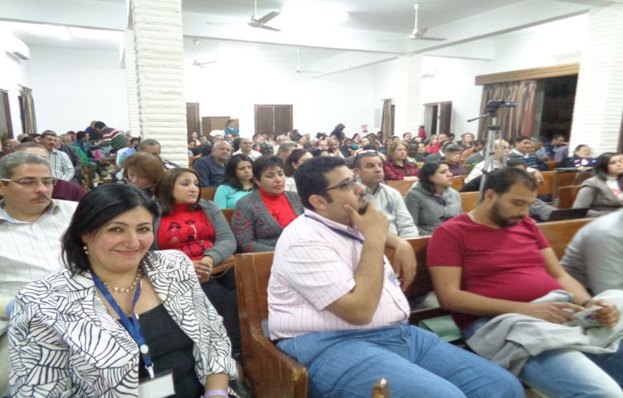
Abraham – Sudan Minister Christians in Cairo 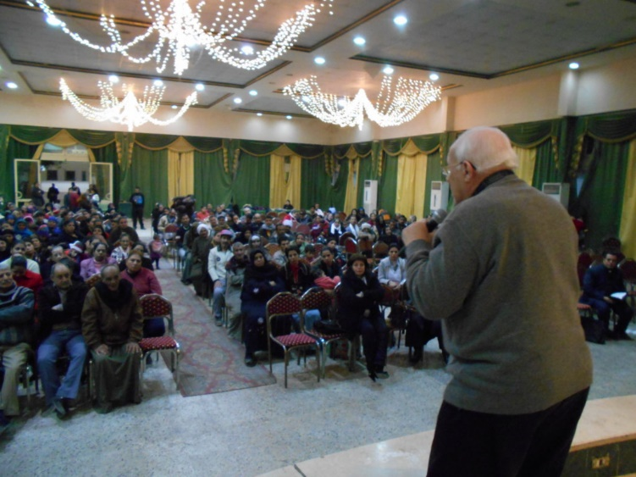
Safaa Preaching

Reaching the Billions

David and Lynn Poling have been serving as Missionaries to China since 1979. They have set up a campus for training in Hong Kong. Their primary mission is the Chinese Christian Seminary in Hong Kong. From there, they have trained thousands of leaders, many of whom have come from the Mainland and have gone back to be house church leaders. So much of what is being done on the Mainland of China, must be done “under the radar” of the government. Many of their students have move to other countries to serve. Some are in Canada and some are serving in the Middle East. According to official Republic of China law, no children are to be in church until they are 18 years old.
They also work with a leper village and drug de-tox center.
David and Lynn have three adopted Chinese sons, Isaac, Nathan and Samuel.

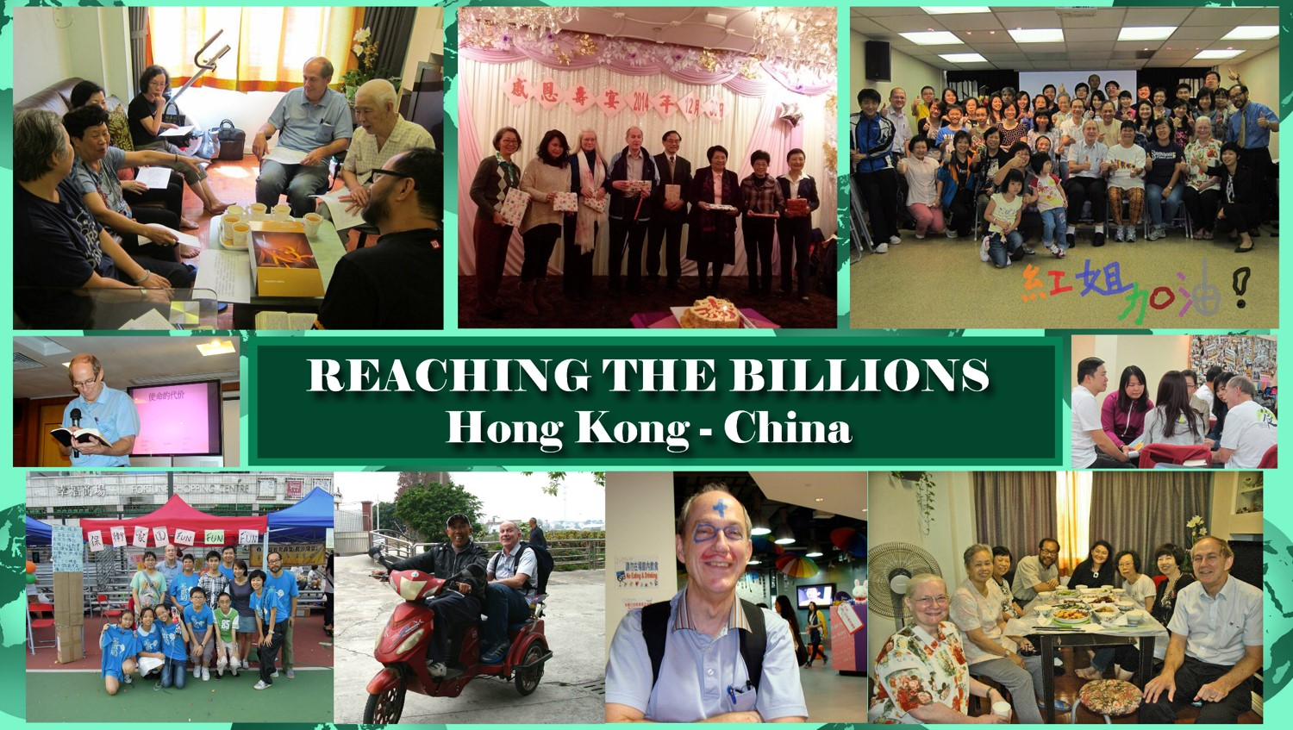

Travis and Emily Weeks
Travis and Emily Weeks are serving as missionaries in Ethiopia, Africa under the guidance of Christian Missionary Fellowship. Travis and Emily grew up in Savannah, Georgia and were active members of Savannah Christian Church (Now Compassion Christian Church). Emily graduated from Atlanta Christian College (Point University) and Travis from Milligan College. Both then graduated from Emmanuel Christian Seminary. They have two daughters, Clare and Charley. They have been in Ethiopia for about three years planting churches in remote areas of Ethiopia. We are thankful to partner with Travis and Emily.
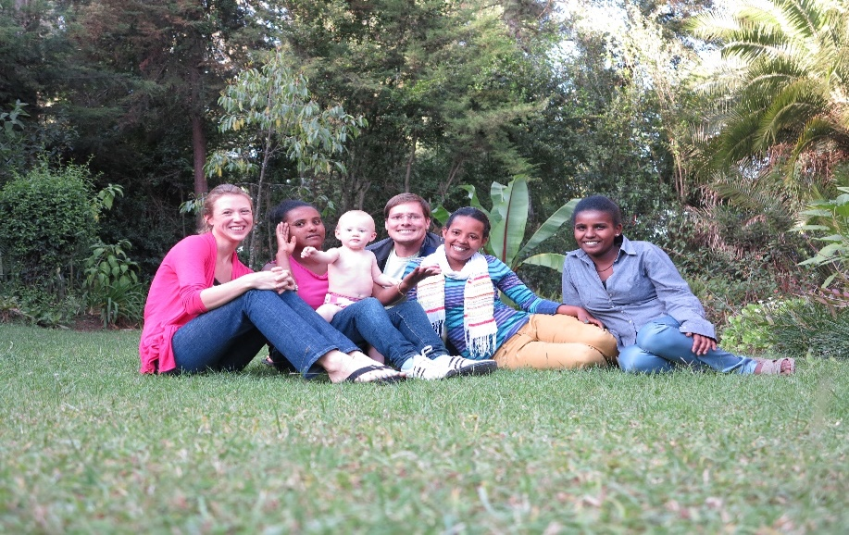 Travis, Emily & Clare with girls from Ethiopia.
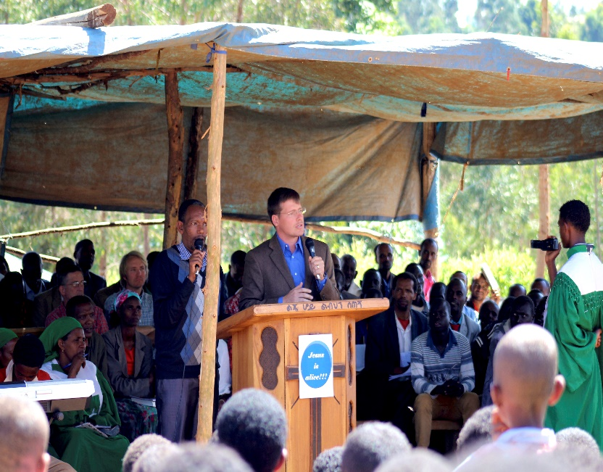 Travis preaching through a translator.

Aaron and Morganne Weeks
Aaron and Morganne are preparing to join the Church Catalyst team in Ethiopia.
Aaron earned his bachelor’s degree and his MBA at Milligan College in Tennessee. His primary role on the team will be working with Income Generating Activities to encourage and support CMF’s national church partner to stand and expand on its own.
Morganne graduated from Lee University, Cleveland, Tenn., and earned her master’s degree to become a physician assistant at South University, Savannah, Ga. She has been practicing outpatient pediatrics since 2013.
Aaron and Morganne grew up in Savannah and were married in 2008. They felt God’s call towards missions after several short-term mission trips. During college, Morganne served with CMF on a REACH internship in Tanzania.
Aaron and Morganne are excited to be able to use the skills that God has given them to serve cross-culturally in Ethiopia.
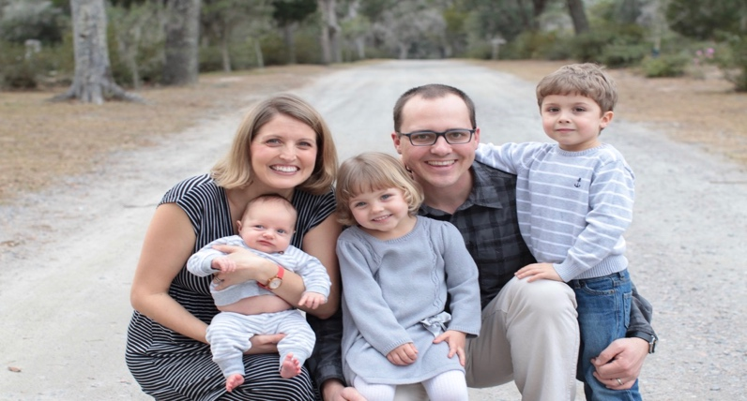
They have three children: Elijah (2013), Anna (2015) and James (2018).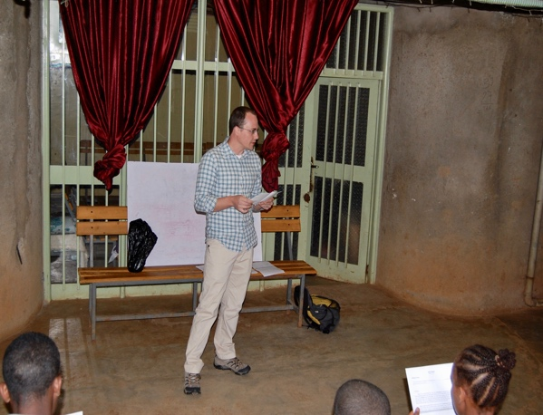 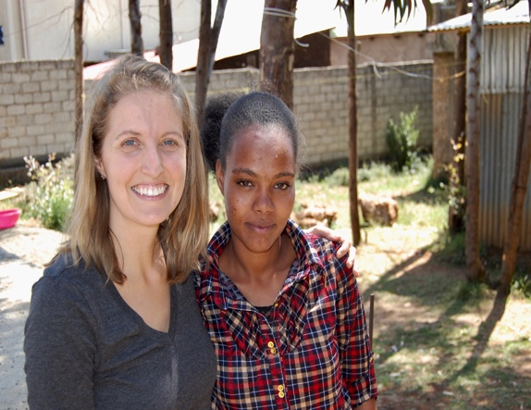

Pioneer Bible Translators
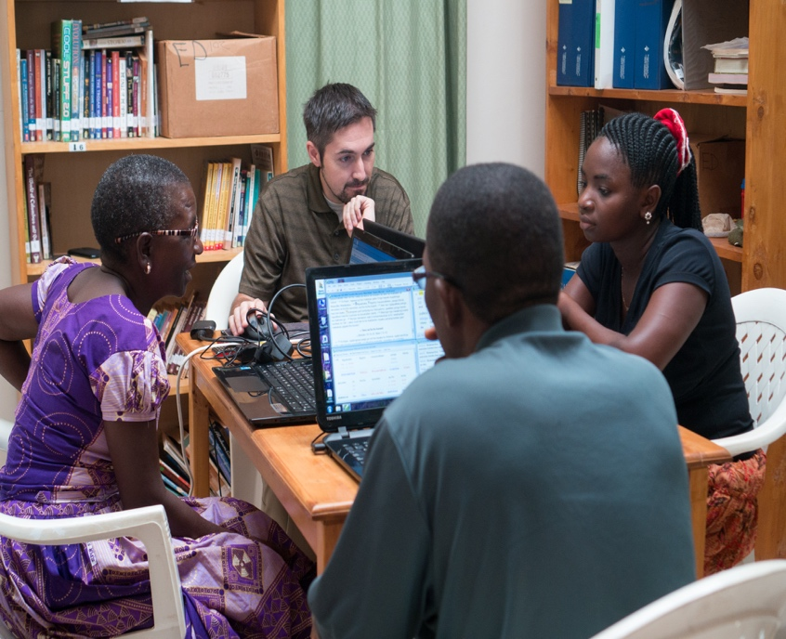
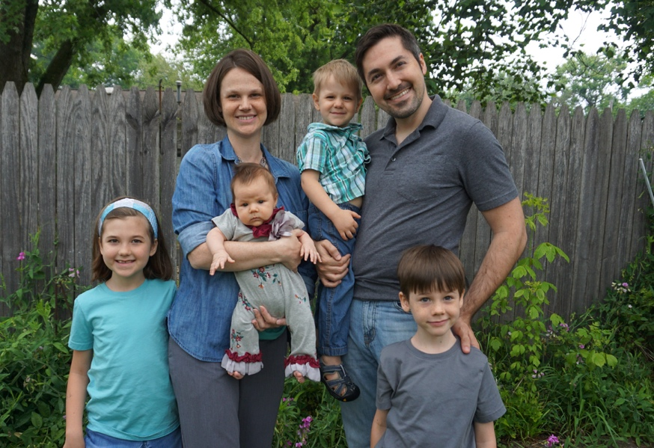

Tim and Erin MacSaveny are serving with Pioneer Bible Translators. They are serving in Tanzania, Africa. One of the amazing things is to hear (read) the Word of God in your own language. Tim and Erin are both Graduates of Johnson University and have been serving with Pioneer Bible Translators since their graduation. They are working on the Gospels of John, Luke and the Book of Acts. They are translating these books into seven different languages spoken in Tanzania. Tim and Erin have four children.

Project Kenya
Project Kenya is a mission work in Nyeri, Kenya. Tim and Teri Hudson lead in this work among the Kenyans. They minister with multiple programs. Project Kenya started with a “feeding program” to provide food for children and families. This has grown to multiple “feeding sites” in and around Nyeri. They have a child sponsor program by which you can sponsor a child for $25.00 per month. This program will help provide daily food and education for a child. Currently, Project Kenya is looking for property to provide a safe space for abused children. Project Kenya is assisting in the planting of new churches in Kenya. The latest area is in Kitale, near the Uganda border. They are providing resources for a Bible College to train Pastors. Project Kenya is very involved with CHE (Community Health Evangelism) training. CHE training helps Kenyans learn a trade to provide for themselves and their families.
2018 Goals:
- Sponsor a Bible Camp for all the sponsored children in April
- Offer short-term mission opportunities for teaching and medical needs
- Increase the feeding budget and open more sites
- Provide more water filters to poverty areas at the cost of $60.00 each
- Continued partnership with local churches and new Church plants
- CHE training
2019 Goals:
- Open a Medical Clinic
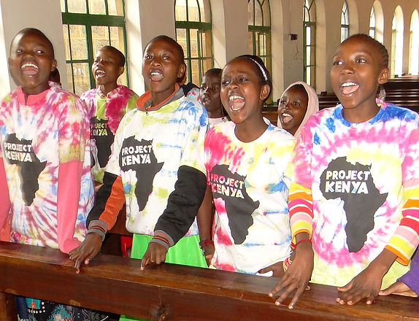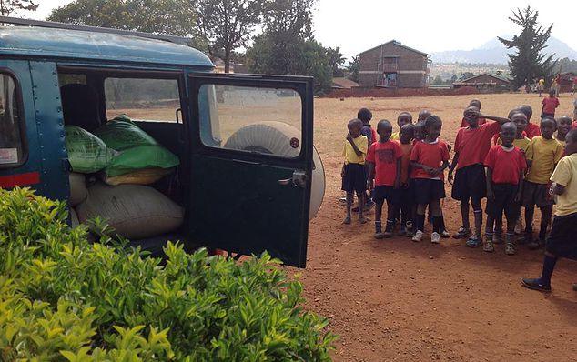

ARC INTERNATIONAL
Daniel Barnes serves as a part of ARC International in Eurasia. He is a graduate of Texas A&M University and has been serving there since late 2020. ARC is a group that supports the local church and mobilizes individuals into the surrounding region. For more information see arcint.net.
I have been on a journey since December 2nd, 2017 towards a call to International Missions. God has been setting me up to do this my whole life and made me aware of it then. In the last year and a half, the Holy Spirt has been working in my life to prepare me for this calling. It appears to me like the blinders are off and I can see clearly for the first time in my life. A major step in this journey was the trip that I took to South Africa in August 2018. This trip taught me a great deal about the form a true calling to mission work can take, and the Lord revealed a great number of important truths to me on that trip.

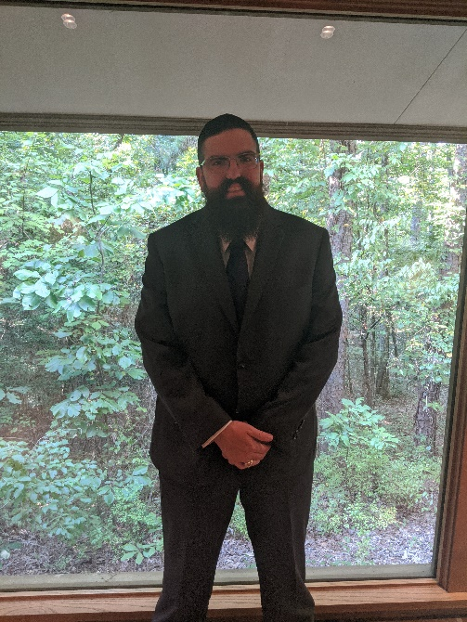

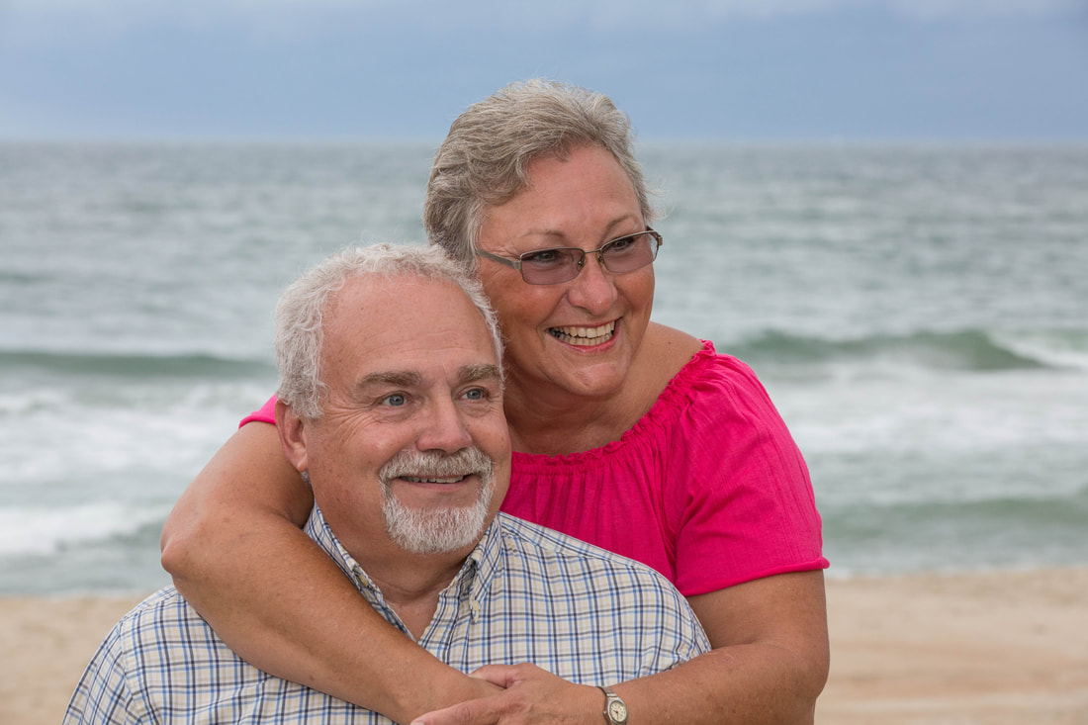

Kevin and Susan Fry
Founders and Directors of Eden Ministries Inc. and Eden Children's Village
Kevin and Susan founded Eden Ministries as Goshen Christian Church African Ministries in 1998. Eden has grown and blossomed much faster into the large undertaking that they originally envisioned, but we’ve yet to realize all God had in His mind from the beginning! We took in our first child in 2000 and have had the honor of caring for 250 total up to this current time. If you’d like to read the whole story, please visit our much more detailed description HERE! Kevin and Susan spend 8 months in Zimbabwe and 4 months traveling and raising funds for the orphanage each year. We are all delighted to join them in the calling and tremendous blessing of following God’s call to love Him through caring for orphans, widows and lost souls across the globe.

www.icareforthevoiceless.org

Who We Are
iCare serves women and children who are victimized, exploited and trafficked by sexual exploitation as well as those who are at risk of being victimized. We step in to raise awareness in the community to educate and equip youth, organizations and churches. We serve through a three-pronged approach of prevention, intervention and restoration.

Our Mission

iCare’s mission is to glorify God by serving those who are being exploited and oppressed by means of commercial sexual exploitations.

Our Vision
To see a community, state, nation, and a world where children are valued and protected: celebrated for their God given talents and abilities and treasured as Priceless handiworks of their Maker.

Good Neighbor Fund
We want to be ready to help those in need. We have needs every year for those who are going through some difficult times and they need help. We often have requests for help with rent, food, and utilities. We believe in helping those we can with special gifts and gracious counseling. One of the marks of the Church is sharing to meet needs of the Believers. (Acts 2:43-45) We will set aside an amount each month to be ready to help in times of need.

Special Response Fund
Each year we normally have requests for help. It may be for weather related relief or for unforeseen tragedies. For example, in 2016, we responded to a minister and his family in Mexico involved in an automobile accident. We also responded through I.D.E.S. (International Disaster Emergency Services) to help families affected by Hurricane Matthew. Normally we come to you for a “love” offering to help minister in such times. In addition to those requests, we also want to be ready to help those who might go on a short missionary journey. In 2016, we were blessed to help a young couple go to Haiti and serve for 10 days. By setting aside $200.00 each month, we will have funds to respond when such requests come. While this amount may not be sufficient for all requests, it will hopefully go a long way.

Food Panty
While the Food Panty is funded with designated donations, I think it fits well in our booklet about missions, benevolence and outreach. We are truly blessed to have such a wonderful ministry at Christway that meets the needs of people in our community. Not only do we have the joy of providing food for our community, we have the wonderful opportunity talk and pray with them. The Food Panty is for anyone in our church or community.

