November
2021
Sunday | Monday | Tuesday | Wednesday | Thursday | Friday | Saturday
 | 1 | 2 | 3 | 4 | 5 | 6
 |  | Narcotics Anonymous, 7:00 p.m. | Handbells, 4:30 p.m.  Dinner’s on Us! 5:30 p.m.  Choir Practice, 7:00 p.m.
7 | 8 | 9 | 10 | 11 | 12 | 13
Daylight Savings Ends  All Saints Sunday and Communion Sunday  Worship @ Kemp,  9:30 a.m. |  | Ladies’ Luncheon @ Kemp UMC, noon  Narcotics Anonymous, 7:00 p.m. | Handbells, 4:30 p.m.  Choir Practice, 7:00 p.m. | Veterans Day
14 | 15 | 16 | 17 | 18 | 19 | 20
Worship @ Kemp,  9:30 a.m. |  | Narcotics Anonymous, 7:00 p.m. | Handbells, 4:30 p.m.  Choir Practice, 7:00 p.m. | Overbooked Book Club, @ Urban Homestead, 7:00 p.m.
21 | 22 | 23 | 24 | 25 | 26 | 27
Worship @ Kemp,  9:30 a.m.  Hanging of the Greens, following Worship  Charge Conference, @ Carmel UMC, 3 p.m. |  | Kemp Leadership Board Meeting, 6:00 p.m., Kemp Parlor  Narcotics Anonymous, 7:00 p.m. |  | 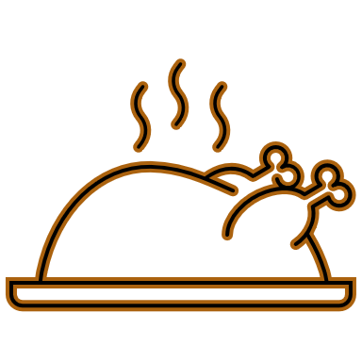  Happy Thanksgiving!
28 | 29 | 30
Worship @ Kemp,  9:30 a.m. |  |  | .

