Dear [Sponsor’s Name],

I have signed up for the A21 Freedom Run, partnering with Daybreak Church, on June 11 to help raise funds for the A21 Campaign. A21 is a Christian-based, international organization. Their mission is to abolish slavery and human trafficking around the world. You can find out more by visiting A21.org.

While we are actively raising funds for this great organization, we need your help to make our efforts go even further! You can help us raise funds so that we can help stop human trafficking, and your support is crucial in these efforts.
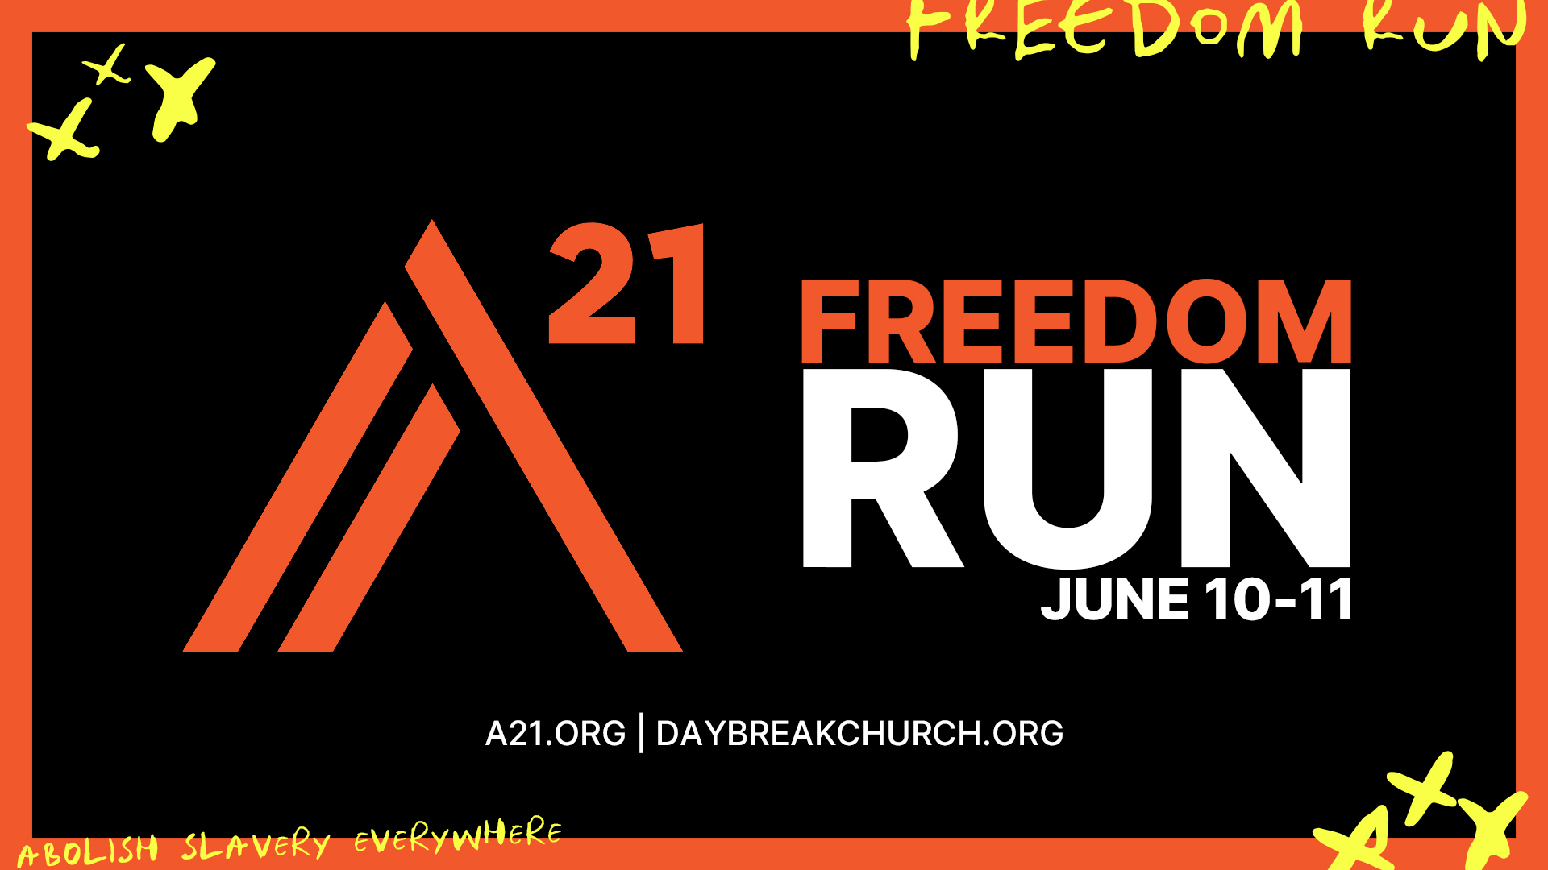
If you are able, I would love it if you could make a donation to help achieve my goal of raising $1,000 for this great cause. Altogether we are looking to raise $100,000, in total, for A21 during the Freedom Run.

Thank you in advance for your contribution. Your donation will help save lives and allow people to hear the message of Jesus

You can make a donation by:
-Check payable to Daybreak Church and “Freedom Run” and “my name” in the memo
-Visiting daybreakchurch.org/freedomrun and click “Donate Here”

If you have any questions at all, you can email Daybreak Church at info@daybreakchurch.org

Thank you again!
Sincerely,
[Fundraiser’s Name]

Daybreak Church 6515 Ambrosia Lane Carlsbad, CA 92011 | Daybreakchurch.org

