
During the summer of 2025, our small groups at Harvest Bible Chapel will be taking time to work through the “One Another” teachings of Scripture in conjunction with our Sunday sermon series. The phrase “one another” is used often in the New Testament in conjunction with commands for Christians on how they are to live out their faith in relationships with others. These teachings are redemptive instruction for an important area of our lives that have been hindered by the fall of man in Genesis 3. Ever since sin entered our world, relationships have been complicated by selfishness, pride, conflict, and much more. Thankfully, God speaks richly into our brokenness and gives us hope in the grace he provides through his Son and Spirit. Christians are not enslaved to sin but can live a new life in Christ! There is much to learn about putting off the old self when it comes to relational sin and putting on a new, redemptive way of interacting in Christ.
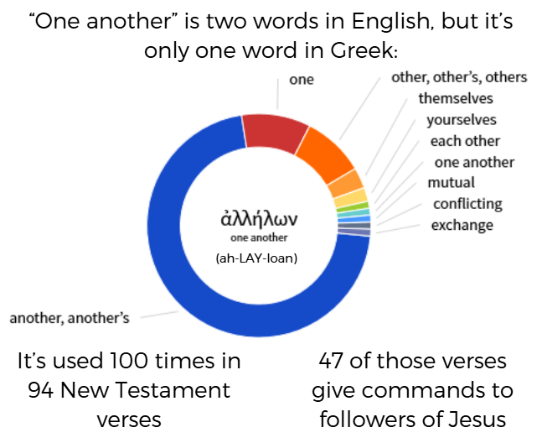
Goals
The goals of this study are fourfold:
- Promote unity in the church body (Colossians 3:14; Ephesians 4:1-6; Romans 12:4-5)
- Grow individual hunger for God and His Word (1 Peter 2:2; Matthew 5:6; John 4:13-14)
- Deepen one’s understanding of God’s plan for their life (Ephesians 1:1-14; 2 Timothy 3:16-17)
- Call individuals to respond appropriately to God’s Word (Colossians 1:9-10; 2 Peter 1:3-11):
  - By glorifying God (Colossians 1:17; 3:23, 1 Corinthians 10:31)
  - By making disciples for Jesus (Matthew 28:19–20)
  - By growing in our love for God and love for others (Matthew 22:37-40)

Study Format
The main premise of this study is to ingest, meditate on, and apply God’s Word. The study is not meant to replace your regular time in God’s Word, but it will require some work outside of small group. The below format is meant to let the Word of God more deeply saturate your heart for the Sunday sermon, the small group meeting, and throughout the week.
There are three parts to the study each week:
- Prep-work: This section is ideally done before you hear the sermon on Sunday or before you come to small group each week. It will take at least one day of reading and studying the text outside of small group and Sunday morning, but you are welcome to spend more time here.
- Sermon: This is attentive listening and engagement with the Sunday sermon. Take time to write down notes, questions, and steps for personal application.
- Small Group Questions: Ultimately, this is the pulpit curriculum. These questions are aimed at sharing what you learned and then working on further understanding and application of the text with your SG. Questions are optional to be answered ahead of SG meeting time.
Study 1: Unity One Anothers
Prep-work
Prayer: Before beginning the study of God’s word, ask God to help you love him more, to give you wisdom for understanding his word, and then for ways to obey and trust his word today.
Read: Mark 9:50; John 6:43; Romans 12:16, 15:5, 15:7; 1 Corinthians 11:33; Galatians 5:15, 26; Ephesians 4:2, 32; Colossians 3:13; 1 Thessalonians 5:15; James 4:11, 5:9, 5:16
Examine: Look carefully at the passages to better understand what the author is trying to communicate. Ask and answer the following questions:
- What is the immediate context of each verse?
- Can you think of connections from each verse to the greater context of their book? Of the entire Bible?
- What are some practical ways you could live out the unity one anothers?

Summarize: If you were to restate the intent from these verses in one sentence, what would you say?

Share: Write how you would explain to someone else these one anothers connection to the gospel of Jesus Christ.

Sermon
Pay careful attention during the sermon and take notes along the way. Make sure to write down any additional questions or insights that you had during the message. Take time after the sermon to think through what things challenged and encouraged you and how to apply the truth of God’s Word to your life.

Small Group Questions
- What is one thing you learned from your prep-work that can help you in your relationship with others?

- What was one thing that encouraged you from the sermon? One thing that challenged you?

- Why do you think the unity one anothers were given to the church?
- What do the unity one anothers communicate that God values for his church?
- What are the dangers of Christians failing to live this way? What are the blessings of living this way?
- Share a personal story of how you have experienced someone living these out with you. How did it impact your life?
- Evaluate your own life based on these one anothers. Which are you consistently obeying? Which do you need to grow in?
- Discuss how your small group can live out these one anothers together.
Study 2: Humility One Anothers
Prep-work
Prayer: Before beginning the study of God’s word, ask God to help you love him more, to give you wisdom for understanding his word, and then for ways to obey and trust his word today.
Read: John 13:14; Romans 12:10, 16; Galatians 5:13; Ephesians 5:21; Philippians 2:3; 1 Peter 5:5
Examine: Look carefully at the passages to better understand what the author is trying to communicate. Ask and answer the following questions:
- What is the immediate context of each verse?
- Can you think of connections from each verse to the greater context of their book? Of the entire Bible?
- What are some practical ways you could live out the humility one anothers?

Summarize: If you were to restate the intent from these verses in one sentence, what would you say?

Share: Write how you would explain to someone else these one anothers connection to the gospel of Jesus Christ.

Sermon
Pay careful attention during the sermon and take notes along the way. Make sure to write down any additional questions or insights that you had during the message. Take time after the sermon to think through what things challenged and encouraged you and how to apply the truth of God’s Word to your life.

Small Group Questions
- What is one thing you learned from your prep-work that can help you in your relationship with others?

- What was one thing that encouraged you from the sermon? One thing that challenged you?

- Why do you think the humility one anothers were given to the church?
- What do the humility one anothers communicate that God values for his church?
- What are the dangers of Christians failing to live this way? What are the blessings of living this way?
- Share a personal story of how you have experienced someone living these out with you. How did it impact your life?
- Evaluate your own life based on these one anothers. Which are you consistently obeying? Which do you need to grow in?
- Discuss how your small group can live out these one anothers together.

Study 3: Love One Anothers
Prep-work
Prayer: Before beginning the study of God’s word, ask God to help you love him more, to give you wisdom for understanding his word, and then for ways to obey and trust his word today.
Read: John 13:34, 15:12, 15:17; Romans 12:10, 13:8; Galatians 5:13; Ephesians 4:2; 1 Thessalonians 3:12, 4:9; 1 Peter 1:22, 5:14; 1 John 3:11, 3:23, 4:7, 4:11; 2 John 5
Examine: Look carefully at the passages to better understand what the author is trying to communicate. Ask and answer the following questions:
- What is the immediate context of each verse?
- Can you think of connections from each verse to the greater context of their book? Of the entire Bible?
- What are some practical ways you could live out the love one anothers?

Summarize: If you were to restate the intent from these verses in one sentence, what would you say?

Share: Write how you would explain to someone else these one anothers connection to the gospel of Jesus Christ.

Sermon
Pay careful attention during the sermon and take notes along the way. Make sure to write down any additional questions or insights that you had during the message. Take time after the sermon to think through what things challenged and encouraged you and how to apply the truth of God’s Word to your life.

Small Group Questions
- What is one thing you learned from your prep-work that can help you in your relationship with others?

- What was one thing that encouraged you from the sermon? One thing that challenged you?

- Why do you think the love one anothers were given to the church?
- What do the love one anothers communicate that God values for his church?
- What are the dangers of Christians failing to live this way? What are the blessings of living this way?
- Share a personal story of how you have experienced someone living these out with you. How did it impact your life?
- Evaluate your own life based on these one anothers. Which are you consistently obeying? Which do you need to grow in?
- Discuss how your small group can live out these one anothers together.
Study 4: “Other” One Anothers
Prep-work
Prayer: Before beginning the study of God’s word, ask God to help you love him more, to give you wisdom for understanding his word, and then for ways to obey and trust his word today.
Read: Romans 14:13, 16:16; 1 Corinthians 7:5, 16:20; 2 Corinthians 13:12; Galatians 6:2; Ephesians 4:25; Colossians 3:9, 16; 1 Thessalonians 4:18, 5:11; Hebrews 10:24; James 5:16; 1 Peter 4:9
Examine: Look carefully at the passages to better understand what the author is trying to communicate. Ask and answer the following questions:
- What is the immediate context of each verse?
- Can you think of connections from each verse to the greater context of their book? Of the entire Bible?
- What are some practical ways you could live out the “other” one anothers?

Summarize: If you were to restate the intent from these verses in one sentence, what would you say?

Share: Write how you would explain to someone else these one anothers connection to the gospel of Jesus Christ.

Sermon
Pay careful attention during the sermon and take notes along the way. Make sure to write down any additional questions or insights that you had during the message. Take time after the sermon to think through what things challenged and encouraged you and how to apply the truth of God’s Word to your life.

Small Group Questions
- What is one thing you learned from your prep-work that can help you in your relationship with others?

- What was one thing that encouraged you from the sermon? One thing that challenged you?

- Why do you think the “other” one anothers were given to the church?
- What do the “other” one anothers communicate that God values for his church?
- What are the dangers of Christians failing to live this way? What are the blessings of living this way?
- Share a personal story of how you have experienced someone living these out with you. How did it impact your life?
- Evaluate your own life based on these one anothers. Which are you consistently obeying? Which do you need to grow in?
- Discuss how your small group can live out these one anothers together.

