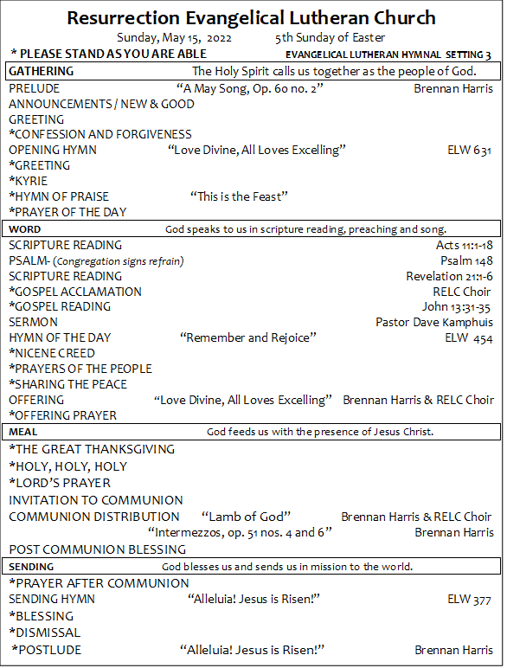

SERVING DURING WORSHIP TODAY

Presider: | Rev. David Kamphuis
Assisting Minister:  Lector: | RELC Youth  RELC Youth
Music: | Brennan Harris and RELC Choir
Media: | Charles Anderson, Chris Kibbe,  Todd Daniels, Dan Mushalko  Drew Nelsen, Kate Venable, Mike Tumeo
Ushers: | RELC Youth
Greeters: | RELC Youth

ANNOUNCEMENTS
- Ministry Coordinators: Guidelines for the Ministry Fair are now available. Renee Mushalko will be distributing them this month, so see her if you want yours before she gets to your group. Forms can be returned any time, but no later than August 1st. See Renee Mushalko or Pastor Dave for more info.
- 30 Hour Famine: RELC youth are participating in the 30 Hour Famine again this year and will then help with worship on May 15th. Their goal with the 30 Hour Famine is to raise $240 to feed one child for 6 months. Here is the link for online donation! https://30hourfamine.worldvision.org/team/RELCYouthGroup
- RELC Book Club 5/17 @ 7pm: Book club will meet in Room 7C to discuss “Book of Lost Names” by Kristen Harmel and then take a couple months off for summer.
- Planting Day 5/21 @ 9am: Please come help the Giving Garden start planting.
- First English Dinner 5/26: We need cookie donations for this meal! Please bring any cookie donations to the church office or kitchen by noon on May 25th. Your next options to help prep or serve a meal for First English Lutheran Church will be in June or July. Reach out to Carol Williams with questions or cookie donations.
- Don’t forget to to send pictures to the church office@RELC.org Pictures of events or fellowship at RELC are always welcome for the website, socail media or the newsletter. Last call for directory pictures!

This Week at RELC
Sunday 5/15 |  | High School Youth Group 30 Hour Famine
 | 8:30-9am | RELC Choir rehearsal (WLC)
 | 9:00 am | Sunday School (Godly Play, Youth -gr 4-7 & Adult only)
 | 10:00 am | Worship (WLC)
 | 11:15 am | Q & A with Pastor Dave and Dan (WLC)
Monday 5/16 | 4:30 pm | BOLD (parking lot)
Tuesday 5/17 | 11:00 am | Bible Study (narthex)
 | 6:00 pm | Cubs Den Meeting
 | 7:00 pm | Communication Meeting (office)
 | 7:00 pm | RELC Book Club (Room 7C)
Wednesday 5/18 | 7:00 pm | Boy Scout Troop 672 Meeting
 | 7:00 pm | RELC Choir rehearsal (choir room)
Thursday 5/19 | 7:00 pm | Bible Study (Zoom)
Friday 5/20 |  | Boy Scout Pack 789 Cookout (backlot and side yard)
Saturday 5/21 | 9:00 am | Giving Garden Planting Day (outside, garden)
 | 9:30 am | BOLD prep (Rooms 6 & 7)

WELCOME
This is Christ's church.
There is a place for you here.
Our Mission is to…
WELCOME All. TELL The Story. GROW As Disciples.

3500 Main Street Hilliard, Ohio 43026
(614) 876-7926 mailto:office@relc.org
http://www.relc.org
Like us on Facebook @relc.hilliard
Follow us on Instagram @relc.hilliard
Subscribe to Youtube to watch previous services

Staff Contact Information
Rev. David Kamphuis, Pastor
pastordave@relc.org cell: 616-745-7788 office: 614-876-7926

Brennan Harris, Director of Music
Brennan.harris@relc.org cell: 917-972-3607

Katherine Hunt, RELC Office
office@relc.org 614-876-7926 (M-F 10-2)

