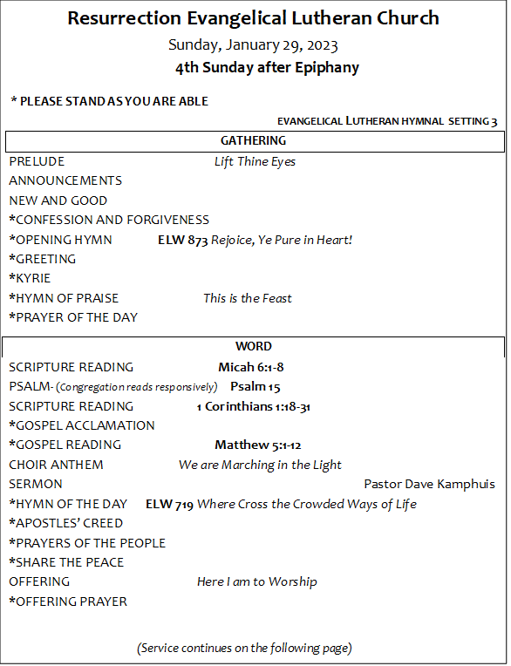



***Serving During Worship Today***

*Assisting Minister -Candy Franz*

*Lector -Melanie Anderson*

*Music – Jae Hyeong Park and RELC Choir*

*Ushers -Nancy Bryner &*

*Greeters –*

*Media – Charles Anderson, Chris Kibbe, Todd Daniels, Dan Mushalko,*

*Drew Nelsen, Kate Venable, Drew Dittmer, Mike Rossetti, and Mike Tumeo*

**This Week at RELC**

|  |  |  |
| --- | --- | --- |
| **Sunday 1/29** | 8:30 am | Choir Rehearsal (WLC/ Choir Room) |
|  | 9:00 am | Sunday School Classes -Adult Godly Play and Youth |
|  | 10:00 am | **Worship (WLC)** |
|  | 11:15 am | Q & A with Pastor Dave and Dan (WLC) |
| **Monday 1/30** | 5:30 pm | BOLD Food Pantry (parking lot) |
|  | 5-9 pm | Darby Winter Guard practice (WLC) |
| **Tuesday 1/31** | 11:00 am | Bible Study (narthex) |
|  | 7:00 pm | Cub Scout 672 Den Meeting (WLC/Classrooms) |
| **Wednesday 2/1** | 10:30 am | Staff Meeting (office) |
|  | 7:00 pm | Boy Scout Troop 672 Meeting (WLC/ classrooms) |
|  | 7:00 pm | Choir Rehearsals (Choir Room) |
| **Thursday 2/2** | 5-9 pm | Darby Winter Guard practice (WLC) |
|  | 7:00 pm | Bible Study (Zoom) |
|  | 7:00 pm | Boy Scout Leader Meeting |
| **Friday 2/3** | 5-9 pm | Darby Winter Guard practice (WLC) |
| **Saturday 2/4** | 9:30 am | BOLD Prep (Rooms 6 & 7) |
|  | 1-4 pm | Private Event (WLC) |

**ANNOUNCEMENTS**

* **New Offering Envelopes should be available by mid February.**
* **Youth Stromboli Sale -** Orders will be ready for pick up Feb. 5th.
* **Youth Group Valentine’s Mystery Lunch 2/5 after worship service.**
* **OCC is planning out the year and collecting Washcloths this month still.**
* **Men’s Fella-ship Breakfast 2/11 Saturday at 8:30 am. -**All Men welcome.
* **Join the RELC Lunch Ladies for a Sentimental Saturday meal at York Steak House on Broad Street –**Please RSVP to office 614-876-7926 or email for a proper count. (We will meet there at York Steak House, 4220 W Broad St, Columbus, OH 43228)
* **Church Directory-** Have you updated your families address and phone number? Please reach out to the [office@relc.org](mailto:office@relc.org) or 614-876-7926 to update information so we can have an updated Church Directory in March! Starting Ash Wednesday we will have pages out in the lobby to check for two weeks and then the updated 2023 version will be released in March. Please email new info or missing pictures to office.
* **RELC Book Club update -**April book has been changed to *The Dress Shop on King Street* by Ashley Clark. We are no longer doing *The Sound of Wings* due to limited supplies. Stay tuned, but February Book Club meeting will take place after Shrove Tuesday Pancake Dinner. February book is still *The Goodbye Quilt*.
* **Please make sure every Ministry sends event dates for the new year to the office ASAP!** We want to make sure we keep the calendar and the congregation updated.

**Here is an Epiphany Blessing you can do at home! Just grab a piece of chalk.**

