Forgiveness in our culture it’s not a popular concept. Why should I forgive someone? You don’t understand what they did to me. If you only knew, you would never forgive them either. Forgiveness has literally become a curse word. But what does God have to say about forgiveness? Why does God forgive sin? Why is it so important to forgive people? Let's explore what God's word has to say about forgiveness.

A Story about Forgiveness

21 Then Peter came to him and asked, “Lord, how often should I forgive someone who sins against me? Seven times?” 22 “No, not seven times,” Jesus replied, “but seventy times seven! 23 “Therefore, the Kingdom of Heaven can be compared to a king who decided to bring his accounts up to date with servants who had borrowed money from him. 24 In the process, one of his debtors was brought in who owed him millions of dollars. 25 He couldn’t pay, so his master ordered that he be sold—along with his wife, his children, and everything he owned—to pay the debt. 26 “But the man fell down before his master and begged him, ‘Please, be patient with me, and I will pay it all.’ 27 Then his master was filled with pity for him, and he released him and forgave his debt. 28 “But when the man left the king, he went to a fellow servant who owed him a few thousand dollars. He grabbed him by the throat and demanded instant payment. 29 “His fellow servant fell down before him and begged for a little more time. ‘Be patient with me, and I will pay it,’ he pleaded. 30 But his creditor wouldn’t wait. He had the man arrested and put in prison until the debt could be paid in full.

31“When some of the other servants saw this, they were very upset. They went to the king and told him everything that had happened. 32 Then the king called in the man he had forgiven and said, ‘You evil servant! I forgave you that tremendous debt because you pleaded with me. 33 Shouldn’t you have mercy on your fellow servant, just as I had mercy on you?’ 34 Then the angry king sent the man to prison to be tortured until he had paid his entire debt. 35 “That’s what my heavenly Father will do to you if you refuse to forgive your brothers and sisters from your heart.”

- Matthew 18:21-35

Due to the amount of information on forgiveness this study will be broken into two studies. The first study deals with God’s forgiveness and the second study will deal with human forgiveness.

Part 1

What is Forgiveness?

How would you define forgiveness?

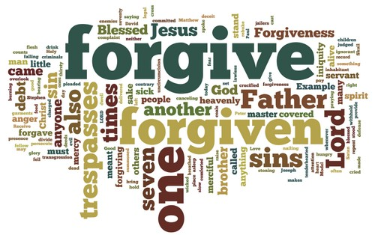

The dictionary defines forgiveness this way:

1. to grant relief from payment of

2. to cease to feel resentment against

God's forgiveness

Let's start by looking at God’s forgiveness because when it comes to forgiveness we will never understand why we need to forgive others until we understand God's forgiveness.

Why does God forgive us?

Why you believe God forgives us? Try to answer this question in the space below.

O Lord, you are so good, so ready to forgive, so full of unfailing love for all who ask for your help.

- Psalm 86:5

God forgives us because He loves us and because it is a part of His nature, it’s who He is, He wants to forgive us.

Sometimes we would like to think that God is willing to forgive us because we are such nice people. But that isn't the case. God forgives us because it is in His nature to forgive, and God does not change.

Read: Malachi 3:6 Put this verse in your own words.

It's a good thing that God's nature does not change or else we might not always be forgiven. But as long as we go to God and sincerely ask for God to forgive us He will. Read I John 1:9.

Does God forgive ALL sin?

"Just one more chance, please. It will never happen again." Have you ever heard yourself saying that to a parent or a teacher? Well, what about God, will He forgive you every time? Will He forgive all your sins?

Below is a list of sins. Write a Y (yes) or a N (no) beside each sin, noting whether or not you believe God will forgive that sin or not.

_____ lying _____ stealing

_____ hate _____ Witchcraft

_____ adultery/sex outside of marriage _____ laziness

_____ murder _____ cheating

_____ homosexuality _____ disobeying parents

“The LORD is slow to anger and filled with unfailing love, forgiving every kind of sin and rebellion. But he does not excuse the guilty.” - Numbers 14:18a

God is always willing and ready to forgive all sin every time. When you don't deserve a second chance, God will let you have one. That is how much He loves and cares about you. God will never give up on you. He longs for you, and delights in welcoming you back when you've blown it.

Read Luke 15: 11-32

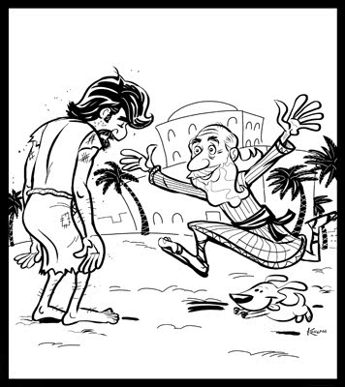
Jesus told this story to give you a picture of just how ready God is to forgive you. He's like that dad, standing on the porch, looking down the road for you - running toward you when He sees you coming. He doesn't forgive you because He has to. He forgives you because, like that dad, He loves you and what He wants more than anything else is to have you home with Him.

If God is going to forgive me anyway, does it really matter if I do wrong stuff?

True or False

____ Christianity is about getting away with as much as I can and still go to heaven

____ I can do whatever I want, because God will always forgive me

"Well then, should we keep on sinning so that God can show us more and more of his

wonderful grace? Of course not! Since we have died to sin, how can we continue to live in it?"

- Romans 6:1-2

Think about it this way. Let's say that you’re dating someone - exclusively. You expect them to be faithful to you, don’t you? Why? Because, that's the nature of your relationship. What if they weren't faithful and you confronted them? What if they looked sheepish and said, "Well I knew that you'd forgive me if I got caught anyway..." It wouldn't work, would it? Because it's about the relationship you have, not whether they got caught. It works that way in our relationship with God. Paul was answering this very question when he said, "Should we sin more so that we can receive more of God's grace?" NO CHANCE!!

Why do we need to confess and repent our sin?

If we claim we have no sin, we are only fooling ourselves and not living in the truth. But

if we confess our sins to him, he is faithful and just to forgive us our sins and to cleanse us from

all wickedness. - 1 John 1:8-9

In your own words define:

Confess _________________________________________________________________________

________________________________________________________________________________

Confession is an acknowledgement of sin or sinfulness, an admission of guilt

True confession involves a commitment not to continue to sin. We wouldn't be genuinely confessing our sins to God if we planned to commit a particular sin again and again. This is where repentance plays into forgiveness.

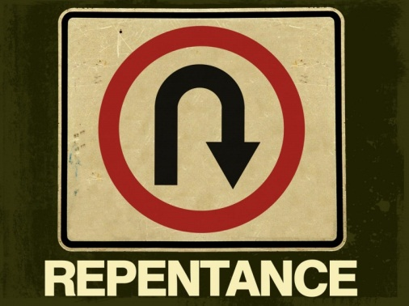
Define repentance:

Repent _______________________________________________________

_______________________________________________________

Repentance is to make a change for the better as a result of regret for one's sins. It is a 180 degree turn from your sins toward God and what He wants for your life. Does this mean that we won't make mistakes? No! However, with God's help we can become more pleasing to God.

Part II

Human Forgiveness

- Why should we forgive others?

- How many times do we need to forgive others?

- How can I forgive myself?

- Why do we need to confess and repent of the sins I do?

We must first seek God’s forgiveness, then seek the forgiveness from others, & then forgive ourselves.

Read Romans 12:21 “Don’t let evil get the best of you, but conquer evil by doing good.”

Rewrite this verse in your own words: _____________________________________________________________________________________

_____________________________________________________________________________________

Human forgiveness…

No sin is too great to be forgiven! Do you feel that you could never come close to God because you have done something terrible? God can and will forgive you of any sin. While God forgives us, however, He does not always erase the natural consequences of our sin.

Forgiveness is the mark of the Christian life. If we love someone the way God loves us, we will be willing to forgive them.

Forgiveness is an act of the will. Forgiveness involves both attitudes and actions. If you find it difficult to feel forgiving of those who have hurt you, try responding with kind actions. If appropriate, tell such people that you would like to heal your relationships. Give them a helping hand. Send them a gift. Smile at them. Many times you will discover that right actions lead to right feelings.

If we expect to be forgiven, we need to practice forgiveness. Jesus gives a startling warning about forgiveness. Reread Matt 18: 21-35. If I refuse to forgive others, God will also refuse to forgive me. Why?

_______________________________________________________________________________________

_______________________________________________________________________________________

Read & Write Out in your own words Matthew 6:14

_______________________________________________________________________________________

_______________________________________________________________________________________

How many times do we need to forgive others?___________

Read: Matthew 18:21 “Seventy times seven,” does it that mean we should keep track of how many times we forgive someone? What does 70 times 7 mean when it comes to forgiveness?

______________________________________________________________________________________

______________________________________________________________________________________

When we don’t forgive others, we are denying that we are all sinners in need of God’s forgiveness. God’s forgiveness of my sin is not the direct result of our forgiving others, but it is based on our realizing what forgiveness means.

It is easy to ask God for forgiveness, but difficult to grant it to others. Whenever we ask God to forgive us for sin, we should ask ourselves, have I forgiven the people who have wronged me?

Is there someone I should be forgiving? Can you think of one or two people?

Write their names below and a short description of what happened.

__________________________________________________________

__________________________________________________________

__________________________________________________________

Why haven’t I forgiven them?

___________________________________________________________

__________________________________________________________________________________________________

What must I do to forgive them right now?

__________________________________________________________________________________________________

__________________________________________________________________________________________________

Am I willing to tell them I have forgiven them? ___yes ___no.

Real forgiveness follows God’s pattern. Because God has forgiven all our sins, we should not withhold forgiveness from others. Realizing how completely Christ has forgiven us should produce a free and generous attitude of forgiveness toward others. When we don’t forgive others, we are setting ourselves outside and above Christ’s law of love.

