What is Prayer?
Prayer is when someone talks to God. Talking to God is like when you talking to a friend. When you pray you tell God about your day, how you feel and what’s on your mind. Prayer can also be something much more spiritual, like praising Him, singing to Him, or singing about Him. It can often be a worshipful experience, an expression by Christians of their appreciation for what God has done for them.

When you talk to your friends what do you generally talk about?
List 5 topics you and your friends are most likely to talk about.

1.
2.
3.
4.
5.

Do you think God would be interested in any of these topics? Why or why not?

How interested in you is God?

Read the following verses and write a brief summary for each...

Psalm 139: 17-18

Psalm 139: 14; Jeremiah 1:5

John 3:16 (reread this verse and this time put your name in for the word “the world”)

How much does God love you? (Write out a response to this question)...

If you love someone, you have a tendency to think about them all of the time. Now do you think, if someone loves you, and thinks about you all the time, and they were the reason you came into existence, don’t you think this person would want to talk to you?_ Yes or No. Why?

Ok, it’s important to talk to God. But what do I say, what do I talk about to God?
Read each of the following verses then write a short comment about what you think the verses are saying about praying to God.

- Philippians 4:6-7

- James 5:13

- II Thessalonians 3:2

- Ephesians 3:16

V. Will God hear me and does He really answer my prayers?

Read each of the following verses and then write a short comment about what you think the verses are saying about God answering prayers.

- Genesis 25:21

- Exodus 9: 29

- I Kings 8:28

- Psalms 6:8 - 9

- Matt 21:22

- Mark 11:24

VI. Is there a simple way to help me when I pray?

Think of the word ACTS. When you pray, try to remember each letter and what that letter stands for.

A stands for Adoration

We love God because He loves us. Thank Him for who He is and what He has done for you when He saved you. Praise Him! Center your life on God and everything else will fall into its proper place. He will guide you through times of trouble.

"Because Thy loving kindness is better than life, My lips will praise Thee." Psalms 63:3

C stands for confession.

You need to clear the air so to speak with God, each time you talk to Him. Don’t be afraid to tell Him everything. He already knows what you have done, thought and said, but He still wants you to confess your mistake, bad attitudes, wrong actions, etc., in other words your sins.

"If we claim to be without sin, we deceive ourselves and the truth is not in us. If we confess our sins, He is faithful and just and will forgive us our sins and purify us from all unrighteousness." I John 1:8-9

T stands for thanksgiving.

Are you a thankful person? Thanking God daily changes us from the inside out. We begin to act and think like God. This pleases Him.

"In everything give thanks, for this is the will of God in Christ Jesus concerning you." 1 Thess. 5:18

S stands for supplication.
Supplication is a fancy way of saying, “I want to let God know what I need and how I am feeling.”

Do not be anxious about anything, but in everything, by prayer and supplication, with thanksgiving, present your requests to God. Philippians 4:6
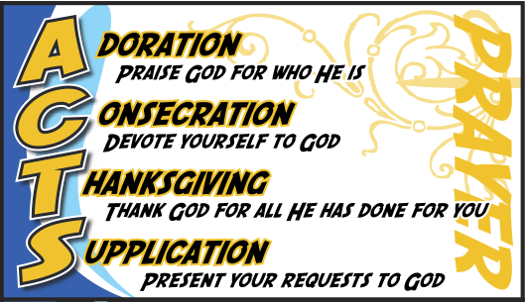

God may not give you what you want when you ask for it, but if you are truly open to His will your heart will be molded as you pray. Then finally you will be able to say...

“Not my will but Thy will be done”
Jesus Christ said this right before He was crucified.

VII. Why Pray?

Because God tells us to do it...

Because God answers prayers...

Because through prayer we get closer to God...

VIII. When should I pray?

Read I Thessalonians 5:17, if I should always be praying when should I start?

Right now would be a good time. Go through A.C.T.S. try it right now. How did it go? Could you think of something to say to God for each letter?

Ok, you are off to a good start. Now let’s keep it up. Fill out the following prayer commitment and then get started experiencing God in an exciting and fulfilling way.

----------------------------------------------------------------------------------------------------------------------------------------------------------------

MY PRAYER COMMITMENT

My goal is to spend _____ minutes in prayer each day.

The best time for me to pray is -

I will ask _____________________ (put a person’s name in here) to check up on me so I will be faithful in praying.

I plan to keep a list of things I am praying about so I can see how and when God answers my prayers - Yes____ No____

I am signing my name and giving this form to____________________________________________________

Signature and Date___________________________________________________________________________

