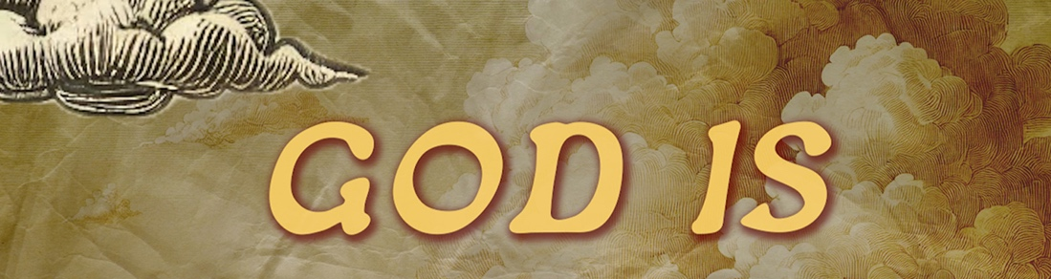
#5 YaHoWaH Rapha. רָפָא יְהֹוָה 5 “The God who Heals”
Passage: Exodus 15:22-27
²² Then Moses made Israel set out from the Red Sea, and they went into the wilderness of Shur. They went three days in the wilderness and found no water. ²³ When they came to Marah, they could not drink the water of Marah because it was bitter; therefore it was named Marah ²⁴ And the people grumbled against Moses, saying, “What shall we drink?” ²⁵ And he cried to the Lord, and the Lord showed him a log, and he threw it into the water, and the water became sweet.
There the Lord made for them a statute and a rule, and there he tested them, ²⁶ saying, “If you will diligently listen to the voice of the Lord your God, and do that which is right in his eyes, and give ear to his commandments and keep all his statutes, I will put none of the diseases on you that I put on the Egyptians, for I am the Lord, your healer.”

²⁷ Then they came to Elim, where there were twelve springs of water and seventy palm trees, and they encamped there by the water.

שלום Rapha= to ___________, healer, physician, to cure, to mend, to sew together, repair thoroughly, ___________________________.

What is God’s response to the brokenness of the world?

I AM going to __________________ it! I AM the _______________________!

What is God healing? The 4 relationships

________________

_____________________________________


_________________

He’s healing ______________________________________.
#5 YaHoWaH Rapha. רָפָא יְהֹוָה 5 “The God who Heals”
Passage: Exodus 15:22-27
²² Then Moses made Israel set out from the Red Sea, and they went into the wilderness of Shur. They went three days in the wilderness and found no water. ²³ When they came to Marah, they could not drink the water of Marah because it was bitter; therefore it was named Marah ²⁴ And the people grumbled against Moses, saying, “What shall we drink?” ²⁵ And he cried to the Lord, and the Lord showed him a log, and he threw it into the water, and the water became sweet.
There the Lord made for them a statute and a rule, and there he tested them, ²⁶ saying, “If you will diligently listen to the voice of the Lord your God, and do that which is right in his eyes, and give ear to his commandments and keep all his statutes, I will put none of the diseases on you that I put on the Egyptians, for I am the Lord, your healer.”

²⁷ Then they came to Elim, where there were twelve springs of water and seventy palm trees, and they encamped there by the water.

שלום Rapha= to ___________, healer, physician, to cure, to mend, to sew together, repair thoroughly, ___________________________.

What is God’s response to the brokenness of the world?

I AM going to __________________ it! I AM the _______________________!

What is God healing? The 4 relationships

________________
_____________________________________

_________________

He’s healing ______________________________________.
How is God healing everything?
"He himself bore our sins in his body on the tree, that we, having died to sins, might live for righteousness — by his wounds you were healed." 1 Peter 2:24
1. He heals from __________ _____________________ _______________.
2. _____________.
"Blessed be the God and Father of our Lord Jesus Christ, the Father of mercies and the God of all comfort. He comforts us in all our affliction, so that we may be able to comfort those who are in any kind of affliction, through the comfort we ourselves receive from God." 2 Corinthians 1:3-4
Healed people ________________________ people.
Life Group Discussion Questions
https://www.waipunachapel.com/life-groups/
God is healing everything.
What are the broken areas of life that break your heart the most?

What stood out to the most with regards to our relationship with God, creation, ourselves, and others?

What is one area in your life where you need YHWH Rapha, God our healer.

Name a time in your life where God was Rapha for you.

What are some situations where you needed healing, but felt absolutely powerless in the situation?

Read and discuss 1 Peter 2:24
How have you experienced this in your life physically, emotionally, or spiritually?

Read 2 Corinthians 1:3-4
How have you been a comfort to others around you in the past?
How can you be a comfort to others this week?
Send Questions/Feedback to jonathan@waipunachapel.com

How is God healing everything?
"He himself bore our sins in his body on the tree, that we, having died to sins, might live for righteousness — by his wounds you were healed." 1 Peter 2:24
1. He heals from __________ _____________________ _______________.
2. _____________.
"Blessed be the God and Father of our Lord Jesus Christ, the Father of mercies and the God of all comfort. He comforts us in all our affliction, so that we may be able to comfort those who are in any kind of affliction, through the comfort we ourselves receive from God." 2 Corinthians 1:3-4
Healed people ________________________ people.
Life Group Discussion Questions
https://www.waipunachapel.com/life-groups/
God is healing everything.
What are the broken areas of life that break your heart the most?

What stood out to the most with regards to our relationship with God, creation, ourselves, and others?

What is one area in your life where you need Jehovah-Rapha, God our healer.

Name a time in your life where God was Rapha for you.

What are some situations where you needed healing, but felt absolutely powerless in the situation?

Read and discuss 1 Peter 2:24
How have you experienced this in your life physically, emotionally, or spiritually?

Read 2 Corinthians 1:3-4
How have you been a comfort to others around you in the past?
How can you be a comfort to others this week?
Send Questions/Feedback to jonathan@waipunachapel.com

