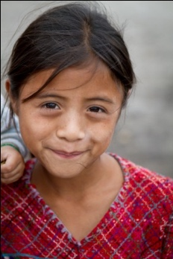
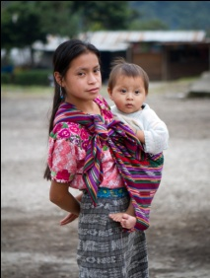
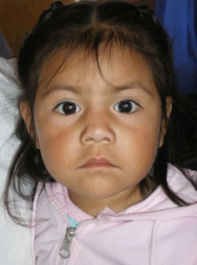
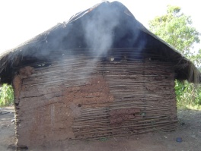
Guatemala Medical Missions Opportunity

What is the Guatemala Medical Missions Trip?
- A Medical Missions trip to serve villagers in Guatemala, both physically and spiritually.
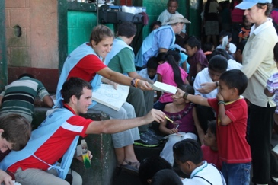
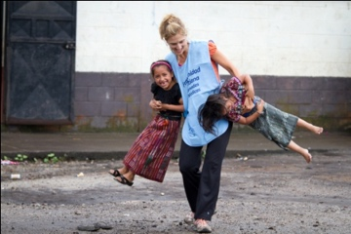
  - Soul Clinic
  - General Medical
  - OB/Gyn
  - Limited Surgical
  - Dentistry
  - Pediatrics
  - Optical (Eyeglasses)

When is the 2023 Missions to Guatemala?
- May 18-22, 2023 (Thursday-Monday)

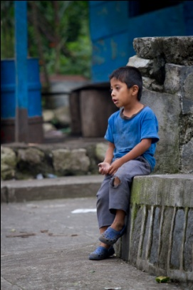
How Long is the Missions Trip?
- The mission trip begins with early morning travel from BWI airport to Guatemala on Thursday.
- Mission work is typically performed on Friday and Saturday in a village chosen by our brothers and sisters from Fraternidad Cristiana de Guatemala (FRATER) (http://frater.org). Depending on the travel time to/from the village, we may stay one or two nights in the village. If we travel back to Guatemala City on Saturday night, we will worship at FRATER on Sunday and fellowship with our host families.
- We debrief with our FRATER team on Monday morning, and travel back to BWI. We typically make it back to BWI by midnight.

Who is Needed?
- 20-23 Christians with a passion for missions
  - Optimal for those that want to participate in missions but cannot take extended leave
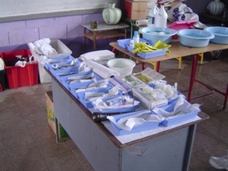
- Medical and non-medical personnel
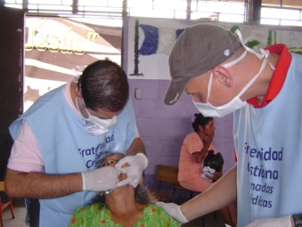
- Translators
- Prayer Warriors (Soul Clinic)
- Children must be at least 13 years of age

Who will make up the team?
- The team will consist primarily members of Southern Maryland Christian churches – however, Christians from around the country with a willingness to serve regularly participate
- Members from Living Word Community Church - York, PA (LWCC performs other trips to Guatemala annually)
  - http://www.lwccyork.com
- FRATER (Guatemala Church Partnership)
  - http://frater.org
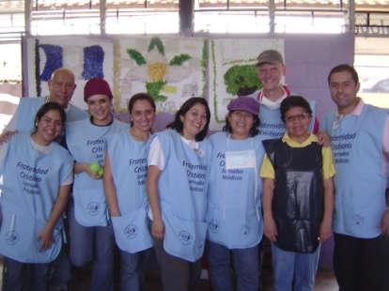
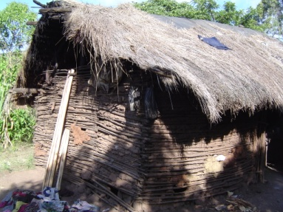
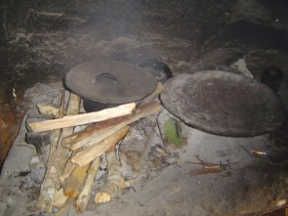
  - In addition to planning and coordinating the mission trips, the FRATER church provides host families for us while we are in Guatemala City

How will it happen?
- Team member funded (approx. ~$900/member) – cost includes funds to purchase medicines for the village
- Immunizations organized by Redeeming Grace Baptist Church (RGBC)
- Training – Training will be provided at RGBC. We will hold four preparation meetings on Sunday afternoons every two weeks leading up to the trip. The first week will include immunizations. The second meeting will prepare members for mission. The third meeting will be dedicated to fellowship. The last week will include packing donations for the trip.
- Team Covenant – All members agree on a Team Covenant, and commit to each other while on mission
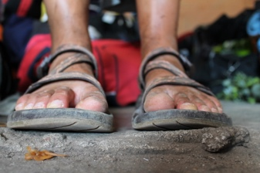
- Strengths & Weaknesses – All members identify their strengths and weaknesses – we all pray for each other in preparation for the trip
- Servant Attitude – We travel to Guatemala with a heart of a servant
  - We perform our roles as a servant to the Guatemalan people
  - When in Guatemala, we serve the FRATER missions team

How Can I Sign Up?
- If you are interested, you can submit an application to the RGBC website: http://www.rgbcmd.org
- We are looking for a commitment by January 31, 2023 (we need to purchase tickets and provide team member information to the FRATER team)

I can’t go. How else can I support this mission?
- Pray! Pray especially for:
  - The FRATER team who leads this effort in country to serve the Guatemalan people.
  - The Missionaries from the United States as they prepare to serve Him and the people of Guatemala.
  - The villagers that we will serve – that their hearts will be open to the truth of the Gospel.
- Provide financial support for this mission through Redeeming Grace Baptist Church. Donations will help to purchase needed supplies and support those with limited means to participate on the Mission.

I still have questions. Who should I contact?
- Please feel free to contact Christian Utara at Christian.Utara@jhu.edu or (301) 904-6200.

