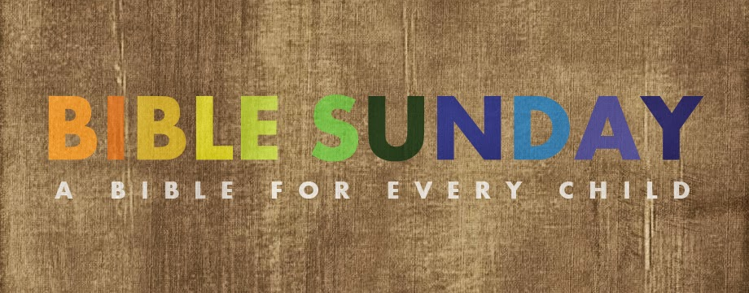
Children in 1st grade to 5th grade are invited to receive a Bible in church on April 16 at the 9:00 service. After the service a workshop will be held from 10:15 – 11:30 to instruct the children on how to use their Bible.
Please indicate what works for your family:
- My child will attend the service and workshop.
- My child will only attend the service.
- My child cannot attend either event. A Bible is still given.
My child’s full name _________________________________________________________
Please return by April 10 to Katie Weston or Donna Meoli

Children in 1st grade to 5th grade are invited to receive a Bible in church on April 16 at the 9:00 service. After the service a workshop will be held from 10:15 – 11:30 to instruct the children on how to use their Bible.
Please indicate what works for your family:
- My child will attend the service and workshop.
- My child will only attend the service.
- My child cannot attend either event. A Bible is still given.
My child’s full name _________________________________________________________
Please return by April 10 to Katie Weston or Donna Meoli

