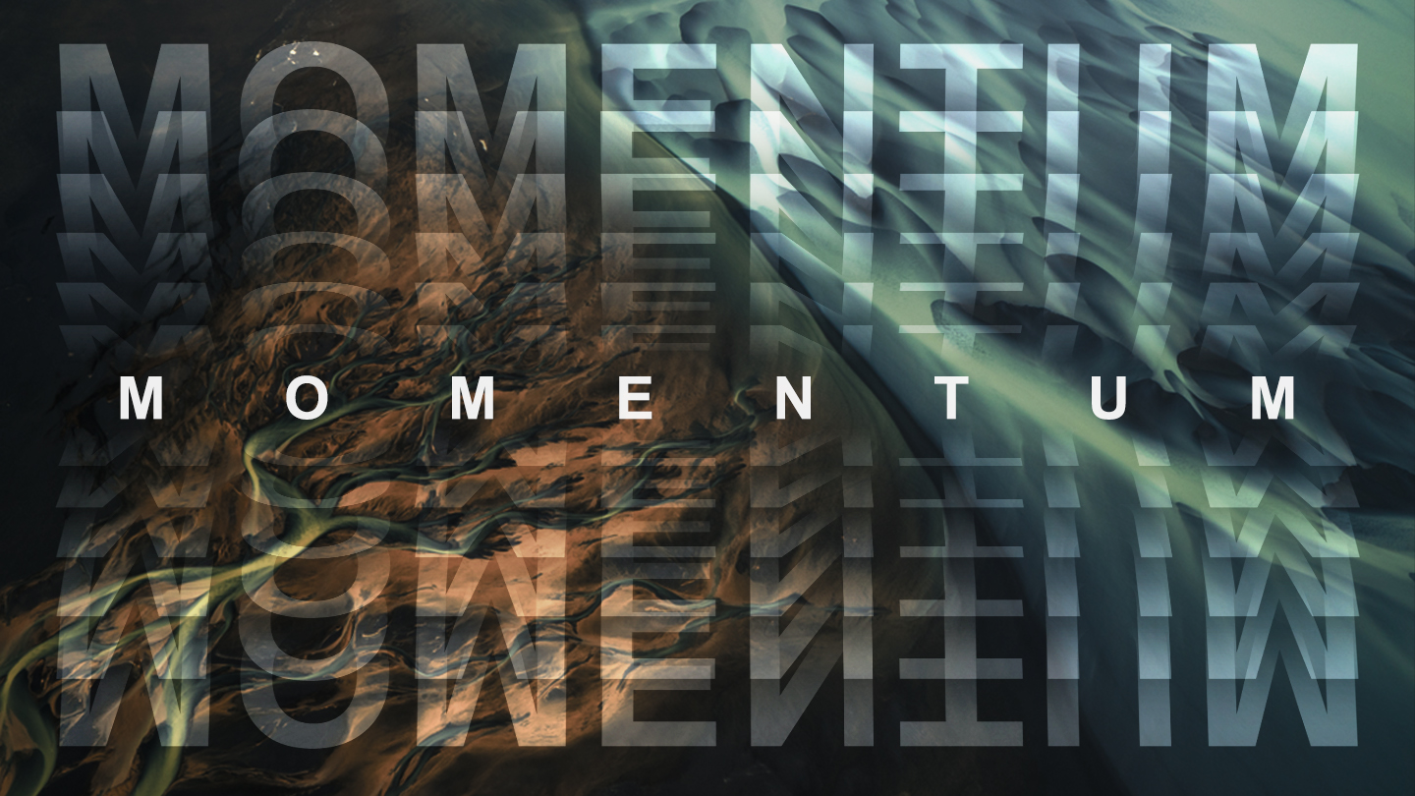
Discovering God When You’re Hurting
DR. GLYNN STONE, SENIOR PASTOR
MOBBERLY BAPTIST CHURCH

JOHN 21:1-9, 15-17, CSB After this, Jesus revealed himself again to his disciples by the Sea of Tiberias. He revealed himself in this way: ² Simon Peter, Thomas (called “Twin”), Nathanael from Cana of Galilee, Zebedee’s sons, and two others of his disciples were together. ³ “I’m going fishing,” Simon Peter said to them. “We’re coming with you,” they told him. They went out and got into the boat, but that night they caught nothing. ⁴ When daybreak came, Jesus stood on the shore, but the disciples did not know it was Jesus. ⁵ “Friends,” Jesus called to them, “you don’t have any fish, do you?” “No,” they answered.⁶ “Cast the net on the right side of the boat,” he told them, “and you’ll find some.” So they did, and they were unable to haul it in because of the large number of fish. ⁷ The disciple, the one Jesus loved, said to Peter, “It is the Lord!” When Simon Peter heard that it was the Lord, he tied his outer clothing around him (for he had taken it off) and plunged into the sea. ⁸ Since they were not far from land (about a hundred yards away), the other disciples came in the boat, dragging the net full of fish. ⁹ When they got out on land, they saw a charcoal fire there, with fish lying on it, and bread.
¹⁵ When they had eaten breakfast, Jesus asked Simon Peter, “Simon, son of John, do you love me more than these?” “Yes, Lord,” he said to him, “you know that I love you.” “Feed my lambs,” he told him. ¹⁶ A second time he asked him, “Simon, son of John, do you love me?” “Yes, Lord,” he said to him, “you know that I love you.” “Shepherd my sheep,” he told him. ¹⁷ He asked him the third time, “Simon, son of John, do you love me?” Peter was grieved that he asked him the third time, “Do you love me?” He said, “Lord, you know everything; you know that I love you.” “Feed my sheep,” Jesus said.

NOTES:

- God has a purpose for your pain.

- You can’t stay where you are and go with God.

- Our biggest disappointments can become our greatest appointments.

