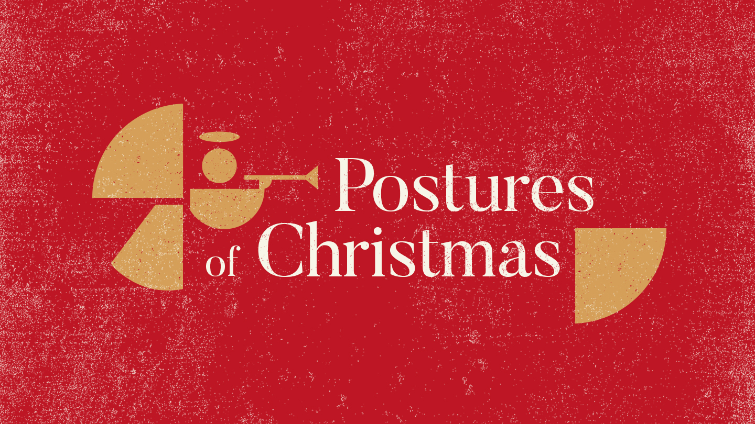
POSTURES OF CHRISTMAS: BOW DOWN
DR. GLYNN STONE, SENIOR PASTOR
MOBBERLY BAPTIST CHURCH

MATTHEW 2:7-10, CSB ⁷ “Then Herod secretly summoned the wise men and asked them the exact time the star appeared. ⁸ He sent them to Bethlehem and said, “Go and search carefully for the child. When you find him, report back to me so that I too can go and worship him.” ⁹ After hearing the king, they went on their way. And there it was—the star they had seen at its rising. It led them until it came and stopped above the place where the child was. ¹⁰ When they saw the star, they were overwhelmed with joy.”

NOTES:

- Today, anyone can bow before Jesus.

- One day, everyone will bow before Jesus.

When should I bow?

- Before your day
- Before your meal
- During your commute
- During your crisis
- When you have a pay day
- When you finish your day

