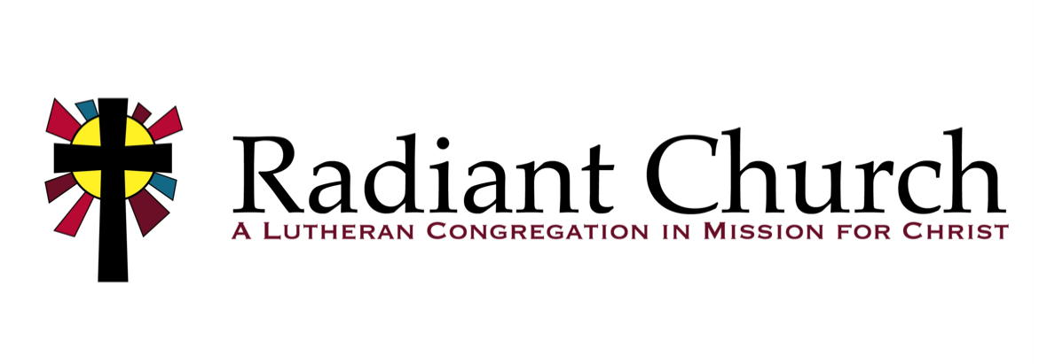
August 31, 2025
“Exaltation”
Luke 14:1, 7-14

Key Verse: “For everyone who exalts himself will be humbled, and he who humbles himself will be exalted.” (Luke 14:11)

Our honor comes from God
“When someone invites you to a wedding feast, do not take the place of honor, for a person more distinguished than you may have been invited. ⁹ If so, the host who invited both of you will come and say to you, ‘Give this man your seat.’ Then, humiliated, you will have to take the least important place. ¹⁰ But when you are invited, take the lowest place, so that when your host comes, he will say to you, ‘Friend, move up to a better place.’ Then you will be honored in the presence of all your fellow guests. ¹¹ For everyone who exalts himself will be humbled, and he who humbles himself will be exalted.” (Luke 14:8-11)
To some who were confident of their own righteousness and looked down on everybody else, Jesus told this parable: ¹⁰ “Two men went up to the temple to pray, one a Pharisee and the other a tax collector. ¹¹ The Pharisee stood up and prayed about himself: ‘God, I thank you that I am not like other men—robbers, evildoers, adulterers—or even like this tax collector. ¹² I fast twice a week and give a tenth of all I get.’ ¹³ “But the tax collector stood at a distance. He would not even look up to heaven, but beat his breast and said, ‘God, have mercy on me, a sinner.’ ¹⁴ “I tell you that this man, rather than the other, went home justified before God. For everyone who exalts himself will be humbled, and he who humbles himself will be exalted.” (Luke 18:9-14)
For by the grace given me I say to every one of you: Do not think of yourself more highly than you ought, but rather think of yourself with sober judgment, in accordance with the measure of faith God has given you. (Romans 12:3)
Anyone who thinks he is something when he is nothing, deceives himself. (Galatians 6:3)

We honor others the way God honors us
Then Jesus said to his host, “When you give a luncheon or dinner, do not invite your friends, your brothers or relatives, or your rich neighbors; if you do, they may invite you back and so you will be repaid. ¹³ But when you give a banquet, invite the poor, the crippled, the lame, the blind, ¹⁴ and you will be blessed. Although they cannot repay you, you will be repaid at the resurrection of the righteous.” (Luke 14:12-14)
Your attitude should be the same as that of Christ Jesus: ⁶Who, being in very nature God, did not consider equality with God something to be grasped, ⁷but made himself nothing,
taking the very nature of a servant, being made in human likeness. ⁸And being found in appearance as a man, he humbled himself and became obedient to death— even death on a cross! (Philippians 2:5-8)

Discipleship Training: Discovery Bible Study
Sunday, August 31
11:15am in Room 102
Our focus in this class will be learning the Discovery Bible Study method, a simple and reproducible process where Scripture is the primary teacher. The goal is that anyone and everyone can study Scripture together to understand the character of God, encourage them to obey what they are learning and help them to share it with others.

Continuing Prayer

Wednesdays at 6:30am
Sundays at 8:30am
We are continuing our discipline of prayer by meeting in person two days a week. Bring your Moravian Daily Texts book or access the readings via the app or online. You may submit your prayer requests on the Prayer Request card on Sundays or by scanning the QR code.

Human Trafficking Awareness March
Friday, September 5

8:30-10:30am at Northeast of the Well
2025 Newport Blvd, Ste 110, Costa Mesa
Join Northeast of the Well in raising our voices against the evil and sin of human trafficking. The march will be just under two miles. Please register in advance on the Northeast website (www.northeastofthewell.org) or by scanning the QR code.

Sunday Funday
Sunday, September 7
11:00am at Central Park West
6700 Central Park Dr, HB
Invite your friends and family members to our next Sunday Funday at Central Park West! As usual, we’ll have some delicious food, fun games and crafts for the kids, and engaging conversation with our friends and neighbors in the greater Huntington Beach area. Come on out and extend the tangible love of Jesus!

Angels of Love Golf Tournament
Monday, September 15
Costa Mesa Country Club
Get your foursome together and sign up for the annual Angels of Love Golf Tournament on Monday, September 15! This tournament is the major fundraiser for Angels of Love and provides the needed funds to purchase Angels that are distributed in hospitals, nursing homes, police stations, and fire stations. Sponsorship opportunities are also available. Even if you aren’t a golfer, we can use your help on the day of the event. To sign up to play, sponsor, or help, email Roland at rolrdm@aol.com.

