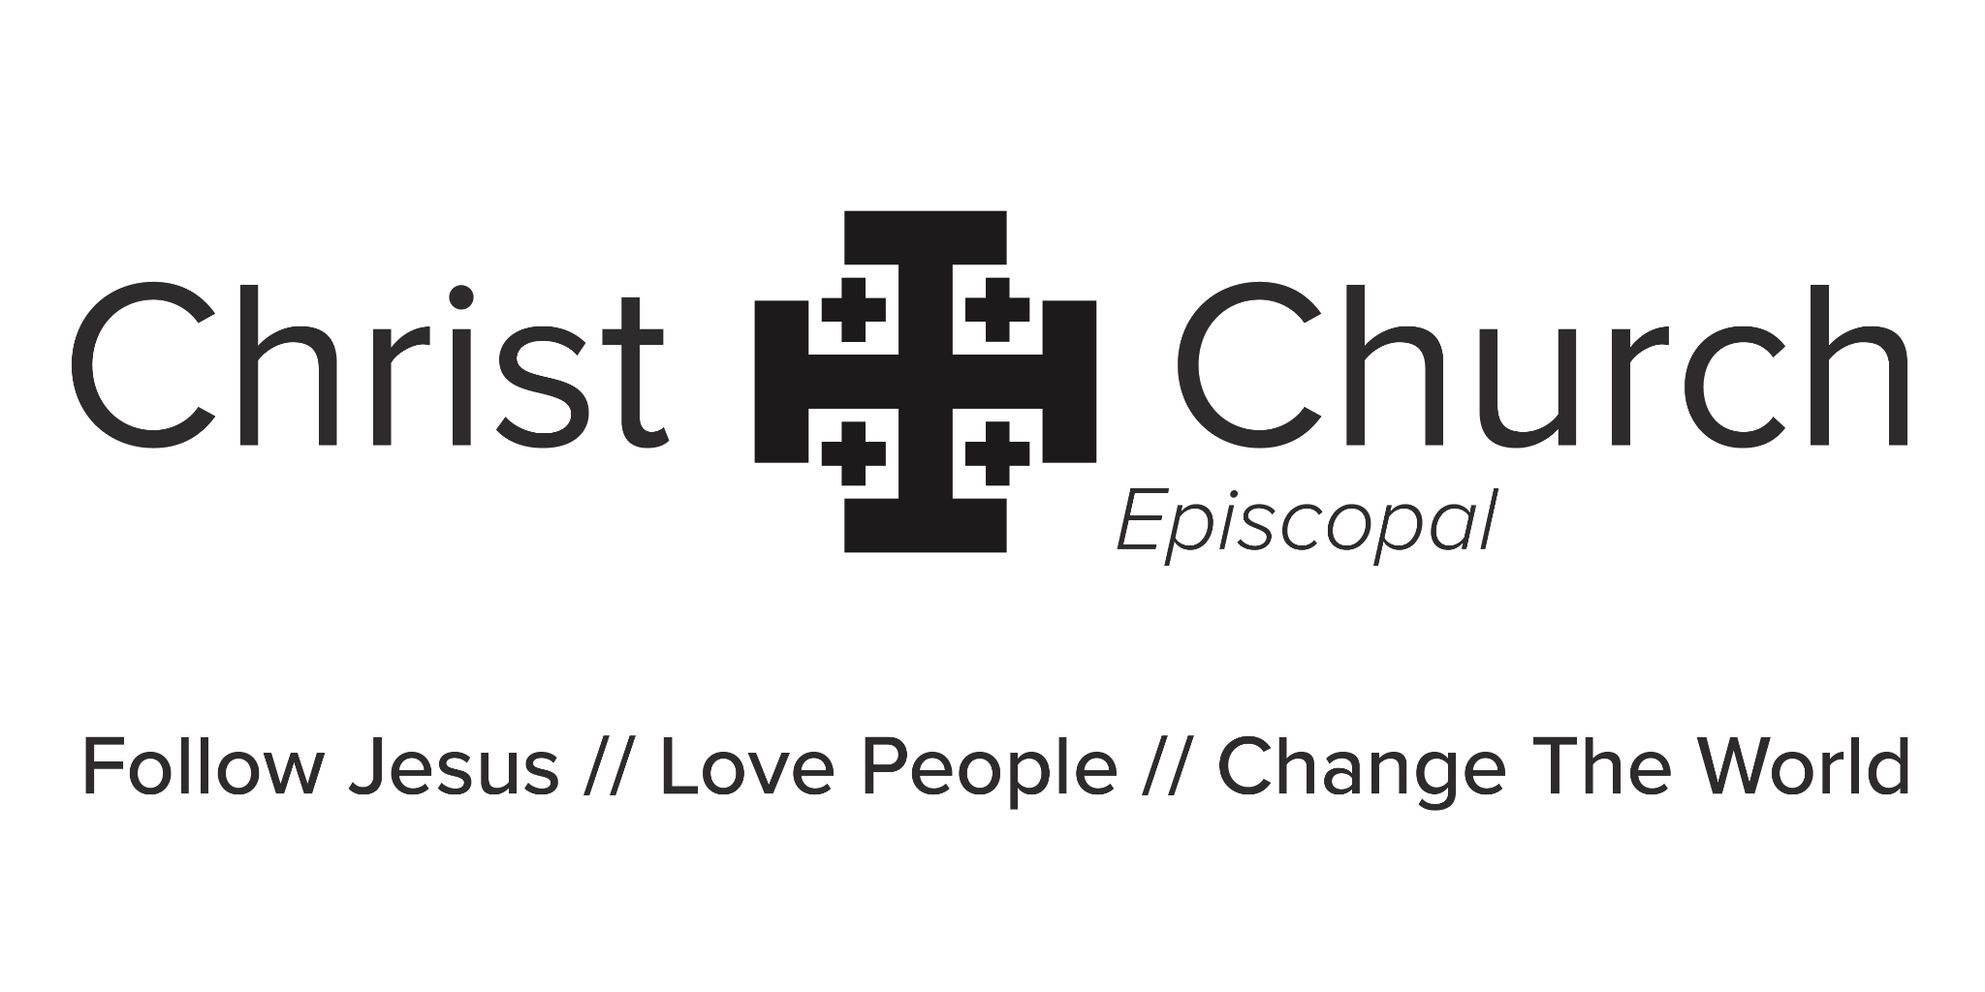
TWENTY SECOND SUNDAY AFTER PENTECOST
October 25, 2026
___________________________________________________

We extend a special welcome to those who are single, married, divorced, gay, filthy rich, dirt poor, y los que no hablan inglés. We extend a special welcome to those who are crying newborns, skinny as a rail, or could afford to lose a few pounds.

We welcome you if you can sing like Andrea Bocelli or can’t carry a tune in a bucket. You’re welcome here if you’re “just browsing,” just woke up, or just got out of jail. We don’t care if you’re more Catholic than the Pope, or haven’t been in church since little Joey’s Baptism.

We extend a special welcome to those who are over 60 but not grown up yet, and to teenagers who are growing up too fast. We welcome soccer moms, NASCAR dads, starving artists, tree-huggers, latte-sippers, vegetarians, junk-food eaters. We welcome those who are in recovery or still addicted. We welcome you if you’re having problems or you’re down in the dumps or if you don’t like “organized religion.” We’ve been there too.

If you blew all your offering money at the dog track, you’re welcome here. We offer a special welcome to those who think the earth is flat, work too hard, don’t work, can’t spell, or because grandma is in town and wanted to go to church.

We welcome those who are inked, pierced, or both. We offer a special welcome to those who could use a prayer right now, had religion shoved down your throat as a kid, or got lost in traffic and wound up here by mistake. We welcome tourists, seekers and doubters, bleeding hearts, and you!

THE PRAYER BEFORE WORSHIP
God, your Son Jesus Christ promised to be with us whenever we gather together in His name. We thank you for Christ Church and the love that holds us together. Make us eager to gather for worship. Inspire us to learn and grow spiritually, as individuals and as a faith community. We seek knowledge of Your will for us. We pray for the strength and courage, the wit and wisdom, and the humor and creativity to follow Jesus, love people and change the world. Amen.

The Liturgy of the Word

THE HYMN IN PROCESSION (9:00) Hymnal #551 Rise up, ye saints of God

(11:00) Jesus Loved the Devil Out of Me

Jesus loved the devil out of me

Yes Jesus loved the devil out of me

When He took me by the hand

Ol' Satan just gave up and ran

Jesus loved the devil out of me

Life for me was filled with sin and shame

The devil had a plan to claim my name

But just before I crossed the eternal line

Jesus said no Satan this one's mine

No will to live my future looked so cold

The devil stood there waiting for my soul

But just before I walked into his arms

The king of kings my king of kings

Reached for my hand and saved me from all harm

OPENING ACCLAMATION
The people standing, the Celebrant says
Celebrant Blessed be God: Father, Son, and Holy Spirit
People And blessed be his kingdom, now and for ever. Amen.

THE COLLECT FOR PURITY
The Celebrant may say
Almighty God, to you all hearts are open, all desires known, and from you no secrets are hid: Cleanse the thoughts of our hearts by the inspiration of your Holy Spirit, that we may perfectly love you, and worthily magnify your holy Name; through Christ our Lord. Amen.

Any children wishing to go to Children’s Chapel and Godly Play may follow the
procession out of the back of the church at this time.

THE GLORIA Glory to God, from Ordinary: Via Crucis, Jack Milton Bussert
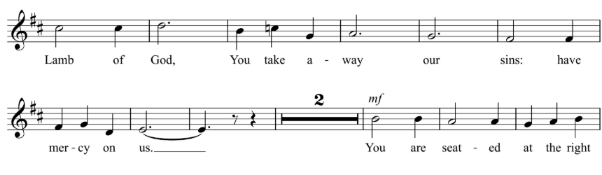
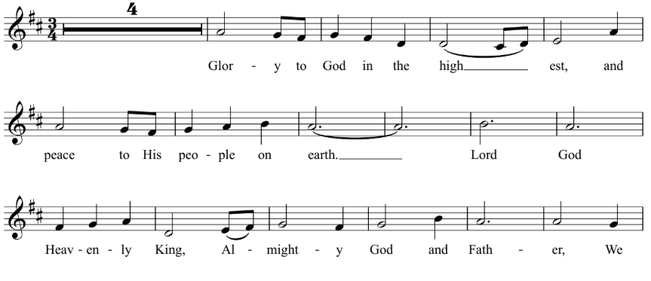
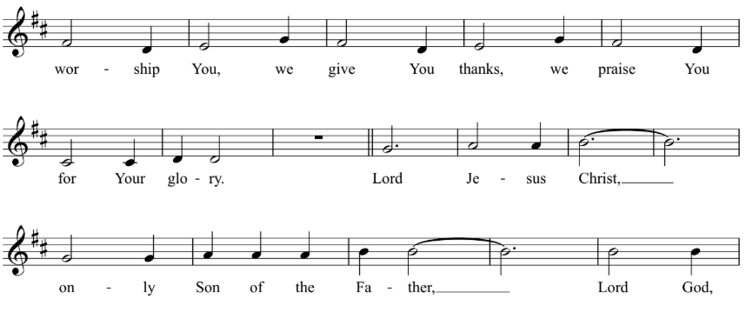

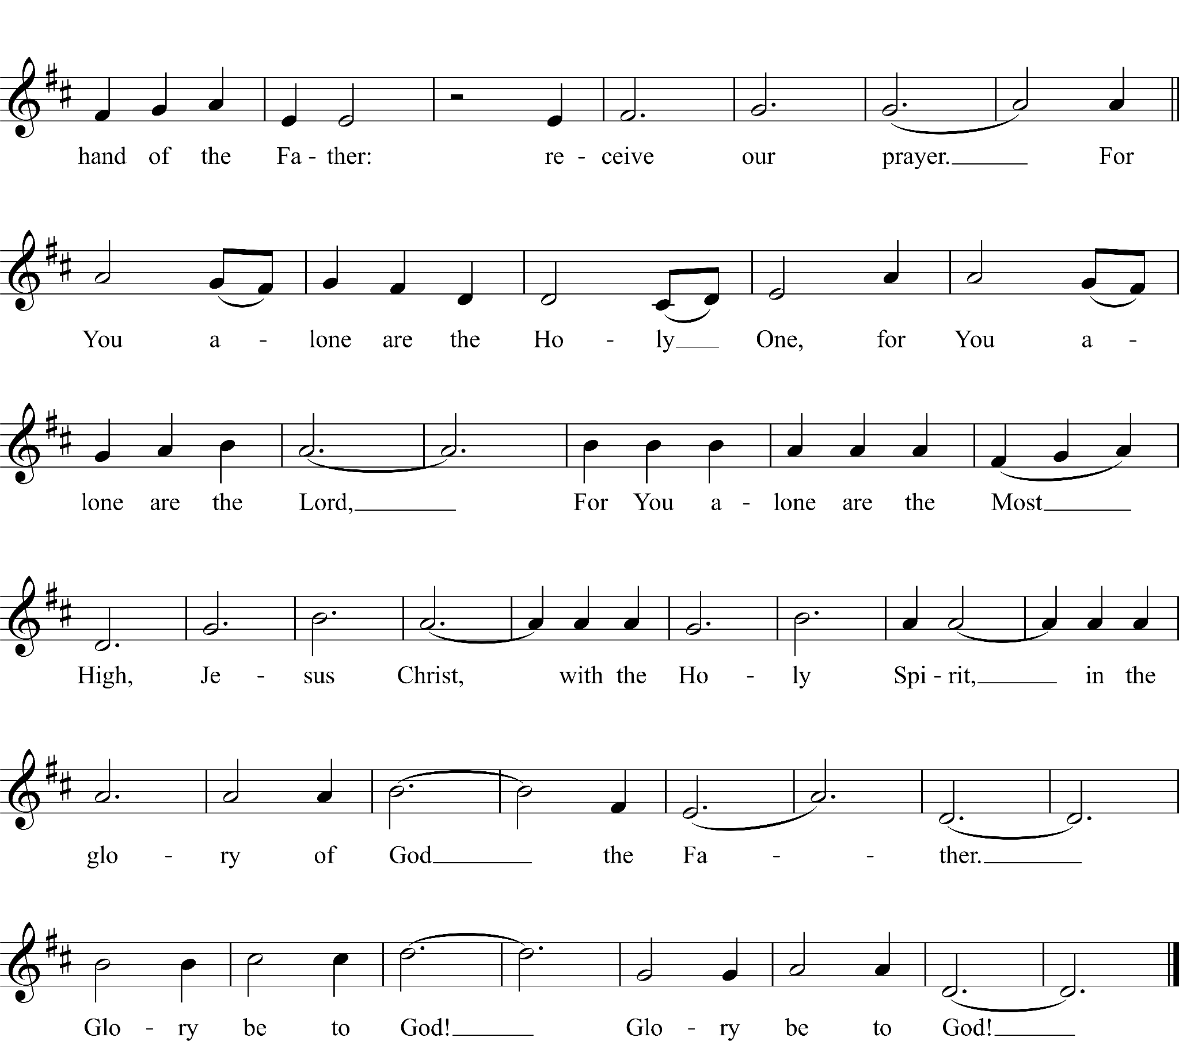

THE COLLECT OF THE DAY
Celebrant | The Lord be with you.
People | And also with you.
Celebrant | Let us pray.
Almighty and everlasting God, increase in us the gifts of faith, hope, and charity; and, that we may obtain what you promise, make us love what you command; through Jesus Christ our Lord, who lives and reigns with you and the Holy Spirit, one God, for ever and ever. Amen.

The people are seated for the reading of the Lessons.

THE FIRST LESSON Deuteronomy 34:1-12

Moses went up from the plains of Moab to Mount Nebo, to the top of Pisgah, which is opposite Jericho, and the Lord showed him the whole land: Gilead as far as Dan, all Naphtali, the land of Ephraim and Manasseh, all the land of Judah as far as the Western Sea, the Negeb, and the Plain—that is, the valley of Jericho, the city of palm trees—as far as Zoar. The Lord said to him, “This is the land of which I swore to Abraham, to Isaac, and to Jacob, saying, ‘I will give it to your descendants’; I have let you see it with your eyes, but you shall not cross over there.” Then Moses, the servant of the Lord, died there in the land of Moab, at the Lord’s command. He was buried in a valley in the land of Moab, opposite Beth-peor, but no one knows his burial place to this day. Moses was one hundred twenty years old when he died; his sight was unimpaired and his vigor had not abated. The Israelites wept for Moses in the plains of Moab thirty days; then the period of mourning for Moses was ended.
Joshua son of Nun was full of the spirit of wisdom, because Moses had laid his hands on him; and the Israelites obeyed him, doing as the Lord had commanded Moses.
Never since has there arisen a prophet in Israel like Moses, whom the Lord knew face to face. He was unequaled for all the signs and wonders that the Lord sent him to perform in the land of Egypt, against Pharaoh and all his servants and his entire land, and for all the mighty deeds and all the terrifying displays of power that Moses performed in the sight of all Israel.

Lector The Word of the Lord.
People Thanks be to God.

THE GRADUAL Psalm 90:1-6, 13-17
Lord, you have been our refuge
from one generation to another.

Before the mountains were brought forth,
or the land and the earth were born,
from age to age you are God.

You turn us back to the dust and say,
"Go back, O child of earth."

For a thousand years in your sight are like yesterday when it is past
and like a watch in the night.

You sweep us away like a dream;
we fade away suddenly like the grass.

In the morning it is green and flourishes;
in the evening it is dried up and withered.

Return, O Lord; how long will you tarry?
be gracious to your servants.

Satisfy us by your loving-kindness in the morning;
so shall we rejoice and be glad all the days of our life.

Make us glad by the measure of the days that you afflicted us
and the years in which we suffered adversity.

Show your servants your works
and your splendor to their children.

May the graciousness of the Lord our God be upon us;
prosper the work of our hands;
prosper our handiwork.
.

THE SECOND LESSON 1 Thessalonians 2:1-8

You yourselves know, brothers and sisters, that our coming to you was not in vain, but though we had already suffered and been shamefully mistreated at Philippi, as you know, we had courage in our God to declare to you the gospel of God in spite of great opposition. For our appeal does not spring from deceit or impure motives or trickery, but just as we have been approved by God to be entrusted with the message of the gospel, even so we speak, not to please mortals, but to please God who tests our hearts. As you know and as God is our witness, we never came with words of flattery or with a pretext for greed; nor did we seek praise from mortals, whether from you or from others, though we might have made demands as apostles of Christ. But we were gentle among you, like a nurse tenderly caring for her own children. So deeply do we care for you that we are determined to share with you not only the gospel of God but also our own selves, because you have become very dear to us.
Lector The Word of the Lord.
People Thanks be to God.

The people stand as they are able for the Sequence Hymn and the reading of the Gospel.

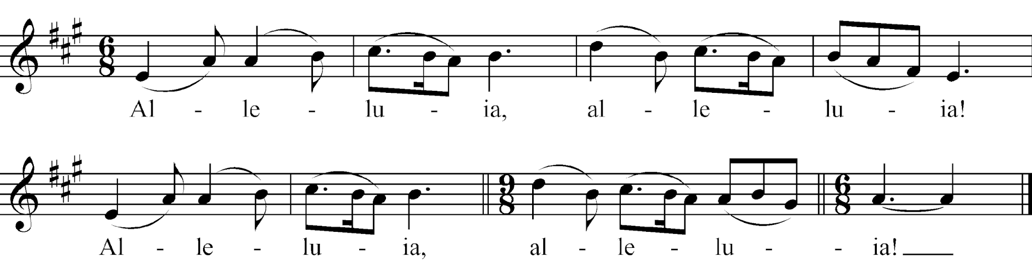
THE SEQUENCE HYMN (9:00) Celtic Alleluia

(11:00) Mass of the Resurrection, Alleluia
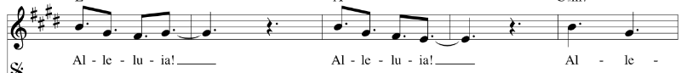

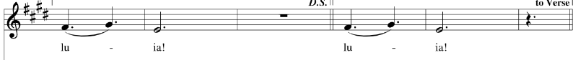

THE GOSPEL Matthew 22:34-46

Deacon The Holy Gospel of our Lord Jesus Christ according to Matthew.
People Glory to you, Lord Christ.

When the Pharisees heard that Jesus had silenced the Sadducees, they gathered together, and one of them, a lawyer, asked him a question to test him. “Teacher, which commandment in the law is the greatest?” He said to him, “’You shall love the Lord your God with all your heart, and with all your soul, and with all your mind.’ This is the greatest and first commandment. And a second is like it: ‘You shall love your neighbor as yourself.’ On these two commandments hang all the law and the prophets.”

Now while the Pharisees were gathered together, Jesus asked them this question: “What do you think of the Messiah? Whose son is he?” They said to him, “The son of David.” He said to them, “How is it then that David by the Spirit calls him Lord, saying,
‘The Lord said to my Lord,
“Sit at my right hand,
until I put your enemies under your feet”’?
If David thus calls him Lord, how can he be his son?” No one was able to give him an answer, nor from that day did anyone dare to ask him any more questions.
Deacon The Gospel of the Lord.
People Praise to you, Lord Christ.

THE SERMON The Rev. Sarah Smith

THE NICENE CREED
All stand and say together.
We believe in one God, the Father, the Almighty, maker of heaven and earth, of all that is, seen and unseen.

We believe in one Lord, Jesus Christ, the only Son of God, eternally begotten of the Father, God from God, Light from Light, true God from true God, begotten, not made, of one Being with the Father. Through him all things were made. For us and for our salvation he came down from heaven: by the power of the Holy Spirit he became incarnate from the Virgin Mary, and was made human. For our sake he was crucified under Pontius Pilate; he suffered death and was buried. On the third day he rose again in accordance with the Scriptures; he ascended into heaven and is seated at the right hand of the Father. He will come again in glory to judge the living and the dead, and his kingdom will have no end.

We believe in the Holy Spirit, the Lord, the giver of life, who proceeds from the Father and the Son. With the Father and the Son he is worshiped and glorified. He has spoken through the Prophets. We believe in one holy catholic and apostolic Church. We acknowledge one baptism for the forgiveness of sins. We look for the resurrection of the dead ✠, and the life of the world to come. Amen.

THE PRAYERS OF THE PEOPLE

The Leader and People pray responsively
In peace, we pray to you, Lord God.

Silence

For all people in their daily life and work;
For our families, friends, and neighbors, and for those who are alone.

For this community, the nation, and the world;
For all who work for justice, freedom, and peace.

For the just and proper use of your creation;
For the victims of hunger, fear, injustice, and oppression.

For all who are in danger, sorrow, or any kind of trouble;
For those who minister to the sick, the friendless, and the needy.

In the Anglican Cycle of Prayer, we pray for The Church of the Province of Central Africa . In our Diocesan Cycle of Prayer, we give thanks for the people and clergy of St. Luke’s, Bartlesville.
For all who proclaim the Gospel, and all who seek the Truth.

For Sarah, Archbishop of Canterbury, for Sean, our Presiding Bishop, and Poulson our Bishop; and for all bishops and other ministers;
For all who serve God in the Church.

For the special needs and concerns of this congregation, and particularly for those who
have asked for our prayers…

A pause is held so that the people may add their own petitions either silently or aloud.

Hear us, Lord;
For your mercy is great.

We thank you, Lord, for all the blessings of this life. For those celebrating birthdays…and for the anniversaries of..

We will exalt you, O God our King;
And praise your Name for ever and ever.

We pray for all who have died, (especially…) that they may have a place in
your eternal kingdom.

The People may add their own petitions at this time either silently or aloud.

Lord, let your loving-kindness be upon them;
Who put their trust in you.
We pray to you also for the forgiveness of our sins.
Silence is kept.

Leader and People
Have mercy upon us, most merciful Father; in your compassion forgive us our sins, known and unknown, things done and left undone; and so uphold us by your Spirit that we may live and serve you in newness of life, to the honor and glory of your Name; through Jesus Christ our Lord. Amen.

The Celebrant then offers the following Absolution.
Almighty God have mercy on you, forgive you all your sins through our Lord Jesus Christ, strengthen you in all goodness, and by the power of the Holy Spirit keep you in eternal life. Amen.

THE PEACE
All stand as they are able.
Celebrant | The peace of the Lord be always with you.
People | And also with you.
Then the Ministers and the People may greet one another in the name of the Lord.

THE ANNOUNCEMENTS

THE BIRTHDAY & ANNIVERSARY PRAYER
Watch over your children, O Lord, as their days increase; bless and guide them wherever they may be. Strengthen them when they stand; comfort them when discouraged or sorrowful; raise them up if they fall; and in their hearts may your peace which passes all understanding abide all the days of their lives; through Jesus Christ our Lord. Amen.

The Liturgy of the Table

THE OFFERTORY SENTENCE
The Celebrant says
Walk in love, as Christ loved us and gave himself for us, an offering and sacrifice to God. Ephesians 5:2

THE OFFERTORY ANTHEM (9:00 ) If Ye Love me

If ye love me
Keep my commandments
And I will pray the Father
And he shall give you another comforter
That he may 'bide with you forever
E’en the spirit of truth

(11:00) Superstition

Very superstitious,
Writing's on the wall.
Very superstitious,
Ladders bout' to fall.
Thirteen month old baby,
Broke the lookin' glass.
Seven years of bad luck,
The good things in your past.

Chorus
When you believe in things,
That you don't understand, then you suffer.
Superstition ain't the way.

Very superstitious,
Wash your face and hands.
Rid me of the problem,
Do all that you can.
Keep me in a daydream,
Keep me goin' strong.
You don't wanna save me,
Sad is my song.

Very superstitious,
Nothin' more to say.
Very superstitious,
The Devil's on his way.
Thirteen month old baby,
Broke the lookin' glass,
Seven years of bad luck,
The good things in your past.

Final Chorus
When you believe in things,
That you don't understand, then you suffer.
Superstition ain't the way, no, no, no.

THE PRESENTATION HYMN Doxology, The Old 100th
Please stand as you are able, as all sing together.
Praise God, from whom all blessings flow;
praise him, all creatures here below;
praise him above, ye heavenly host:
praise Father, Son, and Holy Ghost. Amen.

THE GREAT THANKSGIVING Eucharistic Prayer A
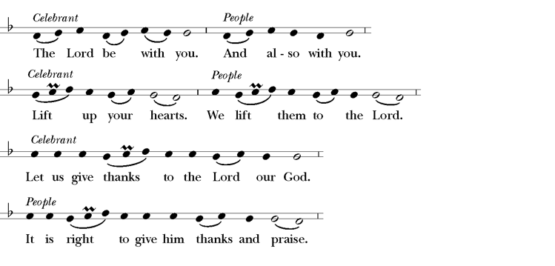
The People remain standing.

The Celebrant continues
It is right, and a good and joyful thing, always and everywhere to give thanks to you, Father Almighty, Creator of heaven and earth.
Here the Celebrant adds a Proper Preface before continuing as follows
Therefore we praise you, joining our voices with Angels and Archangels and with all the company of heaven, who for ever sing this hymn to proclaim the glory of your Name:

THE SANCTUS

(9:00) Hymn S-128 Holy, holy, holy (Mathias)

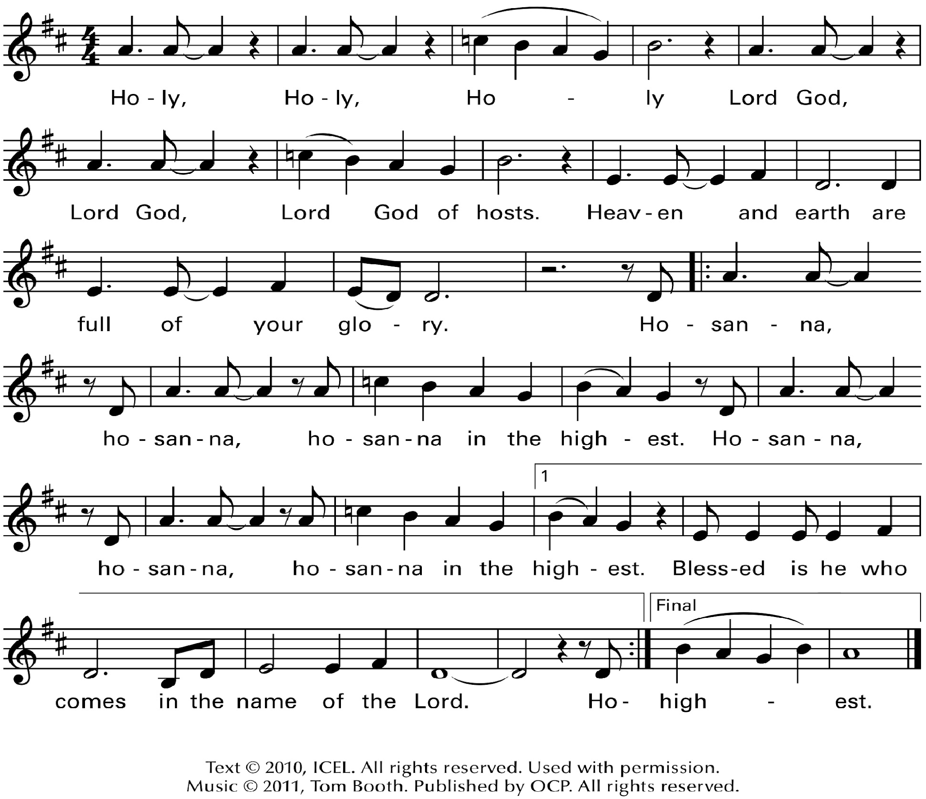
(11:00) Mass of the Desert - Sanctus

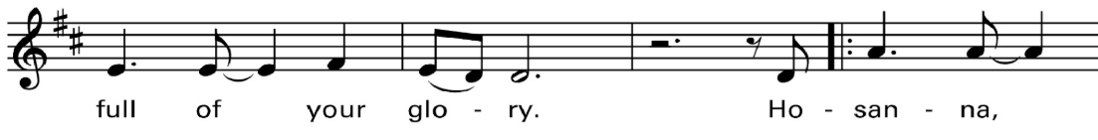

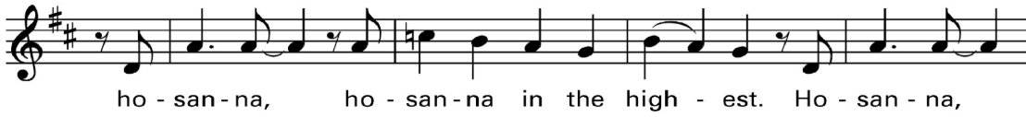

The People remain standing or kneel.

The Celebrant continues

Holy and gracious Father: In your infinite love you made us for yourself; and, when we had fallen into sin and become subject to evil and death, you, in your mercy, sent Jesus Christ, your only and eternal Son, to share our human nature, to live and die as one of us, to reconcile us to you, the God and Father of all.

He stretched out his arms upon the cross, and offered himself in obedience to your will, a perfect sacrifice for the whole world.

On the night he was handed over to suffering and death, our Lord Jesus Christ took bread; and when he had given thanks to you, he broke it, and gave it to his disciples, and said, “Take, eat: This is my Body, which is given for you. Do this for the remembrance of me.”

After supper he took the cup of wine; and when he had given thanks, he gave it to them, and said, “Drink this, all of you: This is my Blood of the new Covenant, which is shed for you and for many for the forgiveness of sins. Whenever you drink it, do this for the remembrance of me.”

Therefore we proclaim the mystery of faith:

Celebrant and People

Christ has died.

Christ is risen.

Christ will come again.

The Celebrant continues
We celebrate the memorial of our redemption, O Father, in this sacrifice of praise and thanksgiving. Recalling his death, resurrection, and ascension, we offer you these gifts.

Sanctify them by your Holy Spirit to be for your people the Body and Blood of your Son, the holy food and drink of new and unending life in him. Sanctify us also that we may faithfully receive this holy Sacrament, and serve you in unity, constancy, and peace; and at the last day bring us with all your saints into the joy of your eternal kingdom.

All this we ask through your Son Jesus Christ. By him, and with him, and in him, in the unity of the Holy Spirit all honor and glory is yours, Almighty Father, now and forever. Amen

And now, as our Savior Christ has taught us, we are bold to say,

People and Celebrant

Our Father, who art in heaven, hallowed be thy Name, thy kingdom come, thy will be done, on earth as it is in heaven. Give us this day our daily bread. And forgive us our trespasses, as we forgive those who trespass against us. And lead us not into temptation, but deliver us from evil. For thine is the kingdom, and the power, and the glory, for ever and ever. Amen.

THE BREAKING OF THE BREAD
The Celebrant breaks the consecrated bread. A period of silence is kept.

THE FRACTION ANTHEM (9:00) Hymnal S 164 Jesus, Lamb of God
(11:00) Mass of the Desert - Fraction
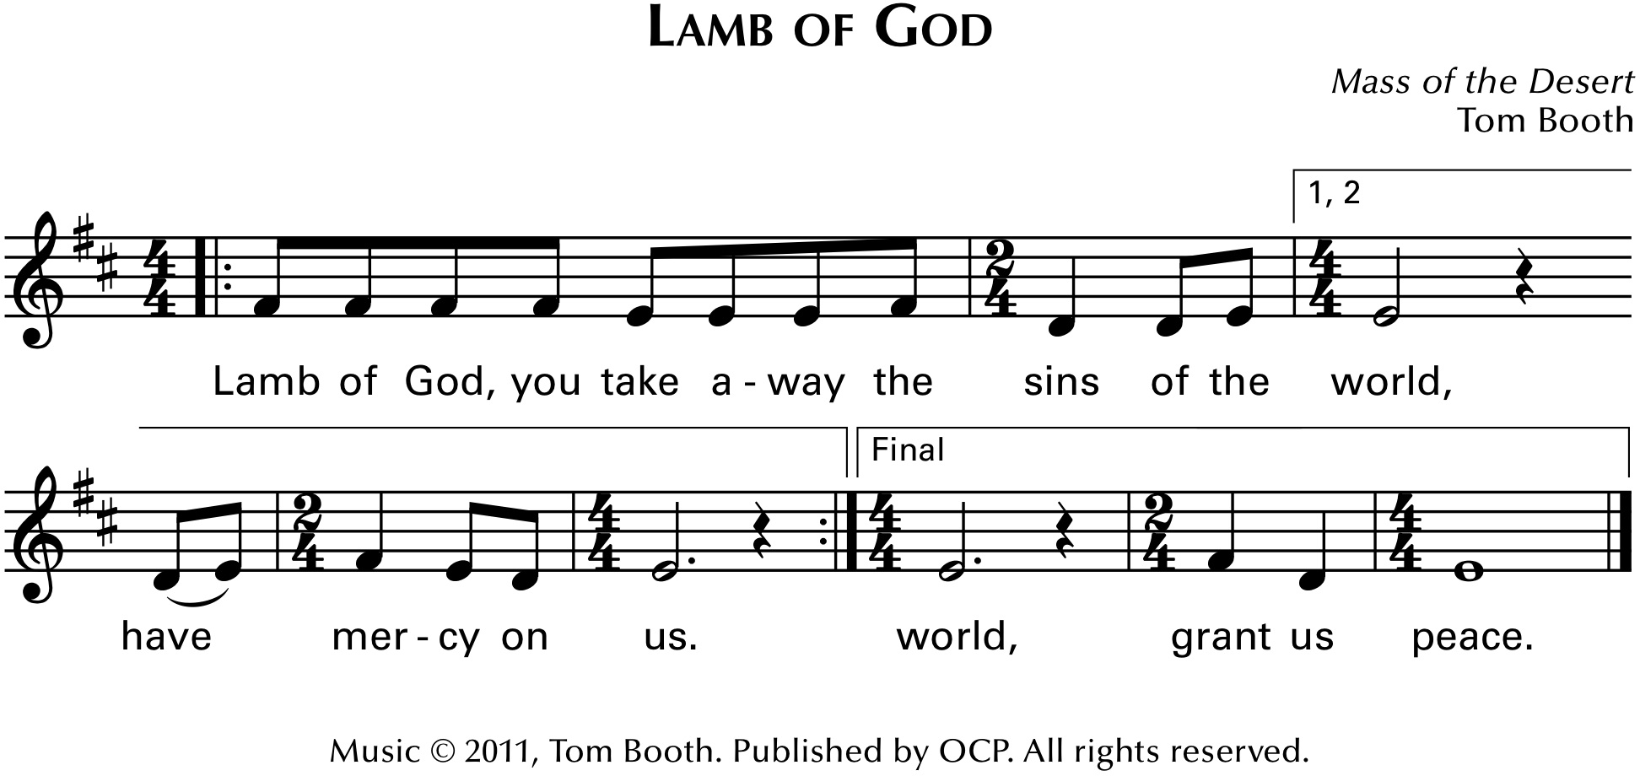

THE INVITATION TO THE TABLE
The Celebrant invites the congregation to receive the Sacrament saying these or similar words
This is the table of the Lord. It is made ready for those who love and for those who want to love more. So, come: you who have much faith, and you who have little; you who have been here often, and you who have not been here long; you who have tried to follow, and you who have fallen short, come. Because it is the Risen Christ who invites you.
It is the Risen Christ who wants to meet you here.

THE MINISTRATION OF COMMUNION
All are welcome to receive the consecrated bread and wine of the Eucharist. You may stand or kneel at the railing and receive the bread (a wafer) in the palm of your hand. Gluten-free wafers are available upon request. Receive the wine either by drinking from the cup (guiding it to your lips) or by touching the wafer lightly to the wine and then consuming it. If you prefer to receive a blessing, please indicate that by crossing your arms over your chest. If you would prefer to receive in your chair, please let an Usher know, and a clergy person and Eucharistic Minister will bring the consecrated bread and wine to you.

PRAYERS IN THE CHAPEL (9AM ONLY)
Anyone wishing to receive personal prayers (one-on-one) may do so immediately following Communion. These prayers are offered during the 9AM liturgy in The Rev. Dr. Everett Lees Chapel by a trained member of Christ Church. Simply head back to the Chapel after receiving the bread and the wine and a prayer team member will be stationed and awaiting you there.

THE MUSIC DURING THE MINISTRATION (9:00) Hymnal #423 Immortal, invisible, God only wise

(11:00) Edens

When I doubt what I used to believe
And I drown in my anxiety
You are here in these waters with me as always

My despair doesn’t scare You away
Nor my demons my questions my pain
Your compassion outlives all my shame as always
Always

Chorus
You are here
Closer than the heart in my chest
Truer than the thoughts in my head
Even in the shadow of death I know You’re with me

(Right) Here
Catching my tears in Your hands
Lifting my head when I can’t
Redeeming in seconds the life I thought was wasted
You make Edens out of wastelands

When the others have left You remain
Through the highs and the lows just the same
'Cause your kindness outlasts and outweighs
As always always

You’re redeeming everything everything everything
You’re redeeming everything everything everything
You’re redeeming everything everything everything
You’re redeeming everything everything everything
Oh you make Edens out of wastelands
You make
Edens out of wastelands

THE POSTCOMMUNION PRAYER
After Communion, the Celebrant says
Let us pray
Celebrant and People
Eternal God, heavenly Father, you have graciously accepted us as living members of your Son our Savior Jesus Christ, and you have fed us with spiritual food in the Sacrament of his Body and Blood. Send us now into the world in peace, and grant us strength and courage to love and serve you with gladness and singleness of heart; through Christ our Lord. Amen.

THE BLESSING
The Priest offers a seasonal blessing upon the people.

THE HYMN IN PROCESSION (9:00) Postlude (instrumental)

(11:00) Munsters Theme Song (instrumental)

THE DISMISSAL
Deacon Let us go forth in the name of Christ.
People Thanks be to God.

If you are a guest with us today, please take a moment to fill out the “I’m New” card (located on the seatback in front of you) and place it in the offering basket. A member of our clergy or staff will be happy to connect with you this week.

Flowers this week are from Michael & Katie Abboud in
honor of their daughter Emily’s birthday

HAPPENING TODAY!

EYC LUNCH & GAMES
We'll be carving up some fun at this month's EYC Lunch & Games from 12-2 p.m.! Students in grades 6–12 are invited to join us for chili, cornbread, and pumpkin carving!

TRUNK OR TREAT
Trunk-or-Treat is this evening from 5-6:30 p.m.! Join us for an evening of costumes, candy, our popular Cake Walk and plenty of spooky fun for our Christ Church families and community!

CURRENT FORMATION OFFERINGS

ADULT CONFIRMATION CLASS
- Sundays at 10 am from October 11-November 15
Fr. Matt will lead us through the tenants of our faith, the polity and practices of the Episcopal Church, and what it means to be a member of Christ Church. The Bishop will visit on November 15th for the liturgy and we want to have a robust group to confirm or receive just after becoming a parish, so please join us!

BOOK STUDY: PRAYER IN THE NIGHT
- Sundays at 10 am from October 11-November 15
Where do we find comfort in seasons of worry, grief, or uncertainty? Join Bethany Proffitt for a discussion of Tish Harrison Warren’s Prayer in the Night: For Those Who Work or Watch or Weep, exploring suffering, prayer, and hope through the nighttime prayer of Compline.
GO TELL IT ON TURKEY MOUNTAIN
- Sundays at 10 am from October 11 - 25
What does it mean to answer God’s call - and where might that call lead us? Join Andy Richardson for this three-week exploration of evangelism in the Episcopal Church as we consider God’s call to us, how we respond, and how living into that call can help change the world. Come explore what it means to take our faith beyond the walls of the church.

WEDNESDAY NIGHT ADULT FORMATION: GENESIS
- Wednesdays at 6 pm through October 28
Join Fr. Matt for a closer look at Genesis as we explore its stories, poetry, and sometimes difficult encounters with God. We’ll wrestle with angels, bargain with God, and discover the truths Genesis offers - and above all, the faithfulness of God. Can’t make Wednesday evenings? The same class is offered Tuesdays at 1:30 p.m. in the Parish Hall.

SAVE THE DATE

MEN’S RETREAT AT ST. CRISPIN’S
- November 20–22
Through worship, conversation, and reflection, we'll explore what it means to follow Christ in our daily lives while building deeper connections with one another. Whether you're new to Christ Church or have been here for years, this retreat offers an opportunity to step away, recharge, and grow in faith. Register at christchurchtulsa.churchcenter.com/registrations/events/3888112



Please keep an eye out for a letter from our Stewardship Committee and Rector in the coming days. It contains important information about our budgeting process and an invitation for you to support our continued ministries by making a pledge. Together, we will nourish the Garden that God has entrusted to us! The ingathering of pledges will take place during the combined liturgy with The Rt. Rev. Poulson Reed on November 15th!

WEEKLY OFFERINGS

MONDAYS
7:30-8:30pm Pub Theology @ McNellie’s South

TUESDAY
7:30-9:30am Men’s Breakfast Group
(first and third Tuesday) @ Apple Barrel Café on Mingo & 61 st
Led by Larry Comstock
9:30am – 12:00pm MONOS Contemplative Prayer Group @ Christ Church

WEDNESDAYS
10:00am-12:00pm Yarnsters @ Christ Church
5:00-7:20pm WEDNESDAY NIGHTS @ Christ Church (see above)
7:20-8:20pm Choir Rehearsal (Adults)

THURSDAYS
7:00-8:00pm Southside Traditions AA (meets @ Christ Church)
6:00-7:30pm Thursday Night Light
(second week of the month) @ The Caring Center, Downtown Tulsa

FRIDAYS
8:00-9:00am Men’s Prayer Group @ Christ Church
Led by Don Dyer

SUNDAYS
9:00am Traditional Eucharist with Choir
10:00am Music Makers for Grades 1-6
11:00am Contemporary Eucharist with Band
7:00-8:00pm Southside Traditions AA (meets @ Christ Church)

CHRIST CHURCH EPISCOPAL
10901 S. Yale Ave., Tulsa, OK 74137

christchurchtulsa.org

