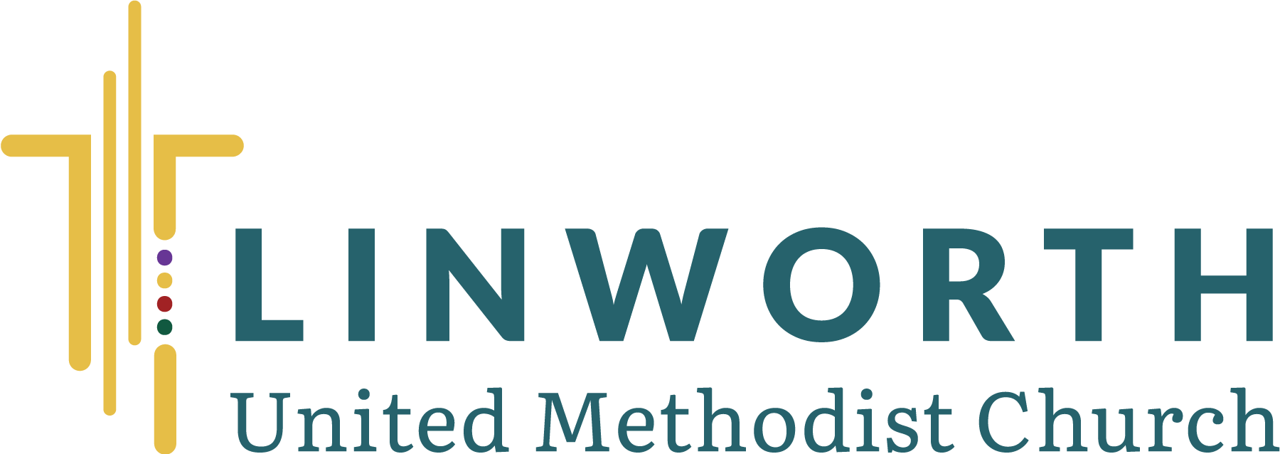

2026 Endowment Fund Grant Application

Please designate the area to which a grant application is being made:

up to $6,000 from the Missions Endowment Fund for missions in and beyond the local church community

up to $3,600 from the Property Endowment Fund for improvements, additions to, or construction of physical facilities

up to $27,600 from the General Endowment Fund for special needs and ministries determined by the church leadership

Note: The Endowment Fund will not be used for those parts of the church’s established programs which are funded through the annual operating budget of the church and the regular giving of its members. Only the pastors and church committees authorized by the Administrative Council may submit grant applications.

ALL APPLICATIONS MUST BE SUBMITTED TO THE LEGACY COMMITTEE CHAIR at endowment@linworthumc.org or in paper copy to the Legacy Committee church mailbox in Room 210 by 5:00pm APRIL 30, 2026.

Project Name:

Authorized Linworth UMC Committee or Pastor Sponsoring Grant (select only one):

Administrative Council | Finance Committee | Pastor Anna Guillozet
Staff-Parish Relations | Missions Committee | Pastor Brian Otte
Trustees Committee | Stewardship Committee

Date Committee Approved Grant Application (n/a for pastors):

Committee Chairperson Name (n/a for pastors):

__________________________________ Date: ____________
Chairperson or Pastor Signature

Linworth UMC Grant Applicant Name:

Telephone: Email Address:

Grant Project Information:

1. Project Description (include the client group and the number of people expected to serve):

2. Project Goals/Objectives:

3. Geographic area to be served by this project:

4. Will volunteers be used? Yes No If yes, in what capacity will they be used?

5. Amount requested for this grant: $

6. Date when endowment funds are needed:

7. Project duration:

8. Total project cost:

9. Identify other funding already available for this project:

10. List plans for future/ongoing funding needs for this project beyond this grant year:

Additional Information which may be useful for consideration (attach more documentation to this application, if necessary):

If you have any questions or require assistance with this application process, please contact
the Legacy Committee Chair at endowment@linworthumc.org.

ALL APPLICANTS WILL BE INFORMED CONCERNING THE STATUS OF THEIR APPLICATION
BY MAY 31, 2026

Grant Review (for Linworth UMC Legacy Committee use only)

Date Received: ________________________

Date Reviewed: _______________________

Approved Partial Approval Declined

Comments: ___________________________________________________________________

_____________________________________________________________________________

_____________________________________________________________________________

_____________________________________________________________________________

_____________________________________________________________________________

_____________________________________________________________________________

_____________________________________________________________________________

_____________________________________________________________________________

_____________________________________________________________________________

By action of the Linworth UMC Legacy Committee on (date): ________________________

____________________________ ____________________________
Legacy Chair Printed Name Legacy Chair Signature

