REGISTRATION: Spring 2026
Camper Name: _______________________________
Address: _______________________________
City: ___________ST: ___ ZIP: ______
Church: _______________________________
DOB: ____/____/ ____ Grade: ______
Gender (circle one): M / F

CONTACT INFORMATION:
In case of emergency, we will make every effort to contact you. Please provide two emergency contacts.

Primary Contact: ______________________________
Home #: _______________________________
Cell#: _______________________________
2nd Contact: _______________________________
Home #: _______________________________
Cell#: _______________________________
Primary Contact E-Mail:
_______________________________

PERMISSIONS:
Camper has my permission to participate in:
Rifles: ________ Archery: ________
Hatchets: _____ Sling Shot: ________

Signed: _______________________________ (Parent/guardian signature)

CAMPER MEDICAL INFORMATION

Current Medications: ______________________________________________________________
Allergies: ______________________________________________________________

Other health info (objections to certain medications, limitations, etc.):
______________________________________________________________
Does your child require any assistance to navigate physical or social surroundings?
______________________________________________________________
Family Doctor: _______________________________
Office#: _______________________________
Insurance Name: _______________________________
Policy#: _______________________________

This form gives my legal consent for the treatment of my child. I understand that the camp medical personal will make every effort to contact me, but will not delay treatment. I do hereby state that I am the parent and/or legal guardian of the named minor, born ____/_____/ ____. I consent to any necessary examination, anesthetic, medical or surgical treatment, and/or hospital care to be and on the advice of duly licensed medical personal during the period of my absence. I understand that Virginia has the Good Samaritan Law.

Signed: _______________________________ (Parent/guardian signature)

Participation Agreement for Campers

I agree that Camp Tuk-A-Way will in no way be held responsible for medical treatment or liability resulting from health or physical conditions existing prior to or after my camper's attendance at camp. I further agree to indemnify and hold harmless Camp Tuk-A-Way from any claims related to the spread of any infectious diseases, including but not limited to COVID-19, that my camper may receive or carry to another individual at Camp Tuk-A-Way as a result of attending Camp Tuk-A-Way’s programs, and as such, I assume all risks associated with these activities.

I certify that, ___________________________, will not have had a fever, persistent cough, body aches, fatigue, shortness of breath, loss of taste or smell, or any other symptoms 5 days before camp. I understand that I will not bring my camper to camp if any of the above happens.
Signed: _______________________________ (Parent/guardian signature)

WHAT TO BRING: Bible, pen, notebook, sleeping bag, pillow, clothes for a day, tennis shoes, jacket, sweatshirt, clothes and shoes for games, personal necessities, towel, flashlight, insect repellant.

DRESS CODE:
- Pants should fit snugly at the waist (boxers should not be visible).
- Neither shirts nor shorts should be cut-offs.
- Rips in jeans should be no higher than your fingertips when placed at your side.

- Male campers should be shirtless only in the cabin unless given specific permission.
- Tops should have no necklines revealing cleavage, should be long enough to cover the midriff, and should not be sheer.
- Shorts should be approximately mid-thigh in length and not too tight.
- No leggings may be worn alone.
- Pajamas should only be worn in the cabin.

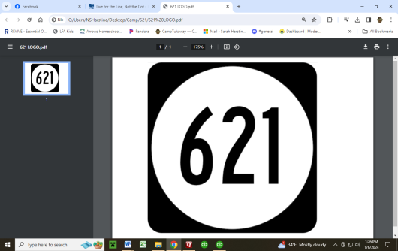
WHAT NOT TO BRING: ANY and ALL electronic and digital devices, peanuts or peanut products, energy drinks, snacks, candy, weapons (including nerf and other fake weapons), fireworks, lighters, laser pointers, harmful substances (including but not limited to alcohol, non-prescription drugs, tobacco, and cigarette related products), pets, aerosol deodorants.
$35 per Camper
6th Grade – 12th Grade

April 10 - 11
Drop Off
Friday 7pm
Pick Up
Saturday 7pm
NOTE: Eat before you are dropped off
Any of these items will be confiscated by the director and returned at the end of the retreat.
NOTE: BRING A SNACK TO SHARE DURING FRIDAY NIGHT CAMP FIRE
Ideas: Cookies, Chips, Crackers, Candy

CAMPER’S PLEDGE: “I hereby agree to abide by all camp rules and dress code. I will respect everyone and follow all instructions.
I acknowledging that failure to do so will be just grounds for my dismissal without refund”

Signed:__________________________
(Camper signature)

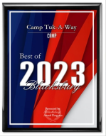
Signed:__________________________

Camp Tuk-A-Way
2262 Craig Creek Road
Blacksburg, VA 24060
540-961-4100
www.camptukaway.com

(Parent/guardian signature)
Speaker:
Christopher Leigh

