North Country Fellowship Elder Position
NCF is looking to add an Elder to its leadership team. This position is part-time.

Job Description
Elders serve in council and conference with the Senior Elder in all matters pertaining to the welfare and work of the church. They are responsible with the Senior Elder for the oversight of all ministries of the church.
Areas of responsibility include, but are not limited to:
- The preaching, teaching, training, and equipping ministries of the church, including the conduct of the worship service as gifts and abilities allow.
- Visitation, counseling, and the discipling of new converts and members.
- The careful examination of all candidates for church membership, recommending to the church those considered eligible for membership.
- All matters of discipline of members.
- The administration of the ordinances.
Elders have a mutual responsibility of encouragement, exhortation, and accountability to each other in the performance of their ministries.

Compensation
The biblical precedent for multiple Elders is a priority for NCF. Being a small congregation in a rural area, NCF has purposefully adopted a bi-vocational model to enable a multi-elder structure on a limited budget. This may change in the future as finances allow, but it is expected that there will always be the option for bi-vocational elder positions.
Part time may be defined as 16-20 hours a week, depending on availability. Compensation is set at $1,000/month. Elders are provided up to four weeks paid vacation per year and are expected to coordinate that with the other Elders.
Elders are compensated as self-employed and are responsible for their own taxes. However, income may be categorized as housing allowance and professional expenses to minimize the tax liability.

Qualifications
The qualifications for Elders shall be those set forth in I Timothy 3:1-7 and Titus 1:5-9. An elder must be a man who has been called by God to his ministry (I Tim. 2:7; 2 Tim. 1:11), gifted by the Holy Spirit to equip the body for the work of the ministry (Eph 4:11-13) . He must be in complete agreement with our Statement of Faith.

About NCF
The church is a blended congregation of transient military and permanent local residents. The typical age is around 35 years old, and 30-40% of the weekly attendance is children under age 18. Average weekly attendance is around 90. Due to the transient nature of the military, about half of the congregation leaves within 3 years.
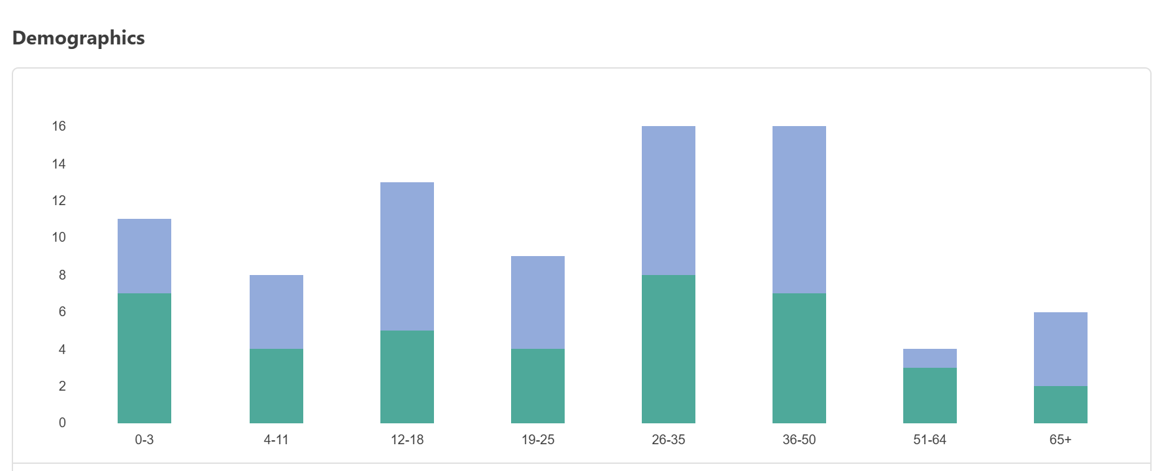

Application
Applicants for the position should submit the following to elders@ncfchurch.org :
- Letter of interest/intent
- Summary document with testimony, doctrinal position, and philosophy of ministry
- Areas of giftedness along with any relevant ministry or educational experience

